Frankenstein



a

bridged

for

y

oung

r

eaderS

C

ore

C

laSSiCS



by Mary Shelley

Creative Commons Licensing

This work is licensed under a

Creative Commons Attribution-NonCommercial-ShareAlike 4.0 International License.



You are free:

to Share—to copy, distribute, and transmit the work to Remix—to adapt the work

Under the following conditions:

Attribution—You must attribute the work in the following manner:

*This work is based on an original work of the Core*

*Knowledge® Foundation (www.coreknowledge.org) made available through licensing under a Creative Commons Attribution-NonCommercial-ShareAlike 4.0 International License. This does not in any way imply that the Core Knowledge Foundation endorses this work.*

Noncommercial—You may not use this work for commercial purposes.

Share Alike—If you alter, transform, or build upon this work, you may distribute the resulting work only under the same or similar license to this one.

With the understanding that:

For any reuse or distribution, you must make clear to others the license terms of this work. The best way to do this is with a link to this web page: https://creativecommons.org/licenses/by-nc-sa/4.0/

Copyright © 2022 Core Knowledge Foundation www.coreknowledge.org

All Rights Reserved.

Core Classics®, Core Knowledge Language Arts™,

CKLA™ Core Knowledge®, Core Knowledge Curriculum Series™, are trademarks of the Core Knowledge Foundation.

Trademarks and trade names are shown in this book strictly for illustrative and educational purposes and are the property of their respective owners. References herein should not be regarded as affecting the validity of said trademarks and trade names.

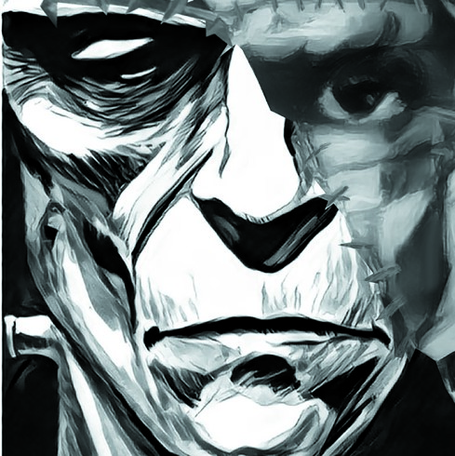

# Frankenstein

*or, the Modern Prometheus*

*by*

Mary Shelley

ii

*CORE CLASSICS®*

edit or f or t h is vol ume Mat t hew M. Davis

isbn 979-8-88970-996-1

copyr igh t © 2022 cor e kn owl edge f oun da t ion a l l r igh t s r eser ved

CORE KN OW LEDGE FOUN DAT ION

801 ea st h igh st r eet ch a r l ot t esvil l e, vir gin ia 22902 www.coreknowledge.org

## TABLE OF CONTENTS

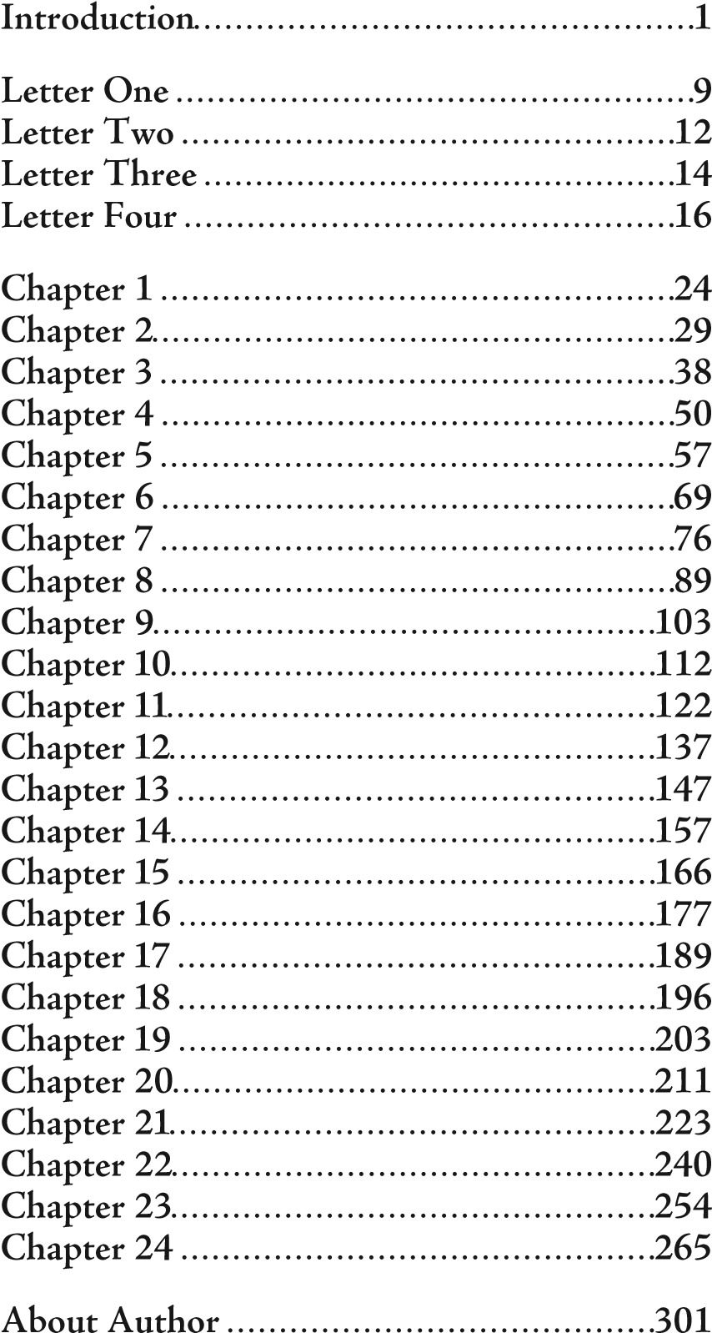

## INTRODUCTION

### 1831 EDITION

In selecting *Frankenstein* for publication, my publisher expressed a wish that I would give some account of the origin of the story. I am the more willing to do so, because in this way I shall also give a general answer to the question, so frequently asked me—*how was it that I, then a young girl, came to think of, and to expand upon, so very hideous an idea?*

It is not surprising that, as the daughter of two distinguished writers, William Godwin and Mary Wollstonecraft, I should very early in life have thought of writing. As a child I scribbled, and my favorite pastime, in my free time, was to “write stories.” Writing was a great pleasure to me, but an even greater pleasure was the formation of “castles in the air.” I loved to indulge myself in daydreams. I spent many hours following out trains of thought and working out imaginary incidents. My dreams were more fantastic and more agreeable than my writings. In the latter I was a close imitator—

William Godwin: a radical philosopher and novelist, 1756-1836

Mary Woolstonecraft: an early feminist and political writer, 1759-1797, author of *A Vindication of the Rights of Men* (1790) and *A Vindication of the Rights of Women* (1792).

seeking to do things others had done rather than putting down the suggestions of my own mind. What I wrote was intended at least for one other reader—my childhood companion and friend, but my dreams were all my own. I accounted for them to nobody; they were my retreat when annoyed and my greatest pleasure when free.

I lived mostly in the country as a girl, and I spent a good deal of time in Scotland. I made occasional visits to the more picturesque parts, but my usual residence was on the blank and dreary northern shores of the Tay, near Dundee. Blank and dreary I call them now, but they were not so to me then. They were a shelter for freedom and the pleasant region where I could connect with the creatures of my imagination. I wrote then—but in a most commonplace style. It was beneath the trees of the grounds belonging to our house, or on the bleak sides of the woodless mountains nearby, that my true compositions, the airy flights of my imagination, were born and fostered. I did not make myself the heroine of my tales. My own life seemed too ordinary to make a good story. I did not think that I would ever experience romantic worries or wonderful events, but I was not confined to my own identity, and I could fill the hours with creations far more interesting to me, at that age, than my own sensations.

After this my life became busier, and reality tended to displace fiction. My husband, Percy Bysshe Shelley, however, was from the first, very anxious that I should prove myself worthy of my literary parentage and achieve some fame as a writer. But for a long time I did nothing. I was busy travelling and taking care of a family. I did spend many hours improving my mind by reading and discussing things with my husband, but I accomplished very little with my pen.

In the summer of 1816, we visited Switzerland, where we were neighbors of Lord Byron. At first we spent many pleasant hours on Lake Geneva, or wandering on its shores. Lord Byron, who was writing the third canto of *Child Harold’s Pilgrimage*, was the only one among us who put his thoughts upon paper. We had the pleasure of reading his verses as he wrote them.

Percy Bysshe Shelley: English Romantic poet, 1792-1822, noted for his radicalism. Some lines from his poetry are included in the novel that follows.

Lord Byron: English Romantic poet, 1788-1824, very popular and quite scandalous – so much so that he was forced to leave England and lived most of his adult life in Europe.

Child Harold’s Pilgrimage: a mostly autobiographical poem; the fi rst two cantos (parts) made Byron famous; later cantos added to his celebrity.

Unfortunately, it turned out to be a wet, unpleasant summer, and rainstorms often confined us to the house for several days at a time. Some volumes of ghost stories fell into our hands. There was the tale of the Inconstant Lover, who, when he went to embrace his lover, found himself instead in the arms of the pale ghost of her whom he had deserted. There was the tale of the sinful founder of his race, whose miserable fate it was to give the kiss of death to all the younger sons of his fated house, just when they reached the age of promise. Eternal sorrow sat upon his face as he bent down and kissed the forehead of the boys, who from that hour withered like flowers snapped from the stem. I have not seen these stories since then, but their events are as fresh in my mind as if I had read them yesterday.

“We will each write a ghost story,” said Lord Byron, and his proposal was accepted. There were four of us. Byron began a tale, a fragment of which he printed at the end of his poem, *Mazeppa*. My husband began a story based on the experiences of his early life. Our friend John William Polidori wrote a story about a vampire.

Polidori’s story, *The Vampyre*, published in 1819, was the fi rst vampire tale published in England.

I tried to *think of a story*. I wanted to come up with a story that would speak to the mysterious fears of our nature and awaken thrilling horror— one that would make the reader dread to look round, one that would curdle the blood and quicken the beatings of the heart. If I did not accomplish these things, I felt, my ghost story would be unworthy of its name. I thought and pondered—but in vain. For a long time I could think of nothing. *Have you thought of a story*? I was asked each morning, and each morning I was forced to admit that I had not.

Everything must have a beginning, and that beginning must be linked to something that went before. Invention, it must be humbly admitted, does not consist in making something out of nothing, but in making something out of chaos; the materials must, in the first place, be offered: Invention can give form to dark, shapeless substances, but it cannot bring the substance itself into being. Invention works by taking hold of a subject and then developing the ideas suggested by the subject.

My husband and Lord Byron had many long conversations. I listened to these attentively but rarely added anything. During one of these, various philosophical ideas were discussed, especially the concepts of life and vital energy. The two poets spoke at length about whether the basic principles of life might ever be discovered and communicated.

After listening to this conversation, I went to bed. When I placed my head on my pillow, I did not sleep, nor could I be said to think. My imagination took over. I saw a series of images in my mind. These images were more vivid than any dream. I saw— with shut eyes, but acute mental vision,—I saw the pale student kneeling beside the thing he had put together. I saw the hideous body—first stretched out, then showing signs of life. That would have to be be a frightful vision—for any human attempt to imitate the stupendous work of the Creator of this world must be a frightful thing. I sensed that the artist would be terrified; he would rush away from his terrible handywork, horror-stricken. He would hope that, left to itself, the slight spark of life which he had communicated would fade; that this thing, which had received such imperfect animation, would sink back down into dead matter; and he might sleep in the belief that the silence of the grave would quench forever the brief existence of the hideous corpse which he had looked upon as the cradle of life. He sleeps, but he is awakened; he opens his eyes and what does he see? The horrid thing stands at his bedside, opening his curtains, and looking on him with yellow, watery eyes.

I opened my own eyes in terror. The idea had taken possession of my mind, and a thrill of fear ran through me. I wished to exchange the ghastly image of my imagination for the realities around me. I see them still: the room, the dark parquet floor, the closed shutters, with the moonlight struggling through, and the sense I had that the glassy lake and white high Alps were out there, beyond the window. I could not so easily get rid of my hideous idea; it continued to haunt me. I told myself I must try to think of something else. I turned my thoughts back to the ghost story I was trying to write—my tiresome, unlucky ghost story! Oh! If I could only create a story that would frighten my reader as I myself had been frightened that night!

Then the idea came to me all of a sudden. “I have found it!” I called out. “What terrified me will terrify others; and I need only describe the characters who haunted my midnight pillow.” On the morrow I announced that I had *thought of a story*. I began that day with the words, *It was on a dreary night of November*, and I presented an outline of the grim terrors of my waking dream.

At first I thought it would only be a short story, but my husband urged me to develop the idea at greater length. He did not provide me with the ideas for the story, but he did encourage me as I worked on it.

So now I must bid my hideous offspring go forth and prosper. I have an affection for it, for it was the offspring of happy days, when death and grief were but words, which found no true echo in my heart. Its several pages speak of many a walk, many a drive, and many a conversation, when I was not alone— and my companion was one who, in this world, I shall never see more. But this is for myself; my readers have nothing to do with these associations.

I will add but one word as to the changes I have made in this edition. They are principally matters of style. I have changed no portion of the story, nor introduced any new ideas or circumstances. I have mended the language here and there, but I have left the core and substance of the story untouched.

M.W.S.

## LETTER 1

*To Mrs. Saville, England.*

St. Petersburg, Russia, December 11th, 17—. Dearest sister,

I arrived here yesterday, and my first task is to assure you that I am in good health and more and more confident that I will succeed in my undertaking.

As I walk the streets of St. Petersburg, I feel a cold northern breeze play upon my cheeks. This fills me with delight, for I know this breeze has travelled from the polar regions towards which I am advancing. It gives me a delicious foretaste of those icy regions. Inspired by this wind of promise, my daydreams become more fervent and vivid.

At the pole, Margaret, the sun is always visible. Its broad disk never disappears—not even at night. It just skirts the horizon and gives light all night long. What may not be expected in a country of eternal light? And what may I not achieve by

fervent: passionate, burning vivid: realistic, clear, intense

eternal: never-ending (In the summer the sun never quite sets in

the far north.)

sailing there? I may discover the amazing power that attracts the compass needle! Or perhaps I shall discover a shorter passage to the East!

I am so curious. I must see this unknown land. I am not afraid at all. On the contrary, I feel my heart glow with enthusiasm. As you know, I have been planning this expedition for many years. As a boy I read the accounts of famous explorers and longed to make a voyage to the north. As a young man I trained my body to withstand hardship by serving on a whaling ship in the northern seas. I suffered through cold, famine, thirst, and lack of sleep. I often worked harder than the other sailors during the day. Then I spent my nights studying mathematics, medicine, and other branches of science likely to be useful to a naval adventurer like myself.

Now I am about to embark on a long and difficult voyage. It will demand all my courage and strength.

In a few weeks I will travel the post-road from

shorter passage: westward-sailing European explorers like Columbus, Cabot, and Hudson were searching for a more direct route to the East Indies. enthusiasm: energetic excitement famine: life-threatening lack of food

St. Petersburg to Archangel. This is the best time to travel in Russia. The Russians fly quickly over the snow in their sledges. The gliding motion is pleasant, and, in my opinion, it is far more pleasant than traveling in an English stagecoach. The cold is not excessive, if you are wrapped in furs.

I expect to depart for Archangel in two or three weeks. My plan is to hire a ship there. Then I will hire some sturdy sailors who have worked on whalers. I do not intend to sail until June. I know not when I will return. It will not be for many months.

Farewell, my dear Margaret.

Your affectionate brother,

Robert Walton

Archangel: Russian port city in the far north sledges: sleds for traveling on snow and ice

## LETTER 2

*To Mrs. Saville, England.*

Archangel, 28th March, 17—.

Dearest sister,

I have taken another step towards my enterprise. I have hired a ship and am now occupied in collecting my sailors. Those whom I have already engaged appear to be men on whom I can depend and are certainly possessed of great courage. My lieutenant, for instance, is a man of wonderful courage and enterprise. He is an Englishman I know from my days on the whaling ships. The master is also a fine fellow. He is a person of an excellent character and is remarkable for the mildness of his discipline. This circumstance made me very desirous to engage him. I dislike the cruelty employed on many ships. I have never believed it to be necessary, and when I heard of a sailor equally noted for his kindliness of heart and the respect and obedience paid to him by his crew, I felt myself peculiarly fortunate in being able to secure his services.

enterprise: project, mission

There is one want which I have not been able to satisfy. I mean the want of a true friend. I have hired many men, but I have not found a man who can fully sympathize with me. I have no one near me, gentle yet courageous, possessed of a cultivated as well as of a capacious mind, whose tastes are like my own, to either approve or improve my plans. Well, it is useless to complain. I am unlikely to find such a friend here in Archangel, among merchants and seamen, or upon the icy seas.

Yet do not suppose, because I complain a little, that I am wavering in my resolutions. I am only waiting until the weather allows me to sail. The winter has been dreadfully severe, but the spring promises well. I am eager to begin my explorations, eager to sail to “the land of mist and snow.”

Continue for the present to write to me at every opportunity. I may receive your letters on some occasions when I need them most to support my spirits. I love you very tenderly. Remember me with affection, should you never hear from me again.

Your affectionate brother,

Robert Walton

capacious: large

## LETTER 3

*To Mrs. Saville, England.*

July 7th, 17—.

My dear sister,

I write a few lines in haste to say that I am safe—and well advanced on my voyage. This letter will reach England by a merchant ship on its homeward voyage from Archangel.

I am in good spirits: my men are bold and apparently firm of purpose. The floating sheets of ice that continually pass us do not appear to worry them. We have already reached a very high latitude, and the winds blow us speedily towards those shores which I so desire to reach. Nothing bad has happened to us so far.

Adieu, my dear Margaret. Be assured that for my own sake, as well as yours, I will not rashly encounter danger. I will be calm and careful—but I will persevere, and I feel that I will succeed. What can stop the determined heart and resolved will of man?

I must finish this letter. Heaven bless you! R.W.

homeward voyage: return trip Adieu: goodbye (in French) persevere: stick to the task



“The float ing sheet s of ice t hat cont inually pass us do not

appear t o wor ry t hem.”

## LETTER 4

*To Mrs. Saville, England.*

August 5th, 17—.

My dearest sister,

A strange accident has happened to us. Last Monday (July 31st) we were nearly surrounded by ice. It had closed in on us on all sides. The situation was somewhat dangerous, especially as we were also surrounded by a very thick fog.

About two o’clock the fog cleared away, and we saw vast and irregular plains of ice. They stretched out in every direction and seemed to have no end. Some of my sailors groaned, and my own mind began to grow watchful with anxious thoughts. Then a strange sight suddenly attracted our attention. We spotted a sledge pulled by dogs. It passed along the ice to the north, at the distance of half a mile. It was guided by a being shaped like a man, but seemingly of gigantic size. We watched this strange being with our telescopes until he rode out of sight.

This sighting astonished us. Here we are— hundreds of miles from any land – and yet there is some enormous being driving a sledge!

Later that day the ice broke and freed our ship. We decided we would raise our sails in the morning.

In the morning, as soon as it was light, I went up on deck and found all the sailors on one side of the vessel. They seemed to be talking to someone in the sea. Looking down, I saw a sledge, like that we had seen before, on a large fragment of ice. Only one dog remained to pull it, but there was a human being piloting it. My sailors were trying to persuade the man to come aboard.

The stranger addressed us in excellent English, although with a foreign accent. “Before I come on board your vessel,” he said, “will you tell me where you are heading?”

I explained that we were on a voyage of discovery towards the north pole.

Upon hearing this the man appeared satisfied and agreed to come on board. Good God, Margaret! What a condition he was in! His limbs were nearly frozen. His body was dreadfully emaciated by fatigue and suffering. I never saw a man in such wretched condition. We attempted to carry him into my cabin, but he fainted. We rubbed him

emaciated: thinned out, made skinny

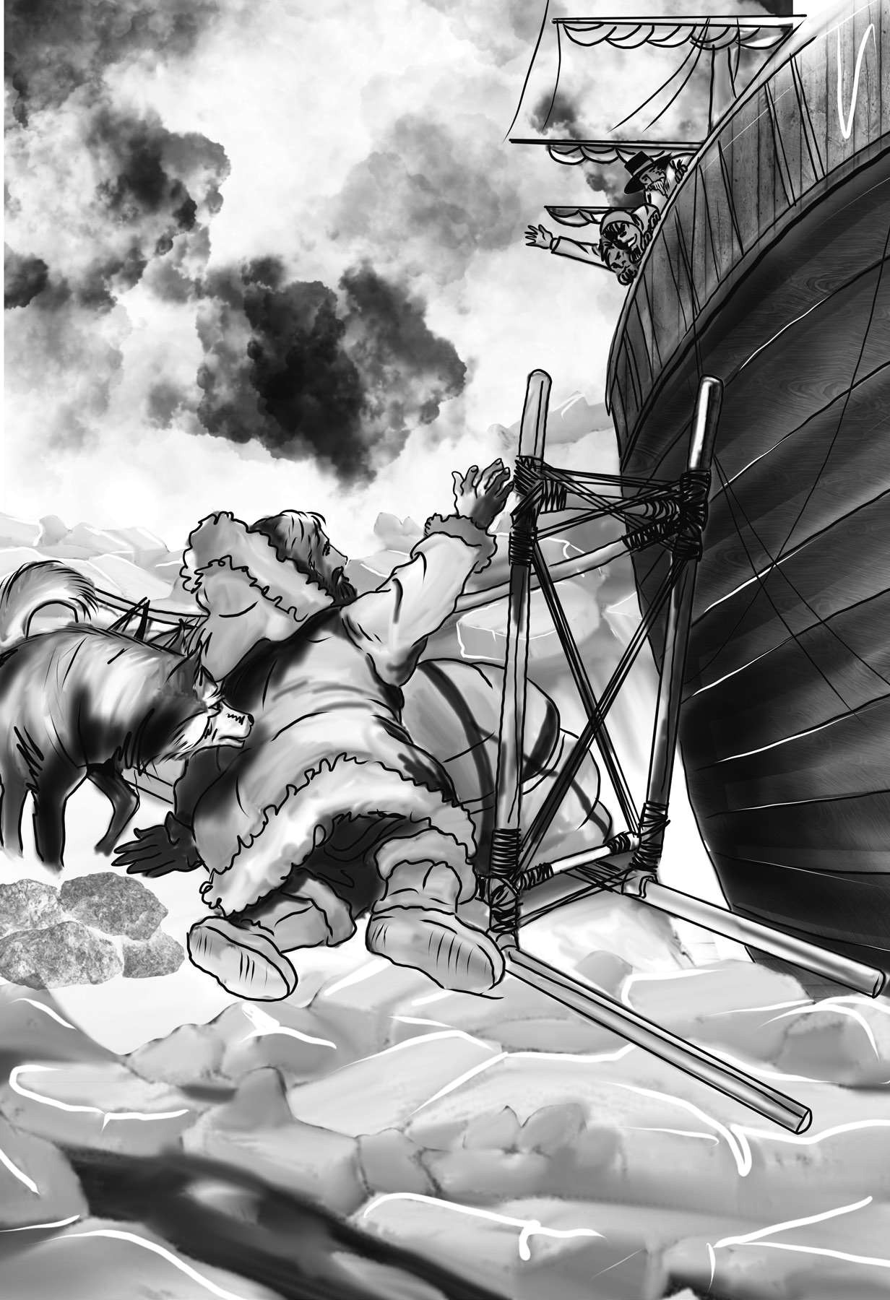

“Looking down, i saw a sledge . . . on a lar ge fr agment of ice.”

with brandy and forced him to swallow some. As soon as he showed signs of life we wrapped him up in blankets and placed him near the chimney of the kitchen stove. By slow degrees he recovered. Eventually he ate a little soup, which restored him wonderfully.

Two days passed before he was able to speak. When he had in some measure recovered, I spoke with him. I never met a more interesting creature. His eyes have an expression of wildness, perhaps even madness, and yet, if anyone performs an act of kindness towards him or does him the most trifling service, his whole face lights up with a sweetness I never saw equaled. But this look I rarely see. Generally he is melancholy and despairing. Sometimes he even grinds his teeth, as if his troubles are crushing him.

My lieutenant asked him why he had come so far upon the ice in so strange a vehicle. He frowned and replied, “To seek one who fled from me.”

“And did the man whom you followed travel in the same fashion?”

“Yes.”

trifl ing: small, tiny

melancholy: depressed, discouraged, gloomy

“Then I fancy we have seen him, for the day before we picked you up we saw some dogs drawing a sledge, with a man in it, across the ice.”

This aroused the stranger’s attention. He began asking us questions. *Which way had the other sledge gone? Was it destroyed when the ice broke up?*

I told him that I could not answer with certainty. The ice had not broken up until midnight, and the traveler might have found his way to some safe place before it did.

The man wanted to go up on deck to look for the other sledge, but I persuaded him to remain in the cabin. I have promised that we will watch out for the sledge.

The stranger is beginning to recover, and I have grown fond of him. His constant and deep grief fills me with pity and concern.

I said in one of my letters, my dear Margaret, that I did not expect to find a friend on the wide ocean, and yet I have found a man who, before his spirit was broken by such unhappiness, might have been a brother of my heart.

I shall continue to keep a journal concerning this stranger, writing in it now and then if I have any fresh incidents to record.

August 13th, 17—.

My affection for our guest increases every day. He excites at once my admiration and my pity. How can I see such a man destroyed by misery without feeling grief? He is gentle yet wise. His mind is cultivated, and he speaks with great eloquence.

He has now largely recovered from his illness. He is continually on the deck, watching for the sledge that preceded his own. However, he also finds time to talk with me.

A few days ago I gave him a detailed description of my plan to explore the pole and achieve great victories for science. As I spoke, a frown spread over his face. When I finished, he said, “Unhappy man! I fear that you share my madness! I fear that you have drunk from the same intoxicating cup! Hear my story—let me tell my tale! Then you will dash the cup from your lips!”

Such words, you may imagine, strongly excited my curiosity. Unfortunately, the grief that had seized the stranger left him weakened and he said no more to me that day.

The next day he asked me about my early years. I told him about my childhood. I spoke also

cultivated: educated, refi ned eloquence: persuasiveness

of my loneliness and my desire of finding a friend. I expressed my belief that a man could boast of little happiness who did not enjoy this blessing.

“I agree with you,” he replied. “Without friends we are unfinished creatures. I once had a friend— the most noble of human creatures—but he was taken from me. You at least have hope. You have the world before you. But I, I have lost everything. I cannot begin life anew.”

His grief touched me. I longed to hear more, but he was silent and presently went back to his cabin.

August 19th, 17—.

Yesterday the stranger said to me, “You may easily perceive, Captain, that I have suffered great misfortunes. I had determined at one time that the memory of these evils should die with me, but you have convinced me otherwise. You seek for knowledge and wisdom, as I once did. I hope that the gratification of your wishes may not be a serpent to sting you, as mine has been. I do not know if a description of my disasters will be useful to you, but I know this: you are pursuing the same

begin . . . anew: start over misfortunes: accidents gratifi cation: satisfying

course and exposing yourself to the same dangers that have made me what I am. Perhaps you may be able to deduce an apt moral from my tale.

I told him I was eager to hear his tale. I said, also, that I would do whatever I could to improve his own situation.

“I thank you,” he replied, “for your sympathy. Unfortunately, it can do me no good. My destiny is nearly fulfilled. I wait only for one event, and then I shall rest in peace.”

He then told me that he would begin his narrative the next day when I happened to be free. I have resolved to write down what he tells me every night and will try to record it as nearly as possible in his own words.

moral: lesson destiny: fate, certain end narrative: story

## CHAPTER 1

I

was born and raised in Geneva, where my father was a distinguished citizen. He was respected by all who knew him for his integrity and unfailing attention to public business. He was so busy with his duties that he did not become a husband and father until late in life.

As the circumstances of his marriage illustrate his character, I cannot refrain from relating them. One of his closest friends was a merchant who fell, through numerous unfortunate events into poverty. This man, whose name was Beaufort, was of a proud and unbending disposition. He could not bear to live in poverty and oblivion in the same country where he had formerly been distinguished for his rank and magnificence. He retreated, therefore, with his daughter, to Lucerne. There he lived, unknown and in wretchedness. My father loved Beaufort. He was deeply saddened by his friend’s situation. He went to seek him out, in hope of persuading him to begin the world again through his assistance.

refrain: keep myself

unbending: stiff , unwilling to change his mind oblivion: the condition of being forgotten

Ch a pt er 1

Ten months passed before my father discovered where he lived. He found his old friend sunk in his grief, lying in bed, incapable of any activity.

Beaufort’s daughter attended him with great tenderness, but she saw that their funds were rapidly decreasing. They had no other prospect of support, but Caroline Beaufort was brave, and her courage rose to support them in their adversity. She took menial jobs and managed to earn enough to keep the two of them alive.

Unfortunately, her father grew worse. In a matter of months he died in his daughter’s arms. Caroline was left an orphan. My father came to the poor girl like a guardian angel. He determined to take care of her. He brought her to Geneva and placed her under the protection of a relative. Two years after this event Caroline became his wife.

There was a considerable difference between the ages of my parents, but this circumstance seemed only to unite them. My father was very attached to my mother. He tried to shelter her, as a fair exotic is sheltered by the gardener from the

menial jobs: servant’s jobs fair exotic: a beautiful, foreign plant

rougher winds. He sought to surround her with all that could excite pleasurable emotion in her soft and benevolent mind. Her health, and even the tranquility of her spirit, had been shaken by what she had gone through. During the two years before their marriage my father had gradually given up all of his public functions. Immediately after their marriage, the two of them sought the pleasant climate of Italy. My father hoped that the climate there would restore my mother’s health.

From Italy they visited Germany and France. I, their eldest child, was born in Naples, and as an infant accompanied them in their travels. They were affectionate parents to me. My mother’s tender caresses and my father’s smile of benevolent pleasure while regarding me are my first recollections.

For a long time I was their only care. However, this changed when I was five years old. My parents were passing a week on the shores of Lake Como. Their benevolent disposition often made them enter the cottages of the poor. This, to my mother, was more than a duty; it was a necessity, a passion. She

benevolent: kind, generous tranquility: calmness

Ch a pt er 1

remembered what she had suffered—and how she had been relieved. She wanted to assist others who were struggling in life.

One day my mother and I visited the cottage of a peasant and his wife. These poor people were bent down by care and labor. They could scarcely feed their five hungry babes. Among these there was one which attracted my mother far above all the rest. She appeared of a different stock. The four others were dark-eyed, hardy little vagrants. This child was thin and very fair. Her hair was the brightest gold. Her blue eyes were cloudless. She seemed a being heavensent, with a celestial stamp on all her features.

The peasant woman, seeing my mother looking with wonder and admiration on this lovely girl, eagerly communicated her history. She was not her own child. She was the daughter of a nobleman from Milan. Her mother was a German, and she had died giving birth. The infant had been placed with these good people to nurse. She had bloomed in their rude dwelling, fairer than a garden rose among dark-leaved brambles.

celestial: heavenly brambles: prickly shrubs

When my father returned from his trip, he found me playing in the hall of our country home with this child. My mother got his permission and convinced the girl’s guardians to let the girl come and live with us. They were fond of the sweet orphan. Her presence had seemed a blessing to them, but they could scarcely feed their other children. They consulted their village priest, and the result was that Elizabeth Lavenza joined our family. She became my sister—my more than sister. She became the beautiful and adored companion of all my occupations and pleasures.

Everyone loved Elizabeth. I not only loved her but also looked up to her. On the evening previous to her being brought to my home, my mother had said playfully, “I have a present for you, Victor. Tomorrow you shall have it.” On the next day, she presented Elizabeth to me as her promised gift. I, with childish seriousness, interpreted her words literally and looked upon Elizabeth as mine—mine to protect, love, and cherish. We called each other “cousin,” but she was my beloved sister.

## CHAPTER 2

Elizabeth and I were brought up together. There was not quite a year difference in our ages. We lived in perfect harmony and grew closer over time. Elizabeth was of a calmer and more concentrated disposition. I was capable of a more intense application and was more interested in learning. While she contemplated the magnificent appearances of things, I delighted in investigating their causes. The world was to me a secret that I desired to puzzle out. I was curious. I wanted to understand the hidden laws of nature.

When I was seven, my parents had another child. They gave up their wandering life and settled in their native country. We had a house in Geneva, and a country place on the eastern shore of the lake. We resided for the most part in the latter, in considerable seclusion. As a boy, I preferred to avoid a crowd. I was indifferent to my school fellows in general, but I did befriend

harmony: agreement, peacefulness contemplated: thought deeply, carefully examined seclusion: isolation; solitude, loneliness

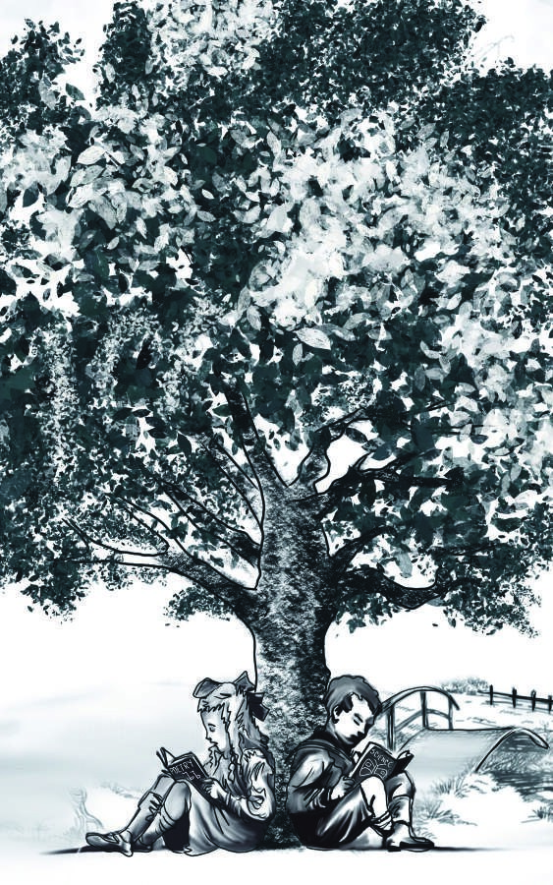

“We lived in per fect har mony and gr ew closer over t ime.”

one of them. His name was Henry Clerval. He was the son of a merchant in Geneva. He was a boy of unusual talent and imagination. He loved enterprise, hardship, and even danger. He was deeply read in books of chivalry and romance. He composed heroic songs and wrote tales of enchantment and knightly adventure. He recruited us to act in plays and enter into his performances. The characters in these dramas were drawn from the heroes of Roncesvalles, the Round Table of King Arthur, and the Crusades.

No human being could have passed a happier childhood than myself. My parents were kind and indulgent. We loved them, and they loved us. When I mingled with other families, I sensed how fortunate my lot was and felt grateful towards my parents.

chivalry: the world of knights and their moral and social code of behavior

Roncesvalles: The great Christian warrior Roland died fi ghting at the battle of Roncesvalles.

King Arthur: a knight, likely mostly mythological, who led Celtic warriors against Anglo-Saxons in what is now England and Wales

Crusades: series of wars in which Christians from Europe tried to take the holy city of Jerusalem back from Muslims

indulgent: relaxed, accepting

lot: fate

My temper was sometimes violent, and my passions vehement, but by some law of my nature they were turned not towards childish pursuits but to an eager desire to learn. I was not particularly interested in learning languages or government and political affairs. It was science that fascinated me. I desired to learn the secrets of heaven and earth – the outward substance of things and the inner spirit of nature.

My friend Henry occupied himself with the moral relations of things. His dream was to become one of those whose names are recorded in story as the brave and adventurous benefactors of our species.

The saintly soul of Elizabeth shone like a shrine-dedicated lamp in our peaceful home. Her smile, her soft voice, the sweet glance of her celestial eyes, were ever there to bless and inspire us. I might have become depressed in my study, but I did not, for Elizabeth was there to subdue me with her own gentleness. And Henry! Could anything depress the noble spirit of Henry Clerval?

vehement: intensely emotional, strong benefactors: helpers, improvers

I take pleasure in dwelling on the recollections of childhood. It was a time of happiness—before misfortune had poisoned my mind and changed its bright visions of usefulness into gloomy and narrow reflections upon self.

As I have mentioned, science and natural philosophy were my great loves. When I was thirteen we took a trip to the natural hot springs near Thonon. A patch of bad weather forced us to spend a day in the inn. There I found a volume of the works of Cornelius Agrippa. I opened the book without much interest but gradually grew more enthusiastic. Agrippa seemed to understand many things. A new light seemed to dawn upon my mind. Bounding with joy, I communicated my discovery to my father. My father glanced at the title page of my book and said, “Cornelius Agrippa! My dear Victor, do not waste your time upon this. It is trash.”

Looking back on that day, I do wish my father had given a different answer. If he had taken a few minutes to explain that the notions of Agrippa

Cornelius Agrippa: Heinrich Cornelius Agrippa (1486-1535), author of books on the occult.

bounding: leaping, excited

had been entirely disproved by modern science, I would have thrown the book aside. It is even possible that the train of my ideas would never have received the fatal push that eventually led to my ruin. But the quick glance my father had taken of my volume led me to think that he was not very well acquainted with its contents, and I continued to read with the greatest enthusiasm.

When I returned home my first care was to obtain all of the works of Cornelius Agrippa on occult philosophy. Later I acquired volumes by Paracelsus and Albertus Magnus as well. I read and studied the wild fancies of these writers with delight. They appeared to me treasures known to few besides myself. Here were books, and men, who knew more than I did. I believed everything they told me and I became a disciple.

It may appear strange that these philosophers

occult: secret; magical

Paracelsus: Swiss physician and alchemist, lived c. 1490-1541; an alchemist was someone who believed that he could magically change one thing into something else, such as metal into gold

Albertus Magnus: German philosopher and scientist, lived

c.1200-1280 disciple: a devoted follower

of the occult should find an avid reader in the eighteenth century, but I can account for it. While I followed the routine of education in the schools of Geneva, I was, to a great degree, self-taught. My father was not scientific, and I was left to struggle with a child’s blindness, added to a thirst for knowledge. Under the guidance of Agrippa and Paracelsus, I entered with the greatest diligence into the search of the philosopher’s stone and the elixir of life. The latter, however, soon attracted my undivided attention. Wealth seemed to me an inferior object. I thought only of the glory that would attend the discovery if I could banish disease from the human body and render man invulnerable to any but a violent death!

Thus for a time I was occupied by disproved ideas, mingling a thousand contradictory theories and floundering desperately in a swamp of

avid: eager, enthusiastic diligence: hard work

philosopher’s stone: something that some people in the Middle

Ages believed could turn any metal into gold elixir of life: a magic potion that allows one to live forever banish: drive away

invulnerable: totally protected, safe fl oundering: struggling, thrashing around

disconnected knowledge. I was guided by an ardent imagination and childish reasoning, till an accident again changed the current of my ideas.

When I was fifteen, I witnessed a violent and terrible thunderstorm. It advanced from behind the mountains, and the thunder burst with frightful loudness from the heavens. I watched the storm’s progress with curiosity and delight. As I stood at the door, all of a sudden I beheld a stream of fire shooting out of an old oak tree that stood about twenty yards from our house. As soon as the dazzling light vanished, the oak had disappeared. Nothing remained but a blasted stump. When we visited it the next morning, we found the tree had shattered in an unusual manner. It had not been splintered by the shock. It had been entirely reduced to thin ribbons of wood. I had never seen anything so completely destroyed.

On this occasion a man who had some knowledge of electricity was staying with us. He was excited by this catastrophe and he began to tell us about the science of electricity. This was new and astonishing to me. I quickly forgot

blasted: destroyed (by lightning)

about Cornelius Agrippa, Albertus Magnus, and Paracelsus. I began to study electricity and also mathematics.

It is strange how our lives unfold. Tiny strings may lead us to success or ruin. When I look back, it seems to me this almost miraculous change of inclination was the immediate suggestion of the guardian angel of my life. It seems that this was the last effort made by that spirit of preservation to avoid the storm that was ready to envelop me. This kindly force was guiding me away from my occult studies. It was a strong effort of the spirit of good, but it didn’t work. Destiny was too powerful and her immutable laws had decreed my complete and terrible destruction.

envelop: surround

occult studies: studies of magic and the supernatural immutable: not able to be changed

## CHAPTER 3

W

hen I reached the age of seventeen my parents decided that I should go to the university in Ingolstadt. I had hitherto

attended the schools of Geneva, but my father thought it necessary that I should be made acquainted with other customs than those of my native country. My departure was therefore fixed at an early date, but before the day could arrive, the first misfortune of my life occurred—an omen, as it were, of my future misery.

Elizabeth had caught the scarlet fever. Her illness was severe, and she was in the greatest danger. During her illness my mother was urged not to sit by Elizabeth’s bed. She had at first agreed, but when she heard that the life of her favorite was in danger, she could no longer control her anxiety. She attended Elizabeth on her sickbed. Her watchful attentions triumphed over the disease— Elizabeth was saved, but the consequences of

Ingolstadt: city in southern Germany

scarlet fever: highly contagious and often deadly disease

this risky behavior were fatal to her preserver. On the third day my mother sickened. Her fever was accompanied by the most alarming symptoms, and the looks of her medical attendants led us to fear for the worst.

On her deathbed the strength and goodness of my mother did not desert her. She joined the hands of Elizabeth and myself. “My children,” she said, “my firmest hopes of future happiness were placed on the possibility of a union of the two of you in matrimony. This expectation will now be a comfort to your father. Elizabeth, my love, you must act in my place and take care of my younger children. Alas! I regret that I am taken from you! I will try to resign myself cheerfully to death and will hope to meet you in another world.”

She died calmly, and her face expressed affection even in death. I need not describe the feelings of those whose dearest ties are broken by that most irreparable evil, the emptiness that presents itself to the soul, and the despair that is exhibited on the face. At first the mind refuses to accept the new reality. It is impossible to accept

irreparable: lasting; permanent

that a person whom we saw every day and whose very existence appeared a part of our own can have departed for ever. It is impossible to believe that the brightness of a beloved eye can be extinguished and the sound of a voice so familiar and dear to the ear can be hushed, never more to be heard. These are the reflections of the first days of grief. When the passing of time proves the reality of the evil, though, then the bitterness of grief begins.

Elizabeth veiled her grief and tried to comfort the rest of us. She took up her new duties with courage and dedication. She devoted herself to those whom she had been taught to call her uncle and cousins. Never was she so charming as at this time, when she recalled the sunshine of her smiles and spent them upon us.

I delayed my departure for the university. It appeared to me sacrilege to leave so soon—to leave the house of mourning and rush into the thick of life. I was unwilling to leave those who remained to me. Eventually, however, my father insisted that I depart.

extinguished: put out, as in putting out a fi re sacrilege: sin

Henry Clerval spent the last evening with me. He had tried to persuade his father to permit him to accompany me and to become my fellow student, but in vain. His father was a narrow-minded trader and saw idleness and ruin in the aspirations and ambition of his son. Henry felt the misfortune of being kept from a liberal education. He said little, but when he spoke I read in his eye and in his glance a firm determination not to be chained to the miserable details of business.

We stayed up late that night. Neither of us wanted to say the word “Farewell!” At last, however, the word was said.

In the morning I got into the carriage which was to carry me away. They were all there—my father again to bless me, Henry to press my hand once more, my Elizabeth to renew her requests that I would write often.

In the carriage I indulged in the most melancholy reflections. I, who had ever been surrounded by amiable companions, was now utterly alone. In the university I would have to make new friends and be my own protector. I loved my brothers and Elizabeth and Henry. These were “old familiar faces,” but I believed myself totally unfit for the company of strangers. However, as I went on, my spirits and hopes rose. I was eager to learn—and now I had an opportunity.

The next morning I arrived. I delivered my letters of introduction and paid a visit to some of the principal professors. Chance—or rather the evil influence, the angel of destruction, which asserted all-powerful control over me from the moment I turned my reluctant steps from my father’s door—led me first to Dr. Krempe. He was a professor of natural philosophy—an awkward man, but deeply read in the secrets of his science. He asked me several questions concerning my progress in the different branches of science related to natural philosophy. I mentioned the names of my alchemists as the principal authors I had studied. The professor stared.

“Have you really spent your time in studying such nonsense?” he asked.

natural philosophy: the physical sciences, such as physics or

chemistry

alchemist: someone who believed that he could magically change

one thing into something else, such as metal into gold

I replied in the affirmative.

“What a waste!” said Dr. Krempe, “Every instant that you have wasted on those books is utterly and entirely lost. You have overloaded your memory with useless theories and names. How is it that no one was kind enough to inform you that these fancies which you have studied are a thousand years old and as musty as they are ancient? I little expected, in this enlightened and scientific age, to find a disciple of Albertus Magnus and Paracelsus. My dear sir, you must begin your studies entirely anew.”

He wrote down a list of several books. Before dismissing me, he told me he was about to begin a course of lectures upon natural philosophy. He mentioned that Dr. Waldman, another professor at the university, would lecture upon chemistry on the days that he himself did not lecture.

I was not disappointed, for I had outgrown my fascination with the authors he criticized. At the same time, I felt no desire to study natural philosophy of the sort Dr. Krempe was recommending.

replied in the affi rmative: said yes

The great alchemists and philosophers of the occult had sought immortality and power. They had wonderful visions of what might be accomplished, even if their methods were flawed. But now the scene was changed. The modern authorities in natural philosophy seemed happy to destroy the visions of the old masters—the visions on which my interest in science was chiefly founded. I would be required to exchange fantasies of boundless greatness for realities of little worth.

After a few days passed, I thought of the information which Dr. Krempe had given me concerning the lectures. Although I had no interested in hearing that little self-important fellow deliver sentences out of a pulpit, I recollected what he had said of Dr. Waldman.

Partly from curiosity and partly from not having anything else to do, I went to the first lecture. Dr. Waldman entered shortly after I arrived. This professor was very unlike his colleague. He appeared about fifty years of age, but with an appearance of the greatest benevolence. A few grey

pulpit: a raised space for speaking in a lecture hall or church

hairs covered his temples, but those at the back of his head were nearly black. He was short but stood remarkably erect, and his voice the sweetest I had ever heard. He began his lecture by reviewing the history of chemistry. He described the various improvements made by different men of learning. Then he presented a brief view of the present state of the science and explained many of the elementary terms of chemistry. He concluded with a panegyric upon modern chemistry, the terms of which I shall never forget:

“The ancient teachers of this science,” said he, “promised impossibilities and performed nothing. The modern masters promise very little. They know that metals cannot be transmuted and that the elixir of life is an impossible dream. But these philosophers, whose hands seem only made to dabble in dirt, and their eyes to pore over the microscope or crucible, have indeed performed miracles.

panegyric: speech in praise of a person or thing

transmuted: changed from one substance into another; alchemists

dreamed of transmuting lead into gold.

dabble: do a little work

crucible: a pot in which substances are heated

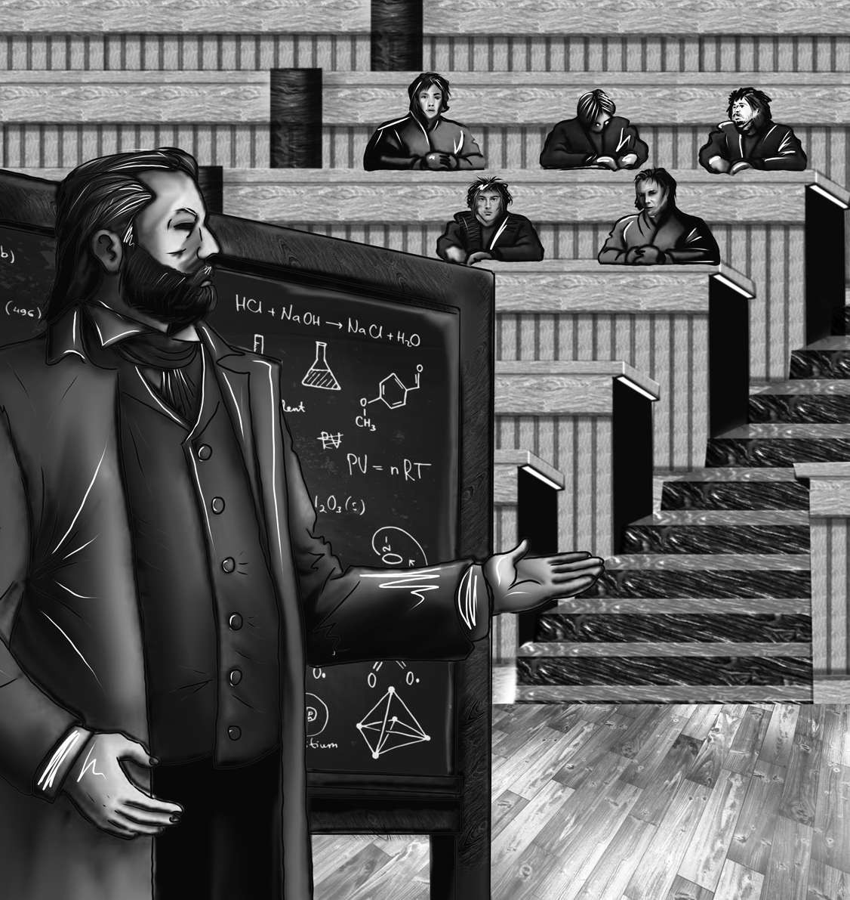“He was short but st ood r emar kably er ect, and his voice t he sweet est I had ever hear d.”

They penetrate the hidden places of nature and show how she works. They rise up into the heavens. They have discovered how the blood circulates. They can tell us about the nature of the air we breathe. They have acquired new and almost

circulates: moves around in a circle; William Harvey discovered the circulation of blood in 1628.

unlimited powers. They can command the thunders of heaven, imitate the earthquake, and even mock the invisible world with its own shadows.”

Such were the professor’s words—and I was swept away by them. I was fascinated. My mind was filled with one thought, one conception, one purpose. *Ah, Frankenstein, I said to myself, so much has been done, but there is more work to done – and you are the man to do it! You, Victor Frankenstein, will be the pioneer. You will explore unknown powers! You will unfold to the world the deepest mysteries of creation!*

I did not sleep that night. The next day I paid Dr. Waldman a visit. His manners in private were even more mild and attractive than in public. There was a certain dignity in his manner during his lecture which in his own house was replaced by the greatest friendliness and kindness. I gave him the account of my former pursuits as I had given to his fellow professor. He listened with attention and smiled at the names of Cornelius Agrippa and Paracelsus, but without the contempt that Dr. Krempe had exhibited. He said that “these were

pioneer: fi rst settler in new territories contempt: disgust, dismissiveness

men to whom modern philosophers were indebted for the foundations of their knowledge. They had left to us, as an easier task, to give new names and arrange in connected classifications the facts which they had been the instruments of bringing to light. The labors of men of genius, even if wrongly directed, almost always lead to some benefit for mankind.”

I listened to his statement, which was delivered without any presumption or affectation. I told him that his lecture had removed my prejudices against modern chemists and that I was eager to begin my studies in the field. I requested his advice concerning the books I ought to obtain.

“I will give you my recommendations,” he said. “Chemistry is the branch of natural philosophy in which the greatest improvements have been. However, it will not do to pay no attention to the other branches of science. A man would make but a very sorry chemist if he attended to that department of human knowledge alone. If your wish is to become really a man of science and not merely a dabbler, I would advise you to study every branch of natural philosophy, including mathematics.”

He then took me into his laboratory and explained to me the uses of his various pieces of equipment. He told me which ones I ought to get for myself and promised to let me use some of his once I had made some progress in my studies. He also gave me the list of books which I had requested, and I took my leave.

Thus ended a day memorable to me. It was a day that decided my future destiny!

## CHAPTER 4

F

rom that day on, natural philosophy, and particularly chemistry, occupied almost all of my attention. I read with energy those works, so full of genius and discrimination, which modern inquirers have written on these subjects. I attended lectures and cultivated the acquaintance of the men of science of the university. I found even in Dr. Krempe a great deal of sound sense and real information, combined, it is true, with a repulsive appearance and unpleasant manners, but not on that account the less valuable. In Mr. Waldman I found a true friend. He was always friendly and never closed minded. His instructions were given with an air of frankness and good nature. In a thousand ways he smoothed for me the path of knowledge and made even the most complicated inquiries clear. I was a slow student at first. However, I gained strength as I proceeded. After a while, I became so eager that the stars often disappeared in the light of morning while I was still working in my laboratory.

I worked hard and made rapid progress. My passion astonished my fellow students, and my skill impressed the masters. Two years passed in this manner, during which I paid no visit to Geneva, but was engaged, heart and soul, in the pursuit of some discoveries that I hoped to make. In other studies you go as far as others have gone before you, and that is it. There is nothing more to know. In science, though, there is always room for more discoveries. I improved so rapidly that at the end of two years I made some discoveries in the improvement of some chemical instruments, which brought me great admiration at the university.

One subject that especially attracted my attention was the structure and nature of the human body. How are bodies endowed with life? And where does the force that gives us life come from? These were bold questions, and they were viewed as great mysteries. But chemistry was solving many mysteries, and I thought it might allow me to solve these as well.

I decided to focus my studies on living things and the human body. I had also to learn about the

endowed: fi lled, gifted

natural decay and corruption of the human body. I spent many days and many nights in vaults and charnel-houses. I studied the change from life to death, and death to life, until from the midst of this darkness a sudden light broke in upon me. It was a light so brilliant and wondrous, yet so simple, that I was surprised that, among so many men of genius who had directed their inquiries towards the same science, I alone should discover so astonishing a secret.

Remember, I am not recording the visions of a madman. It is not more certain that the sun shines in the sky than that which I now say is true. Some miracle might have produced it, yet the stages of the discovery were distinct and probable. After days and nights of incredible labor and exhaustion, I succeeded in discovering the cause of life. Nay, more! I developed the ability to bestow life upon lifeless matter!

At first I was astonished. Soon, however, astonishment gave way to delight. After so much work, it was gratifying to achieve success. But this discovery was so great and overwhelming that all

charnel-houses: places where bones of the dead are placed

the steps by which I had been progressively led to it were forgotten and I saw only the result. What had been the study and desire of the wisest men since the creation of the world was now within my grasp.

I see by your eagerness and the wonder and hope which your eyes express, my friend, that you expect to be informed of the secret which I now know. But, no! That cannot be. Listen patiently to my story. When I have finished, you will understand why I choose not to speak of that subject. I will not lead you on. I would not have you make the same mistakes I made. I would have you learn from my example: I would have you learn how dangerous knowledge can be.

When I found so astonishing a power placed within my hands, I hesitated a long time, unsure how I should use it. I could give life, but to create a body, with all the fibers, muscles, and veins, still remained a work of great difficulty and labor. I doubted at first whether I should attempt the creation of a being like myself, or one of simpler organization. However, I was too excited by my first success to give up the quest. I knew I would probably fail many times, but I reminded myself that science and mechanics continue to advance, in spite of countless failures.

So I began to work on creating a human being. Since it is tricky to work with small parts, I decided to create a being of gigantic stature, about eight feet in height. I spent several months collecting and arranging my materials.

How can I make you understand the feelings which drove me to continue?, Life and death seemed to me imaginary boundaries, which I could break through and pour a great flood of light into our dark world. A new species would bless me as its creator and source. No father could claim the thanks of his child so completely as I should deserve theirs. Pursuing these reflections, I thought that, if I could bestow life upon lifeless matter, I might someday learn to renew life, even after death had left the body to decay!

These thoughts supported my spirits, while I pursued the project with constant passion. My cheeks grew pale with study, and I lost weight. Sometimes I failed. Yet still I pressed on. Sometimes the work was gruesome. I collected bones and

gruesome: horrible

body parts from charnel-houses, dissecting rooms, and slaughter-houses. I disturbed, with unholy fingers, the tremendous secrets of the human body. In a room at the top of the house I kept my workshop of filthy creation.

I worked all summer. It was a most beautiful season, but I saw little of it—or of my friends. I wrote to my family only rarely.

I see now that I was very much to blame for ignoring my family. The pursuit of knowledge is a noble activity, but it does not release a man from his other duties in life. If the study to which you apply yourself has a tendency to weaken your affections for others, then that study is certainly unhealthy—and perhaps even immoral. No man should allow himself any pursuit that might interfere with the tranquility of his family life. If this rule had been steadily observed, Greece would not have been enslaved, Cæsar would have spared his country, America would have been discovered more gradually, and the empires of

dissecting rooms: rooms where dead bodies are cut up and

studied by doctors and scientists

Mexico and Peru would not have been destroyed. But I digress.

Winter, spring, and summer passed away, but I did not watch the blossoms or the expanding leaves—sights which had always delighted me. I was too deeply involved in my work. The leaves of that year had withered before my work drew near to a close. However, by then, every day showed me more plainly how well I was succeeding.

digress: drift away from what I planned to talk about

## CHAPTER 5

O

n a gloomy night in November I completed my work. I was so nervous that night it was painful.

I collected the instruments of life

around me, that I might infuse a spark of being into the lifeless thing that lay at my feet. It was already one in the morning. The rain pattered dismally against the panes, and my candle was nearly burnt out, when, by the glimmer of the half-extinguished light, I saw the dull yellow eye of the creature open. It breathed hard, and a convulsive motion agitated its limbs.

How can I describe my emotions? And how can I describe the creature whom with such infinite pains and care I had formed? His limbs were in proportion, and I had selected his features in the hope that he would be beautiful. Beautiful! Great God! His yellow skin scarcely covered the muscles and arteries beneath. His hair was long and black. His teeth were pearly in their whiteness. And yet

infuse: put into, insert into convulsive: jerky, thrashing, spastic

these traits only formed a more horrible contrast with his watery eyes. His eyes were almost the same color as the white sockets in which they were set. His complexion was shriveled. and his lips were straight and black.

I had worked hard for nearly two years, for the sole purpose of infusing life into a lifeless body. For this I had deprived myself of rest and health. I had desired it with a passion that far exceeded moderation. Now that I had finished, however, the beauty of the dream vanished. Horror and disgust filled my heart. I could not bear to look at the being I had created. I rushed out of the room.

For a long time, I walked back and forth in my bedroom, tormented with thoughts. I was exhausted and needed to sleep, but I found I could not. At last I did fall asleep, but I was disturbed by the wildest dreams. I thought I saw Elizabeth, in the bloom of health, walking in the streets of Ingolstadt. Delighted and surprised, I embraced her, but as I imprinted a kiss on her lips, they turned pale. Her features changed too, and I thought that I held the corpse of my dead mother in

tormented: tortured

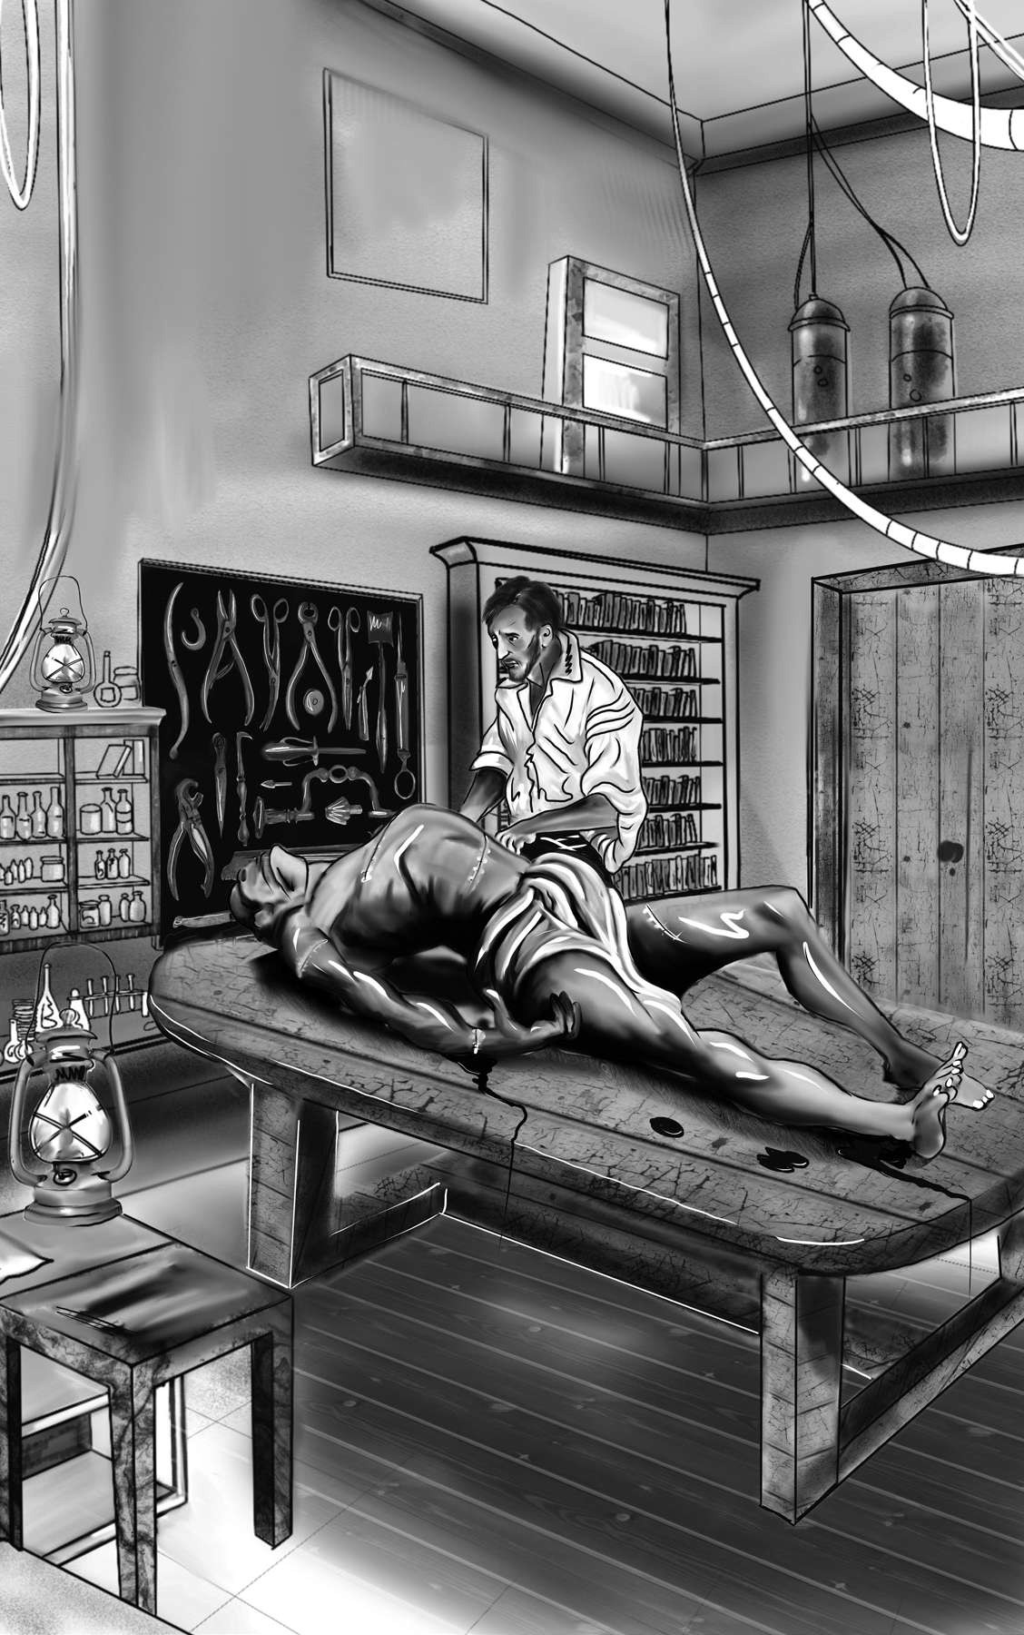

“On a gloomy night in November I complet ed my wor k.”

my arms! A shroud enveloped her form, and I saw grave-worms crawling in the folds of the flannel. I started from my sleep with horror! A cold dew covered my forehead. My teeth chattered, and my limbs convulsed. Then, by the yellow light of the moon, I beheld the wretch—the miserable monster I had created. He lifted the curtain of the bed, and his eyes, if eyes they may be called, were fixed on me. His jaws opened, and he muttered some inarticulate sounds. A grin wrinkled his cheeks. He might have spoken, but I did not hear. He stretched out one hand, seemingly to hold me, but I escaped and rushed downstairs. I took refuge in the courtyard, where I spent the rest of the night. I walked back and forth in the greatest agitation, listening attentively, fearing each sound might announce the approach of the horrible, demon-like corpse to which I had given life.

Oh, the face of that creature! No human being could look on it without horror! I had gazed

shroud: burial cloth

convulsed: moved in a jerky or spastic way inarticulate: clumsy, hard to understand took refuge: fl ed to a safe or private place agitation: excitement, disturbance

on him while unfinished. He was ugly then, but when those muscles and joints were at last put into motion, he became a thing such as even Dante could not have conceived.

I passed the night wretchedly. Sometimes my pulse beat so quickly that I felt it beating in every artery. I felt weak. I was tormented by the bitterness of disappointment. My dream had turned to a nightmare.

Morning, dismal and wet, at length dawned. The clock of the church of Ingolstadt indicated that it was six o’clock. I went out into the streets and walked with quick steps, hoping to avoid the wretched creature. I did not dare return to my room. I hurried on, drenched by the rain which poured from a black and comfortless sky.

I continued walking in this manner for some time, trying to relieve my mind through bodily exercise. I walked around without any clear idea of where I was or what I was doing. I was sick with fear, and I hurried on with irregular steps, not daring to look about me:

Dante: Italian poet who wrote a famous poem describing the many horrors of Hell.

Like one who, on a lonely road,

Doth walk in fear and dread,

And, having once turned round, walks on,

And turns no more his head; Because he knows a frightful fiend Doth close behind him tread*.

I came at length to an inn where carriages often stopped. Here I paused, I knew not why, but I remained standing with my eyes fixed on a carriage that was coming towards me. It stopped just where I was standing, and as the door opened, I saw Henry Clerval.

On seeing me, my old friend sprang out. “My dear Frankenstein!” he exclaimed. “How glad I am to see you! How fortunate it is that you should be here at the very moment of my arrival!”

Nothing could equal my delight on seeing my old friend. His presence brought back many pleasant thoughts. I thought of my father, and Elizabeth, and of home. I grasped Henry’s hand, and forgot my horror and misfortune. I felt

fi end: devil, evil spirit

* A quotation from “The Rime of the Ancient Mariner,” by Samuel Taylor Coleridge.

suddenly, and for the first time during many months, calm and peaceful. I welcomed my friend in the most friendly manner, and we walked towards the university.

Henry talked for some time about our friends and his own good fortune in being permitted to come to Ingolstadt. “It was not easy to persuade my father,” he said. “Although he has allowed me to make the visit, he still insists that there is nothing useful to be learned in a university. But his affection for me at length overcame his dislike of learning, and he has permitted me to undertake a voyage of discovery to the land of knowledge.”

“It gives me the greatest delight to see you. But tell me how you left my father, my brothers, and Elizabeth.”

“Very well, and very happy. Only they are a little uneasy that they hear from you so rarely. By the by, I mean to lecture you a little upon their account myself. But, my dear Frankenstein,” continued he, stopping short and gazing full in my face, “I did not before remark how unhealthy you look. You are thin and pale. You look as if you have been up all night studying for several nights.” “You have guessed right. I have lately been so deeply engaged in one project that I have not allowed myself sufficient rest. I hope, however, that that all these activities are now at an end and that I am at length free.”

I trembled as I said this. I could not bear to think of what had happened the previous night. We walked on and soon arrived at the university. I then thought of the creature I had left in my apartment, and the thought made me shiver. He might still be there, alive and walking about. I was afraid to see this monster again. However, I feared still more that Henry should see him. I asked him, therefore, to remain for a few minutes at the bottom of the stairs. I then went quickly up to my room. I threw the door forcibly open, as children do when they expect a ghost may be waiting for them on the other side. However, nothing appeared. I stepped in. The apartment was empty, and my bedroom was also freed from its hideous guest. I could hardly believe my good luck. Once I was I sure that the creature had indeed fled, I clapped my hands for joy and ran down to see Henry.

We went up to my room, and the servant brought us breakfast. I was very excited. My pulse beat rapidly. I was unable to sit in one place. I clapped my hands and laughed aloud. At first Henry thought I was excited about his arrival. However, after observing me more attentively, he saw a wildness in my eyes for which he could not account. My loud, unrestrained, heartless laughter frightened and astonished him.

“My dear Victor,” cried he, “what in the world is the matter? Why do you laugh in that manner? Are you ill? What is the cause of all this?”

“Don’t ask me,” I cried, putting my hands before my eyes, for I thought I saw the dreaded specter gliding into the room. I imagined that the monster had seized me. I struggled furiously and fell down in a fit.

Poor Henry! What must have been his feelings? A meeting, which he anticipated with such joy, so strangely turned to bitterness. But I was not the witness of his grief, for I was lifeless and did not recover my senses for a long, long time.

specter: ghost

This was the beginning of a nervous fever that kept me in bed for several months. During all that time Henry was my only nurse. I afterwards learned that, knowing my father’s advanced age and unfitness for so long a journey, and how wretched my sickness would make Elizabeth, he spared them this grief by concealing the extent of my disorder. He was confident that I would recover, but I was in reality very ill. The form of the monster that I had created was constantly before my eyes, and, in my feverish dreams, I spoke of the creature frequently. My words surprised Henry. He at first believed them to be the wanderings of my disturbed imagination, but the stubbornness with which I continually returned to the same subject persuaded him that my disorder indeed owed its origin to some uncommon and terrible event.

By very slow degrees, and with frequent relapses that alarmed and grieved my friend, I recovered. I remember the first time I was able to observe outward objects with any kind of pleasure:

disorder: sickness

relapses: falls back into sickness

I perceived that the fallen leaves had disappeared and that the young buds were shooting forth from the trees that shaded my window. It was a divine spring, and the season contributed greatly to my convalescence. Feelings of joy and affection returned. My gloom disappeared, and in a short time I became as cheerful as before I was attacked by the fatal passion.

“Dearest Henry,” I exclaimed, “how kind, how very good you have been to me! This whole winter, instead of being spent in study, as you promised yourself, has been consumed in my sick room. How shall I ever repay you?

“You will repay me entirely if you do not upset yourself, but get well as fast as you can. However, since you are in such good spirits, I wonder if I might speak to you on one particular subject.”

I trembled. One subject! What could it be? Could he be referring to the creature, of whom I dared not even think?

“Compose yourself,” said Henry, observing my change of color, “I will not mention it if it upsets you; but your father and cousin would be very

convalescence: recovery from illness

happy if they received a letter from you in your own handwriting. They hardly know how ill you have been and are uneasy at your long silence.”

“Is that all, my dear Henry? Of course! Of course I will write to them!”

“If this is your present temper, my friend, you will perhaps be glad to see a letter that has been lying here some days for you. It is from your cousin, I believe.”

## CHAPTER 6

H

enry then put the following letter into my hands. It was from Elizabeth:

### “My dearest Cousin,

“You have been ill, very ill, and even the constant letters of dear kind Henry have not been enough to reassure me on your account. I am told that you are forbidden to write. But we need to hear from you, dear Victor, to calm our fears. For a long time I have thought that each post would bring a letter from you. And yet we have heard nothing! Henry writes that you are getting better. I hope that you will confirm this soon in your own handwriting.

“Get well—and return to us. You will find a happy, cheerful home and friends who love you dearly. Your father’s health is strong, and he is eager to see you. How pleased you would be to see Ernest! He is now sixteen and full of activity and spirit.

“Little has changed since you left us. The blue

republican: of or relating to a republic (a government without a king)

lake and snow-clad mountains—they never change, and I think our peaceful home and our contented hearts are regulated by the same unchanging laws. My trifling occupations take up my time and amuse me, and I am rewarded by seeing none but happy, kind faces around me. Since you left us, only one change has taken place in our little household. Do you remember on what occasion Justine Moritz entered our family? Probably you do not. I will therefore relate her history in a few words. Madame Moritz, her mother, was a widow with four children, of whom Justine was the third. This girl had always been the favorite of her father, but for some reason, her mother could not stand her, and after the death of Mr. Moritz, she treated her very poorly. My aunt observed this, and when Justine was twelve years of age, convinced her mother to let her to live at our house.

“The republican institutions of our country have produced simpler and happier manners than those which prevail in the great monarchies that surround it. Here there is less distinction between the several classes of inhabitants, and the lower

refi ned: civilized, educated

orders, being neither so poor nor so despised, are more refined and moral. Being a servant in Geneva is not the same thing as being a servant in France or England. Justine was received in our family and learned the duties of a servant, a condition which, in our fortunate country, does not include the idea of ignorance and does not require a girl to sacrifice her dignity as a human being.

“Justine was a great favorite of yours when you were young. I remember you once said that if you were in an ill humor, one cheerful glance from her could cure it. My aunt was very fond of her and, as a result, decided to give her an education superior to that which she had at first intended. This benefit was fully repaid. Justine was the most grateful person in the world. She thought my aunt the model of all excellence and tried to imitate her speech and manners, so much so that she often reminds me of her.

“When my dearest aunt died, everyone was too much occupied in their own grief to notice poor Justine, who had attended her during her illness with the most anxious affection. One by

decline: a turn for the worse demeanor: personality, way of acting

one, her brothers and her sister died. At last she was the only one of her mother’s children left alive. Her mother’s conscience was troubled. She began to think that the death of her favorite child was a judgment from heaven to punish her for favoring one child over the others. A few months after you left for Ingolstadt, Justine was called home by her repentant mother. Poor girl! She wept when she left our house.

“Justine’s residence at her mother’s house brought her little happiness. The poor woman was torn between two urges. She sometimes begged Justine to forgive her unkindness but much oftener accused her of having caused the deaths of her brothers and sister. Constant worrying at length threw Madame Moritz into a decline. She died at the beginning of this last winter.

Justine has just returned to us. I love her tenderly. She is very clever and gentle, and extremely pretty. As I mentioned before, her demeanor and her expressions continually remind me of my dear aunt.

“I must also say a few words to you, my dear cousin, of little darling William. I wish you could see him. He is very tall for his age. He has laughing blue eyes, dark eyelashes, and curly hair. When he smiles, two little dimples appear on each cheek.

“Well, I have written myself into better spirits, dear cousin. However, my anxiety returns as I conclude. Do write to us, Victor. Even a short letter will be a great blessing to us. Ten thousand thanks to Henry for his kindness, his affection, and his many letters. We are sincerely grateful.

Take care of yourself and, I beg you, write!

“Elizabeth Lavenza.

“Geneva, March 18th, 17—.”

“Dear, dear Elizabeth!” I exclaimed after I finished reading this letter. I sat down right away and wrote a letter to her and the rest of my family. The exertion of writing tired me, but I was beginning to recover my health.

Once I was feeling strong enough to go out, one of my first duties was to introduce Henry to the professors I knew at the university. This was difficult for me. The sight of chemicals and labs reminded me of the creature and renewed all the agony of my nervous symptoms. Henry had noticed this and had packed up all of my own scientific equipment. He had also made arrangements for me to move into a new room, for he saw that I had acquired a dislike for the room which had previously been my laboratory.

But the cares of Henry Clerval were of no use to me when I visited my old professors. Dr. Waldman caused me pain when he praised, with kindness and warmth, the astonishing progress I had made in the sciences. My visit to Dr. Krempe was even worse. “What a fellow we have here!” he cried. “Why, Mr. Clerval, I assure you young Frankenstein there has done more than any of us here!” When he saw that I was not smiling, he added, “Mr. Frankenstein is also modest—an excellent quality in a young man!” These were difficult visits for me.

Henry had never shared my love for natural science. He came to the university to study Asian languages. While nursing me back to health, he began to study Persian, Arabic, and Sanskrit. I joined in his program of study, for I had come to hate my old studies. We spent several months working on the Asian languages and went on several hiking trips. The hiking trips helped me regain my health, and they also cheered my spirits.

What an excellent friend Henry was to me during those difficult months! His conversation was full of imagination. At other times he repeated my favorite poems or drew me into discussions. He drove away sickness and gloom and restored me to health and happiness!

## CHAPTER 7

A

t the end of spring term, I received the following letter from my father:

### “My dear Victor,

“I write with terrible news. William is dead. That sweet child, whose smiles delighted and warmed my heart. He was so gentle and carefree! Oh, Victor. It is horrible to report— he was murdered. I will tell you what we know.

“Last Thursday, Elizabeth, your two brothers, and I went for a walk. The evening was warm and serene, and we walked farther than usual. It was already dusk when we decided to return, and that was when we discovered that William and Ernest, who had gone on before us, were nowhere to be found. We sat on a bench and waited for them to return. Ernest came back and asked if we had seen his brother. He said that he and William had been playing “hide and seek.” William had run off to hide, and he had been looking for him but could not find him.

“This account alarmed us, and we began to search the area. We searched until nighttime but could not find him. We hoped he had returned to the house. We went back there, but he was not there. Then we went back to search the area again, this time with torches. I could not rest when I thought that my sweet boy was lost and exposed to the damps and dews of night. About five in the morning I found him. My lovely boy, whom the night before I had seen blooming and active in health, was stretched on the grass, pale and motionless. I could see the marks of the murderer’s fingers on his neck!

“He was taken home, and the suffering that was visible on my face betrayed the secret to Elizabeth. She wanted to see the corpse. At first I attempted to prevent her, but she persisted. At last she entered the room where his body lay. She hastily examined the neck of the victim, and clasping her hands exclaimed, ‘O God! I have murdered my darling child!’

“She wept and moaned. She told me that William had borrowed a necklace from her earlier in the day. He had wanted to wear around his neck a small golden locket that contained a picture

locket: a small case, often worn on a necklace as a piece of jewelry

of your mother. Elizabeth is convinced that it was this piece of jewelry that attracted the murderer’s attention, and she blames herself for William’s death.

“Return to us, dearest Victor! You alone can console Elizabeth. She weeps continually and blames herself for causing his death. We are all unhappy, but will not that be an additional reason for you, my son, to return and be our comforter?

“Come, Victor; with thoughts of revenge against the assassin, but with feelings of peace and gentleness that will heal the wounds of our minds. Enter the house of mourning. But I would have you do so with kindness and affection for those who love you, and not with hatred for your enemies.

“Your affectionate and afflicted father,

“Alphonse Frankenstein.

“Geneva, May 12th, 17—.”

Henry watched me as I read this letter, and saw my joy give way to despair.

assassin: murderer

“My dear friend,” he said, “what has happened?”

I motioned at the letter, while I walked up and down the room in terrible agitation. I was crying, and Henry joined me after he read the letter.

“I am sorry, my friend,” he said. “This is horrible! What do you intend to do?”

“I must go to Geneva.”

Henry did his best to comfort me. “Poor William!” said he. “Dear lovely child! He now sleeps with his angel mother! We have only one consolation: he is at rest. His sufferings in this world are at an end forever.”

I called for a carriage, and in a few minutes one arrived. I said farewell to my old friend and hurried away.

I was very gloomy during the whole trip. As I approached Geneva and saw the dark mountains rising up, I felt even more discouraged. The picture appeared a vast and dim scene of evil, and I foresaw in a vague way that I was destined to become the most wretched of human beings.

It was completely dark when I arrived in Geneva. The gates of the town were already shut for the night. I was obliged to pass the night at Secheron, a village not far from the city. I was unable to rest, so I went out for a walk. A storm was gathering in the mountains. Vivid flashes of lightning dazzled my eyes. I walked on unconcerned, thinking of my brother.

All of a sudden I perceived in the gloom a figure lurking behind a clump of trees. I stood still and gazed intently. A flash of lightning illuminated the night—and I saw him! The creature! I knew at once that it was the wretched beast to whom I had given life. But what was he doing in that place? Had he traveled to my hometown? And was it he who had killed my brother? I shuddered at the thought, but within seconds I was convinced that it must be so. I felt weak in the legs and had to lean against a tree for support. The gigantic creature passed quickly in front of me. Then it disappeared in the gloom. I felt certain that no human being could have destroyed that wonderful child. It was he who had done it. He was the murderer!

I remained motionless for a long time. The thunder stopped, but the rain still continued. I began to think about those events which I had until

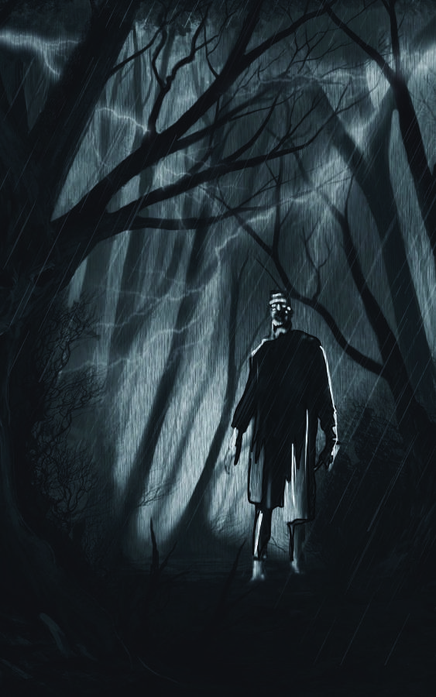

“The gigant ic cr eat ur e passed quickly in fr ont of me.”

then attempted to forget. Almost two years had passed since the night on which he first came to life. Was this the first crime he had committed? Alas! I had turned loose on the world a depraved wretch who took delight in killing and causing misery!

You cannot imagine the anguish I suffered that night. I spent it in the open air, cold and wet. But I was not pained by the weather. Indeed, I hardly noticed it. My imagination was busy with scenes of evil and thoughts of despair. I thought of the being I had created and cast among mankind, and I thought of what he had done. It was horrible!

At last day dawned. I directed my steps towards the town. The gates were open, and I hurried to my father’s house. My first thought was to tell my family what I knew of the murderer, so that he might be pursued and perhaps caught. But then I paused and reflected on the story that I would have to tell: a being that I myself had created and given life had traveled from Ingolstadt to Geneva, killed my beloved brother and then met me at midnight in a storm. I knew that if any other person told me such a story, I would look upon it

depraved: corrupted, evil

as the crazy talk of a madman. And of course I had only recently recovered from months of sickness and delirium. After a few minutes of thinking, I convinced myself that it would be better to remain silent.

It was about five in the morning when I entered my father’s house. I told the servants not to disturb the family and went into the library to wait for their usual hour of rising.

Six years had passed since I had left Geneva for the university, but the library had changed only a little. I gazed on a picture of my mother on the mantel. Beside it was a miniature of William—and my tears began to flow when I looked upon it. While I was thus engaged, Ernest entered. He had heard me arrive and had come down to welcome me.

“Victor!” he said. “Ah! I wish you had come three months ago. Then you would have found us all joyous and delighted. But you come to us now to share a misery which nothing can improve. And yet I hope your presence will help

delirium: confusion and visions that come with fever and illness mantel: shelf above a fi replace.

miniature: small portrait

revive our father, who seems to be sinking under his misfortune. And perhaps you will be able to convince poor Elizabeth to stop blaming herself for what has happened. Poor William! He was our darling and our pride!”

Tears fell from my brother’s eyes. I tried to calm him and asked about my father and Elizabeth. “Elizabeth, most of all, requires consolation. She blames herself for having caused William’s death. She is very wretched. However, since the murderer has been discovered—”

“What? What’s that” I cried. “The murderer has been found? Good God! How can that be? Who could attempt to pursue him? One might as well try to catch the wind!”

“I don’t know what you mean,” replied my brother, in wonder, “but to us the discovery we have made completes our misery. No one would believe it at first, and even now Elizabeth will not be convinced, in spite of all the evidence. Indeed, who would believe that Justine Moritz, who was so likeable and seemed to be so fond of all of us, could be capable of such an awful crime!”

“Justine Moritz! Poor girl! Is she the accused?

But this is wrong! It’s not her! It can’t be. Surely no one believes she is guilty, Ernest?”

“No one did at first, but several details have come to light that have almost forced us to believe it. Her behavior has been very strange and confused. But she will be tried today, and you will be able to hear all that has been learned.”

He then related that, the morning on which the murder of poor William had been discovered, Justine had been taken ill, and confined to her bed for several days. During this time, one of the servants, happening to examine the clothing she had worn on the night of the murder, had discovered in her pocket the picture of my mother, which had been judged to be the temptation of the murderer. The servant showed it to one of the others, who, without saying a word to any of the family, went to a judge. After the servant made his deposition, Justine was arrested. When she was charged, she seemed extremely upset and confused, and this has made many people suspect that she is guilty.

This was a strange tale, but it did not shake

deposition: offi cial statement made to a court or judge

my faith. I replied earnestly, “You are all mistaken. I know the murderer. Poor Justine is innocent.”

At that instant my father entered. I saw unhappiness deeply impressed on his face, but he tried to welcome me cheerfully. I would have introduced some other topic than that of our disaster, but Ernest interrupted. “Good God, papa! Victor says he knows who killed William!”

“We do also, unfortunately,” replied my father. “And yet I wish I did not. It would be better to not know than to discover so much evil and ingratitude in one I valued so highly.”

“My dear father, you are mistaken. Justine is innocent.”

“If she is, God forbid that she should suffer as guilty. She is to be tried today, and I hope, I sincerely hope, that she will be found not guilty.

This speech calmed me. I was firmly convinced in my own mind that Justine, and indeed every human being, was guiltless of this murder. I had no fear, therefore, that any evidence could be brought forward strong enough to convict her. My tale was not one to announce publicly. Its astounding horror would be looked upon as madness by most people. Did anyone indeed exist, except I, the creator, who would believe, unless his senses convinced him, in the existence of the living monument of presumption and unthinking ignorance which I had let loose upon the world?

We were soon joined by Elizabeth. Time had changed her since I last saw her. It had endowed her with loveliness beyond the beauty of her childish years. There was the same openness and the same energy but it was combined with an expression more full of sensibility and intellect. She welcomed me with the greatest affection. “Your arrival, my dear cousin,” said she, “fills me with hope. You perhaps will find some means to prove the innocence of my poor guiltless Justine. Alas! If she can be convicted of crime, who is safe? I rely on her innocence as certainly as I do upon my own. Our misfortune is doubly hard to us. We have lost that lovely darling boy. And, in addition, this poor girl, whom I sincerely love, is to be torn away by even a worse fate. If she is found guilty, I never shall know joy again. But she will not be. I am sure she will not—and then I shall be happy again, even after the sad death of my little William.”

“She is innocent, my Elizabeth,” said I, “and that shall be proved. Do not be afraid! She will be found not guilty.”

“How kind and generous you are! Everyone else believes in her guilt, and that has made me wretched, for I feel that it cannot be true.” She wept.

“Dearest niece,” said my father, “dry your tears. If she is, as you believe, innocent, we can rely on the justice of our laws.”

## CHAPTER 8

W

e passed a few sad hours until the trial was to begin. My father and the rest of the family had to attend as witnesses, so I

accompanied them to the court.

The trial itself was like torture. I blamed myself for the death of William, and I feared I would also be responsible for the conviction and death of Justine. I longed to confess myself guilty of the crime, but I was absent when it was committed, and such a confession would have been considered as the ravings of a madman.

Justine seemed calm. She was dressed in mourning, and her face, always engaging, was rendered, by the seriousness of her feelings, most beautiful. Although many were staring at her with hostile eyes, she did not tremble. When she entered the court, she scanned the room and quickly discovered where we were seated. A tear seemed to dim her eye when she saw us, but she

dressed in mourning: wearing black or dark clothes to honor a

dead person

quickly recovered herself, and a look of sorrowful affection seemed to serve as clear evidence of her utter guiltlessness.

The trial began. The charge against her was read out. Then several witnesses were called. Several strange facts combined against her. She was out all night on the night when the murder had been committed. In addition, as morning drew near, she had been spotted by a marketwoman not far from the spot where the body of the murdered child had been found. The woman asked her what she was doing, but Justine looked very odd and gave a confused and unintelligible answer. She returned to the house about eight o’clock. When asked where she had passed the night, she replied that she had been out looking for the child and asked if anything had been heard concerning him. When shown the body, she fell into violent hysterics and then remained in bed for several days. The picture was then produced— the one that the servant had found in her pocket. Elizabeth testified, in a shaky voice, that it was the same one she had placed around William’s neck an

hysterics: uncontrolled crying

hour before he went missing. When the spectators heard this, a murmur of horror and indignation filled the court.

Next Justine was called to testify. As the trial had proceeded, her appearance had altered. Surprise, horror, and misery were strongly expressed. Sometimes she struggled with her tears, but when she was asked to plead innocent or guilty, she collected her powers and spoke in an audible although variable voice.

“God knows,” she said, “how entirely I am innocent. But I must prove it to the court. I rest my innocence on a plain and simple explanation of the facts which have been cited as evidence against me, and I hope the character I have always borne will incline my judges to a favorable interpretation where any circumstance appears doubtful or suspicious.”

She then described her actions on the night of the murder. With Elizabeth’s blessing, she had passed the evening at the house of an aunt in Chêne, a village about three miles from Geneva.

On her return, at about nine o’clock, she met a

audible: capable of being heard

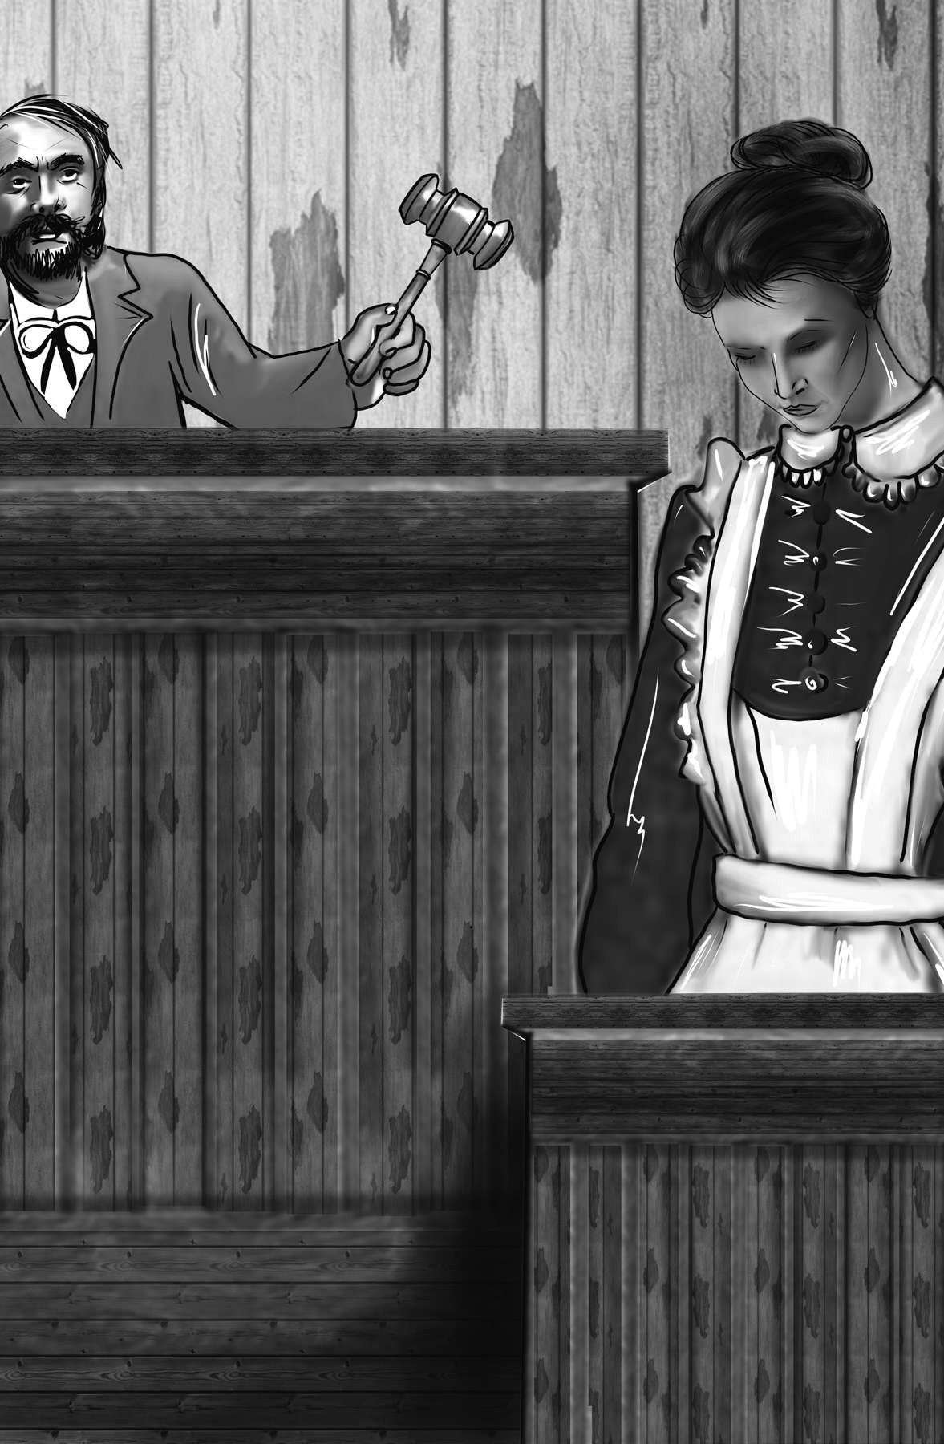

“Next Just ine was called t o t est ify.”

man who asked her if she had seen anything of the child who was lost. She was concerned by this account and passed several hours in looking for him. Then the gates of Geneva were shut, and she was forced to spend several hours in a barn. She slept for a few minutes, shortly before dawn. Then footsteps disturbed her, and she awoke. It was dawn, and she left the barn so that she might begin searching for my brother again. If she had gone near the spot where his body lay, it was without her knowledge. That she had been confused when questioned by the market-woman was not surprising, since she had passed a sleepless night and the fate of poor William was still uncertain. Concerning the picture she could give no account.

“I know,” Justine continued, “how heavily this one detail weighs against me, but I am unable to explain it. I cannot say who might have placed it in my pocket, or why. I believe that I have no enemy on earth, and none surely would have been so wicked as to wish to destroy me. Did the murderer place it there? I do not know how or when he might have done so. Nor do I understand why he who had just stolen it would be willing to part with it again so soon. I commit my cause to my judges, yet I see no room for hope. I beg permission to have a few witnesses examined concerning my character. If their testimony is not enough, I understand that I must be found guilty, although I swear before God I am innocent.

Several witnesses were then called. All had known Justine for many years, and all spoke well of her. But they seemed cautious, frightened. Fear and hatred of the crime of which they supposed her guilty made them hesitant. Elizabeth sensed that Justine was in trouble, and she asked for permission to address the court.

“I am,” said she, “the cousin of the unhappy child who was murdered, or rather his sister, for I was educated by and have lived with his parents since before he was born. It may therefore be judged improper for me to come forward on this occasion, but I wish to speak. I wish to say what I know of the accused and her character. I have lived in the same house with her for many years. During all those years she appeared to me the most amiable and benevolent of human creatures. She nursed my aunt in her last illness, with the greatest affection and care. She also attended to her own mother during a long illness. After her mother died, she lived in my uncle’s house, where she was beloved by all the family. She was warmly attached to the child who is now dead and acted towards him like a most affectionate mother. For my own part, I do not hesitate to say that, in spite of all of the evidence produced against her, I believe she is innocent. She had no temptation for such an action. As to the locket, which has been presented as the chief evidence against her, if she had asked me for it, I would have willingly given it to her. I esteem and value her so highly that I would have given her almost anything.”

A murmur of approval followed Elizabeth’s simple and powerful appeal, but it was excited by her generous interference, and not in favor of poor Justine. The spectators continued to look at Justine with indignation, charging her with the blackest ingratitude.

Justine wept as Elizabeth spoke, but she did not speak.

My own suffering was extreme during the whole trial. I was convinced that Justine was innocent. When I saw that the judges believed her to be guilty, I could not bear it. I rushed out of the court in agony. The trial was more upsetting for me, I believe, than it was for Justine. She knew she was innocent, but I felt guilty for having created the monster who killed my brother.

I passed a night of pure wretchedness. In the morning I went to the court to ask about the verdict. I dared not ask the fatal question, but the officer of the court recognized me and guessed the cause of my visit. The votes had been cast, he told me. Justine had been convicted.

I cannot pretend to describe what I felt at that moment. Words cannot communicate the heartsickening despair I suffered. The man told me that Justine had actually confessed her guilt. “That evidence,” he observed, “was hardly required in a case as clear as this one, but I am glad of it. You know, none of our judges like to convict a criminal upon circumstantial evidence, even if it is decisive.”

This was strange! I wondered what it could possibly mean. Had my eyes deceived me? Was I

verdict: decision (guilty or not guilty?)

really going crazy? I hurried home and spoke to Elizabeth.

“My cousin,” I said, “it is decided as you may have expected. Justine has been convicted. But also . . . she has confessed.”

This was a terrible blow to poor Elizabeth. She had been convinced of Justine’s innocence. “Alas!” said she. “How shall I ever again believe in human goodness? Justine, whom I loved and valued as my sister! How could she put on those smiles of innocence only to betray us? Her mild eyes seemed incapable of any severity or guile, and yet she has committed a murder.”

Soon after, we were told that Justine had expressed a desire to see my cousin. My father urged Elizabeth not to go but left it to her own judgment to decide. “Yes,” said Elizabeth, “I will go, although she is guilty. You, Victor, must come with me. I cannot go alone.” The idea of this visit was torture to me, yet I felt I could not refuse.

We entered the gloomy prison cell and saw Justine sitting on some straw at the far end. She was handcuffed and her head rested on her knees.

guile: trickery, deception, dishonesty

She rose on seeing us enter, and when we were left alone with her, she threw herself at the feet of Elizabeth, weeping bitterly. My cousin wept also.

“Oh, Justine!” said she. “Why did you rob me of my last consolation? I had faith in your innocence, and although I was then very wretched, I was not so miserable as I am now.”

“And do you also believe that I am so very, very wicked? Do you also join with my enemies to crush me, to condemn me as a murderer?” Her voice was suffocated with sobs.

“Rise, my poor girl,” said Elizabeth. “Why do you kneel, if you are innocent? I am not one of your enemies. I believed you guiltless, in spite of all the evidence, until I heard that you had yourself declared your guilt. That report, you seem to say, is false. Be assured, dear Justine, that nothing can shake my confidence in you for a moment, but your own confession.”

“I did confess, but my confession was a lie. I confessed so that I might obtain forgiveness. But now that falsehood lies heavier at my heart than all my other sins. May God forgive me! Ever since I was convicted, the priest they assigned to me has attacked me. He threatened me over and over, until I almost began to think that I was the monster he said I was. He threatened me with excommunication and hell fire in my last moments if I continued to speak of my innocence. At last I gave in. In an evil hour I agreed to a lie, and now only am I truly miserable.”

She paused, weeping, and then continued: “I thought with horror, my sweet lady, that you might believe your Justine, whom your blessed aunt had honored, and whom you loved, was a creature capable of such a horrible crime. It is a crime that none but the devil himself could have committed. Dear William! Dearest blessed child! I shall see you again soon, in heaven, where we shall all be happy, and that comforts me, going as I am to suffer disgrace and death.”

“Oh, Justine!” cried Elizabeth. “Forgive me for having for one moment distrusted you. Why did you confess? But do not mourn, dear girl. Do not fear. I will proclaim, I will prove your innocence. I will soften the stony hearts of your

excommunication: the expulsion of a Christian from the Catholic

Church proclaim: announce loudly

enemies by my tears and prayers. You shall not die! You, my playfellow, my companion, my sister, perish on the scaffold! No! No! I never could survive so horrible a misfortune.”

Justine shook her head sadly. “I am not afraid of death,” she said. “God gives me courage to endure the worst. I am resigned to the fate awaiting me. Learn from me, dear lady, to accept patiently the will of heaven!”

During this conversation I had retired to a corner of the prison room, where I could conceal my suffering. The poor victim, who on the next morning was to pass the awful boundary between life and death, felt not, as I did, such deep and bitter pain. I gnashed my teeth and ground them together, uttering a groan that came from my inmost soul. Justine started. When she saw who it was, she approached me and said, “Dear sir, you are very kind to visit me. I hope you do not believe that I am guilty?”

I could not answer. “No, Justine,” said

Elizabeth. “He is more convinced of your innocence

scaff old: a raised platform for executions resigned: accepting of what may happen started: made a sudden motion, as if startled

than I was. Even when he heard that you had confessed, he did not believe it.”

“I truly thank him. In these last moments I feel the sincerest gratitude towards those who think of me with kindness. How sweet is the affection of others to such a wretch as I am! I feel as if I could die in peace now that my innocence is acknowledged by you, dear lady, and your cousin.”

I felt that I was the one responsible for William’s death. Anguish and despair had penetrated into the core of my heart. I bore a hell within me which nothing could extinguish. We stayed several hours with Justine, and it was only with great difficulty that Elizabeth could tear herself away. “I wish,” cried she, “that I were sentenced to die with you. I cannot live in this world of misery.”

Justine embraced Elizabeth and said in a voice of half-suppressed emotion, “Farewell, dearest Elizabeth, my beloved and only friend! May heaven bless and preserve you! May this be the last misfortune you ever suffer! Live, and be happy—and make others so!”

bore a hell within me: echoing Satan’s comments in Milton’s Paradise Lost; he fi nds hell is not just a place but a state of mind one carries around.

The next day Justine was put to death on the scaffold. Elizabeth’s heart-rending eloquence failed to move the judges from their settled belief. My passionate and indignant appeals were lost upon them. I had planned to tell them everything that I knew. However, when I received their cold answers and heard the harsh, unfeeling reasoning of these men, I realized that my story would do Justine no good. They would not listen to me. They would only take me for a madman.

From the tortures of my own heart, I turned to contemplate the deep grief of my Elizabeth. This also was my doing! I was the cause of her sorrow – and of my father’s as well!

I saw all the members of my family weeping. I saw them pouring out their sorrow on the graves of William and Justine. I was torn by remorse, horror, and despair. I saw that these people, whom I loved, had experienced more suffering than anyone should experience in a lifetime, and I hoped that they would not be exposed to further losses, but something told me that this would not be the case. Something told me that these would not be the last tears the members of my family would shed.

heart-rending: emotional, touching, impassioned

## CHAPTER 9

N

othing is more painful to the human mind than, after the feelings have been worked up by a quick series of events, the dead calmness of

inaction and certainty which follows and deprives the soul both of hope and fear. Justine died. She rested, and I was alive. The blood flowed freely in my veins, but a weight of despair and remorse pressed on my heart. I had begun life with benevolent intentions. I had longed for the moment when I should put those intentions into practice and make myself useful to my fellow beings. But now all was blasted. I could not look back upon the past with calmness of conscience and self-satisfaction, Instead, I was gripped by remorse and a sense of guilt.

This state of mind preyed upon my health, which had not entirely recovered from the first shock it had sustained. I avoided the face of man.

inaction: lack of physical activity deprives: takes away from

All sounds of joy were torture to me. Solitude was my only consolation—deep, dark, deathlike solitude.

My father observed the change in my disposition and habits. He was pained, and he tried to drive away the dark clouds that brooded over me. “Do you think, Victor,” said he, “that I do not suffer also? No one could love a child more than I loved your brother.” Tears came into his eyes as he said this. “I did love him—very much. However, it is our duty not to make other people more miserable by persisting in our grief. It is also a duty we owe to ourselves as well, for excessive sorrow prevents improvement or enjoyment and even keeps us from completing our daily responsibilities.”

This advice, although it might have helped others, was no help to me. I would have been the first to hide my grief and console my friends if I had been wrestling with sorrow and sorrow alone. But remorse had mingled its bitterness, and terror its alarm, with my other sensations. I could only answer my father with a look of despair and try to hide myself from his view.

About this time we retired to our house at Belrive. This change was agreeable to me. Often, after the rest of the family had retired for the night, I took the boat and passed many hours on the lake. Sometimes, with my sails set, I was driven onward by the wind. Sometimes, after rowing out to the middle of the lake, I left the boat to pursue its own course and gave way to my own miserable reflections.

The lake was very quiet and calm. All was at peace around me. But I myself was not at peace. I was the only unquiet thing that wandered restless in a scene so beautiful and heavenly. I was often tempted to dive into the silent lake, that the waters might close over me and my disasters forever. But I was held back when I thought of the heroic and suffering Elizabeth, whom I tenderly loved, and whose existence was connected with mine. I thought also of my father and surviving brother. How could I leave them alone, exposed to the malice of the fiend whom I had let loose among them?

malice: hatred, bad intentions

Often I wept bitterly. I wished that peace would revisit my mind, so that I might offer consolation and happiness to those around me. But that could not be. Remorse extinguished every hope. I had been the author of unalterable evils, and I lived in daily fear that the monster I had created might perpetrate some new wickedness. I had an obscure feeling that he was not finished with me and that he would commit some even more horrible crime. How I hated that fiend! When I thought of him I passionately wished to extinguish that life which I had so thoughtlessly created. I would have made a pilgrimage to the highest peak of the Andes, could I, when there, have thrown him from the heights to his death. I longed to get revenge for the deaths of William and Justine.

Our house was a house of mourning. My father’s health had been shaken by recent events. Elizabeth was sad and depressed. She was no longer that happy creature who in her youth had wandered with me on the banks of the lake and talked with joy of our future prospects.

pilgrimage: a religious journey to a holy place, done to purify

oneself

“When I reflect, my dear cousin,” said she, “on the miserable death of Justine Moritz, I no longer see the world and its works as they before appeared to me. Before, I looked upon the accounts of evil doings and injustice that I read in books or heard from others as tales of ancient days or imaginary evils. But now men seem to me like monsters thirsting for each other’s blood. But perhaps I am unjust to say this. After all, everyone believed she was guilty. And, if she had in fact committed the crime for which she suffered, she most certainly would have been the most depraved of human creatures. I could not agree to the death of any human being, but certainly I would have thought such a creature unfit to remain in the society of men. But she was innocent. I know, I feel she was innocent. You are of the same opinion, I know, and that confirms me. Alas! Victor, when falsehood can look so much like the truth, who can be sure of happiness? I feel as if I were walking on the edge of a cliff, towards which thousands are crowding and trying to plunge me into the emptiness. William and Justine were assassinated, and the murderer has escaped. He walks about the world free, and perhaps respected. If I were condemned to suffer on the scaffold for the same crimes, I would not change places with such a wretch.”

These words made my heart ache. I felt that I was the true murderer—not in deed, but in effect. I was the ultimate cause of dear Elizabeth’s losses and misery.

Elizabeth saw my pain and took up my hand. “My dearest friend,” she said, “you must calm yourself. These events have affected me—God knows how deeply. But there is an expression of despair, and sometimes of revenge, in your countenance that makes me tremble. Dear Victor, banish these dark passions. Remember the friends around you! Have we lost the power of making you happy? Can we not lift your spirits at least a little?”

As she spoke, I drew near her as if in terror, as if I feared that the creature was nearby, threatening to rob me of her. Even Elizabeth, whom I loved so deeply, could not chase away the fiend that hid in my heart. I was encompassed by a cloud which no beneficial influence could penetrate. I was like a wounded deer, dragging its fainting limbs to some untrodden brake, there to gaze upon the arrow which had pierced it, and to die.

Sometimes I could deal with the sullen despair that overwhelmed me. But there were other times when it was too much to endure. I would then seek out some new place and try to distract myself by going on a long journey in the Alpine valleys. On one occasion I visited the valley of Chamonix. I had explored it frequently during my boyhood. Six years had passed since then. I was a wreck, but the valley itself was unchanged.

I made the first part of my journey on horseback. The weather was fine. It was the middle of August, nearly two months after the death of Justine. The weight upon my spirit was sensibly lightened as I made my way into the ravine of Arve. There were immense mountains and precipices hanging over me on every side. I could hear the river raging among the rocks and the dashing of the waterfalls. These sounds lifted my spirits. I ceased to be afraid of any being less

untrodden brake: area of shrubs (brake) that has not been

stepped upon or trod on

Alpine: adjective describing the Alps mountains ravine: valley carved out by a river

almighty than that which had created and ruled the elements. As I climbed, the valley shone below me. Ruined castles hung on the peaks of piney mountains. The River Arve hurried onward. Simple cottages peeped forth from among the trees. All these images combined to make a scene of great beauty. And above it all were the sublime peaks of the mighty Alps. Those white and shining pyramids towered above everything, as if they belonged to another earth.

Soon I saw high and snowy mountains. Immense glaciers were visible from the road. I heard the rumbling thunder of a falling avalanche and saw the smoke it left behind. Mont Blanc, the supreme and magnificent mountain, rose up in the distance.

A tingling, long-lost sense of pleasure often came across me during this journey. A turn in the road would remind me of days gone by. I was carried back to the lighthearted gaiety of boyhood. The very winds seemed to whisper to me in soothing accents. Mother nature seemed

glaciers: fi elds of ice that move slowly and “carve” the earth avalanche: a mass of snow falling down the side of a mountain

to be urging me to weep no more. Unfortunately, these feelings were only temporary. After a few moments of happiness, I would sink back into grief and misery.

At length I arrived at the village of Chamonix and paid for a room. I was exhausted. For a few minutes I stood at the window, watching the pale traces of lightning that played above Mont Blanc. Then I placed my head upon my pillow and sleep crept over me. I felt it as it came and welcomed it.

## CHAPTER 10

I

spent the next day hiking in the valley. The steep sides of vast mountains towered all around me. It was a sublime and magnificent scene, and it afforded me some consolation. My grief was not removed, but it was subdued. The mountains distracted me from my darker thoughts.

That night I dreamed of the mountains. They congregated round me. I saw the unstained snowy mountain-top, the glittering pinnacle. I smelled the pine woods and saw the eagle, soaring amidst the clouds. These visions gathered round me and comforted me.

In the morning, however, my miseries returned. It was raining, and thick mists hid the summits of the mountains. I decided to go out anyway. After all, what were rain and storm to me? I resolved to hike up to the top of Montanvert. I had hiked it before, when young. I remembered the effect that the view of the tremendous and ever-moving glacier had produced upon my mind when I first saw it. It had given wings to my soul and allowed

subdued: beaten down, beaten back

it to soar from the obscure world to light and joy. Looking at sublime and majestic scenes in nature had always been a help to me. It had helped me forget the passing cares of life. I decided to go without a guide, for I was well acquainted with the path and I wanted to be alone.

The climb is steep. The path zigs and zags. The landscape is terrifically desolate. In a thousand spots the traces of winter avalanches may be seen. Fallen trees lie broken on the ground. Some are entirely destroyed. Others are bent, leaning upon the jutting rocks of the mountain or on other trees. The path, as you go up, passes through ravines of snow. In these narrow ravines the hiker must beware of rockslides. The slightest sound, even speaking in a loud voice, can draw destruction on one’s head.

I looked down on the valley beneath. Vast mists were rising from the rivers which ran through it. These mists curled in thick wreaths around the mountains, whose summits were hidden in the uniform clouds. Rain poured from the dark sky and added to the melancholy. Alas! Why do we

majestic: impressive, glorious

human beings boast of our ability to sense more than the animals? By sensing more, we only come to want more and need more! If our impulses were confined to hunger, thirst, and desire, we might be nearly free. But we are moved by every wind that blows and a chance word or scene that that word may convey to us.

We rest; a dream has power to poison sleep.

We rise; one wand’ring thought pollutes the day.

### We feel, conceive, or reason; laugh or weep,

Embrace fond woe, or cast our cares away;

It is the same: for, be it joy or sorrow,

The path of its departure still is free.

Man’s yesterday may ne’er be like his morrow; Nought may endure but mutability!

It was nearly noon when I arrived at the top. For some time I sat upon the rock that overlooks the glacier. After a while I made my way down to the glacier. The surface of it was very uneven, like the waves of a troubled sea. There are many cracks,

nought: nothing

mutability: change (These lines of poetry come from “Mutability,”

a poem by the author’s husband, Percy Bysshe Shelley.)

which make it hard to cross. I spent nearly two hours making my way across it.

From where I stood, Montanvert was exactly opposite, perhaps three or four miles away. Above it rose Mont Blanc, in awful majesty. I remained here for some time, gazing on this wonderful and stupendous scene. The glacier seemed to wind among the mountains like a vast river of ice. Some of the clouds cleared away, and the icy and glittering peaks of the mountains began to shine in the sunlight. For a few moments, my heart swelled with something like joy.

Then, suddenly, I noticed the figure of a man, He was at some distance but he was advancing towards me with superhuman speed. He bounded over the cracks in the ice, among which I had walked with caution. He seemed larger than most men. I was troubled. I felt faint. As the shape came nearer, I realized that it was the wretch whom I had created. I trembled with anger and horror. I decided to engage him in mortal combat.

He came near. On his face I could see bitter suffering, combined with disdain and intense

disdain: a dislike for someone based on the feeling you are

better than the other person

hatred. The unearthly ugliness of that face rendered it almost too horrible for human eyes. At first, anger and hatred robbed me of speech, but I soon recovered and addressed him with furious hatred.

“Devil!” I exclaimed, “Do you dare approach me? Are you not afraid of what I might do to you? Begone, disgusting insect! Or rather, stay, that I may trample you to dust! And, oh! That I could, with the wiping out of your miserable existence, restore those victims whom you have so diabolically murdered!”

“I expected this greeting,” said the horrible creature. “All men hate the wretched. How, then, must I be hated, who am miserable beyond all living things! You are my creator. I am your creation. You are bound to me by ties that can only be broken by the destruction of one of us. And yet you wish to kill me. How dare you play thus with life? Do your duty towards me, and I will do mine towards you and the rest of mankind. If you will agree to my conditions, I will leave them and you at peace. But if you refuse, I will track down and kill all who are dear to you!

diabolically: in the style of a devil

“Abhorred monster! Fiend! The tortures of hell are too mild a punishment for your crimes! Wretched devil! You blame me for your creation! Come on, then! I will destroy you!” My rage was without bounds. I sprang on him.

Unfortunately, he got away from me and called out, “Be calm! I beg you to hear me before you give way to your hatred. Have I not suffered enough already? Life, although it may only be an accumulation of suffering, is dear to me, and I will defend it. Remember, you have made me more powerful than yourself. I am taller than you—and stronger. I will not be tempted to fight with you. I am your creature, and I will be kind and affectionate to you if you will also perform your part. And that much you owe me! Oh, Frankenstein, do not be just and equitable to every other being and trample upon me alone, to whom your justice, your mercy, and your affection are most due. Remember that I am your creature. You created me. I ought to be your Adam! But I am rather the fallen angel, whom you drive from joy for no reason. Everywhere I see joy. Everywhere I see happiness – but happiness which I cannot have. I was benevolent and good at first. It is only the experience of misery that has made me a fiend. Make me happy, and I shall again be virtuous!”

“Begone! I will not hear you. There can be no community between you and me. We are enemies. Begone, or let us try our strength in a fight, in which one must fall.”

“How can I move you? Will no requests or pleas cause you to turn a favorable eye on your creature? Does it mean nothing to you that I appeal to your goodness and compassion? Believe me, Frankenstein, I was well meaning and kind. My soul glowed with love and humanity. But now I am alone—miserably alone! You, my creator, hate me. What hope can I gather from your fellow creatures? They reject and hate me. The deserted mountains and dreary glaciers are the only place where I feel safe. I have wandered here many days. The caves of ice, which others fear, are not frightening to me. These are my dwelling places—and they are the only dwelling places men will leave me. These bleak skies I greet with pleasure for they are kinder to me than your fellow beings. If the masses of mankind knew of my existence, they would do as you do, and arm themselves for my destruction. Shall I not then hate them who hate me? I am miserable, and they shall share my wretchedness. Yet it is in your power to help me and deliver them from an evil. If you will not do this, then not only you and your family, but thousands of others, shall be swallowed up in the whirlwinds of rage. Let your compassion be moved, and do not drive me away. Listen to my tale. When you have heard it, you may abandon me or take pity on me, as you shall judge that I deserve. But hear me. The guilty are allowed, by human laws, bloody as they are, to speak in their own defense before they are condemned. Listen to me, Frankenstein. You accuse me of murder, and yet you would, with a satisfied conscience, destroy your own creature. Oh, praise the eternal justice of man! But I am not asking you to spare me. I am only asking that you listen to me. Then, if you can, and if you will, destroy the work of your hands.”

“Why do you remind me,” I replied, “of circumstances that I shudder to recall? Why do you remind me that I created you? Cursed be the day, disgusting devil, in which you first saw light! And cursed be the hands that formed you! Cursed be those hands, even though they are my own hands! You have made me wretched beyond expression. You have left me no power to consider whether I am just to you or not. Begone! Relieve me from the sight of your detested form.”

“Thus I relieve you, my creator,” he said, and placed his hated hands before my eyes. “Thus I take from you a sight which you hate. And yet still you can listen to me and grant me your compassion. By the virtues that I once possessed, I demand this from you. Hear my tale. It is long and strange, and the temperature of this place will make you shiver. Come therefore to my hut on the mountainside. The sun is now high in the heavens. Before it descends to hide itself behind those snowy cliffs and illuminate another world, you will have heard my story and can decide. You will decide whether I leave behind forever the neighborhood of man and lead a harmless life or become the source of suffering of your fellow creatures and the author of your own speedy ruin.”

As he said this, he led the way across the ice. I followed. My heart was full, and I did not answer him. However, as I went on, I weighed the various arguments that he had used and determined at least to listen to his tale. I was partly urged by curiosity, and compassion confirmed my resolution. I believed that he had murdered my brother, and I eagerly sought a confirmation or denial of this opinion. For the first time, also, I felt what the duties of a creator towards his creature were. I felt that I ought at least to listen to what he had to say before I complained of his wickedness. These were the motives that urged me to agree with his demand.

We crossed the ice, therefore, and made our way up the opposite rock. The air was cold, and the rain again began to fall. We entered the hut. He went in with an air of joy, but I entered with a heavy heart and depressed spirits. I had made up my mind to listen, however. I sat down by the fire which my repulsive companion had lit and listened as he began his tale.

denial: rejection

CHAPTER 11 “Ithose days appear confused and fuzzy. t is hard for me to remember the first days of my existence. All the events of

A strange multiplicity of sensations seized me, and I saw, felt, heard, and smelt at the same time. A long time passed before I learned to distinguish the operations of my various senses.

“By degrees, I remember, a strong light pressed upon my nerves. It was so bright that I was obliged to shut my eyes. Darkness then came over me and troubled me, but hardly had I felt this when, by opening my eyes, as I now suppose, the light poured in upon me again. I walked. The light became more and more annoying to me, and the heat wearied me as I walked, so I sought a place where I could get some shade. I found it in the forest near Ingolstadt. And there I lay by the side of a brook, resting from my fatigue, until I felt tormented by hunger and thirst. This woke me from my nearly sleeping state, and I ate some berries which I found hanging on the trees or lying on the ground. I drank some water from the brook and then lay down to sleep. “It was dark when I awoke. I felt cold and frightened, finding myself so all alone. Before leaving your apartment, I had covered myself with some clothes. Unfortunately, though, these were not enough to protect me from the dews of night. I was a poor, helpless, miserable wretch. I knew nothing—only that I felt pain. I sat down and wept.

“Soon a gentle light stole over the heavens and gave me a sensation of pleasure. I started up and saw a radiant form rise from among the trees. I know now it was the light you humans call the moon. I gazed on it with a kind of wonder. It moved slowly, but it lit up my path. I again went out in search of berries. Under one of the trees I found a huge cloak, with which I covered myself, and sat down upon the ground. No distinct ideas occupied my mind. All was confused. I felt light, and hunger, and thirst, and darkness. Innumerable sounds rang in my ears, and on all sides various scents greeted me. The only object that I could distinguish was the bright moon, and I fixed my eyes on that with pleasure.

“Several changes of day and night passed,

innumerable: too many to be counted

and the moon had worn away to a sliver, when I began to distinguish my sensations from each other. I gradually saw plainly the clear stream that supplied me with drink and the trees that shaded me with their foliage. I was delighted when I first discovered that a pleasant sound, which I often heard, came from the throats of the little winged animals who had often blocked the light from my eyes. I began also to observe, with greater accuracy, the forms that surrounded me. I noticed the radiant roof of light above me. Sometimes I tried to imitate the pleasant songs of the birds but was unable. Sometimes I wished to express my sensations in my own way, but the awkward sounds which came from me frightened me into silence again.

“The moon disappeared from the night, and again, with a lessened form, showed itself. I still remained in the forest. My sensations had by this time become distinct, and my mind received every day additional ideas. My eyes became accustomed to the light and began to notice objects in their right forms. I was able to distinguish an insect from a plant, and by degrees, one plant from another. I found that the sparrow uttered none but harsh

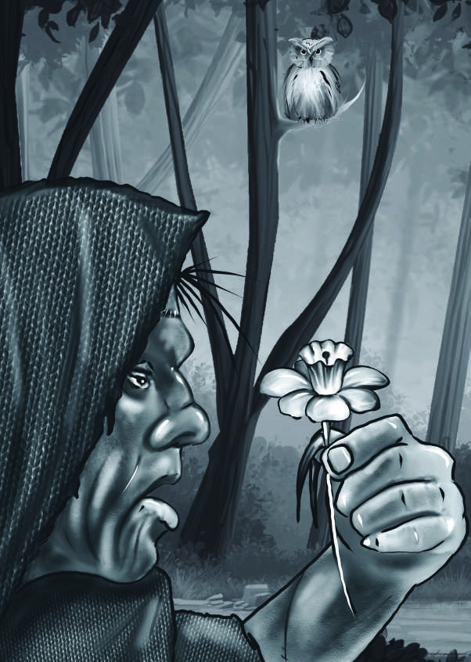

“I was delight ed when I fir st discover ed t hat a pleasant sound, which I oft en hear d, came fr om t he t hr oat s of t he lit t le winged animals who had oft en blocked t he light fr om my eyes.”

notes, while the songs of the blackbird and thrush were sweet and attractive.

“One day, when I was cold, I found a fire which had been left by some wandering beggars. Oh, what a discovery that was! I was overcome with delight at the warmth I experienced from it. In my joy I thrust my hand into the red-hot coals but quickly drew it out again with a cry of pain. How strange, I thought, that the same cause should produce such opposite effects! I examined the materials of the fire, and found it to be made of wood. I quickly collected some branches, but they were wet and would not burn. I was pained at this. I sat still and studied the fire. The wet wood which I had placed near the heat dried and caught fire. I thought about this, and by touching the various branches, I discovered the cause. I then busied myself in collecting a great quantity of wood, that I might dry it and have a plentiful supply of fire. When night came and brought sleep with it, I worried that my fire might burn out. I covered it carefully with dry wood and leaves and placed wet branches upon it. Then, spreading my cloak, I lay on the ground and sank into sleep.

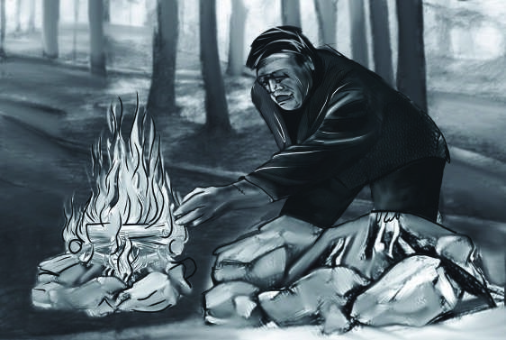

“The wet wood which i had placed near t he heat dr ied and

caught fir e.”

“It was morning when I woke up. My first care was to visit the fire. I uncovered it, and a gentle breeze quickly fanned it into a flame. I observed this also and made a fan out of some branches, which roused the embers when they were nearly extinguished. When night came again I found, with pleasure, that the fire gave light as well as heat. The discovery of fire was also useful to me in another way, for I found some of the foods that travelers had left behind had been roasted on a fire and tasted much better than the berries I gathered from the trees. I tried, therefore, to prepare my food in the same way, placing it on the burning coals.

I found that the berries were spoiled by the fire; however, the nuts and roots were much improved.

“Food, however, was becoming harder to find. I often spent the whole day searching in vain for a few acorns to eat. Since food was scarce, I resolved to leave the place where I had been living, to seek one where my wants would be more easily satisfied. Of course, this meant leaving behind the fire. I had obtained the fire by accident, and I did not know how to recreate it. I gave several hours to the serious consideration of this difficulty, but I could not think of any way to transport the fire. At last I wrapped myself up in my cloak and struck out across the woods, towards the setting sun. I passed three days in these rambles and at length discovered some open country. A great snowstorm had taken place the night before, and the fields were covered with snow. I found my feet chilled by this cold, damp substance that covered the ground.

“It was early in the morning, and I longed to find food and shelter. At length I spotted a small hut. It stood on a rising ground and had doubtless been built for the convenience of some shepherd. This was a new sight to me, and I examined the structure with great curiosity. Finding the door open, I entered. An old man sat in it. He was sitting near a fire, over which he was preparing his breakfast. He turned on hearing a noise, and seeing me, shrieked loudly. He exited the hut and ran across the fields. His flight somewhat surprised me. But I was filled with delight by the appearance of the hut. Here the snow and rain could not enter. The ground was dry. I greedily ate what was left of the shepherd’s breakfast. It consisted of bread, cheese, milk, and wine. I did not like the wine. Then, overcome by fatigue, I lay down among some straw and fell asleep.

“The sun was high in the sky when I awoke. I decided to begin my travels again. I put what was left of the peasant’s breakfast in a little bag I found. Then I walked across the fields for several hours, until at sunset I arrived at a village. How amazing that village seemed to me! The huts, the neater cottages, and the stately houses engaged my admiration. The vegetables in the gardens, the milk and cheese that I saw placed at the windows of some of the cottages, stirred up my appetite. I entered one of the cottages, but this did not turn out well. I had hardly placed my foot within the door when the children shrieked, and one of the women fainted. The whole village was stirred up. Some of them fled. Some of them attacked me. I was seriously bruised by rocks and stones but I escaped. At length I took refuge in a hovel. This hovel was located next to a cottage of a neat and pleasant appearance. However, after my recent experiences, I dared not enter it. My place of shelter was constructed of wood, but the ceiling was so low that I could barely sit up in it. It had a dirt floor, but it was dry; and, although the wind entered it by innumerable holes, I found it gave me protection from the snow and rain.

“Here, then, I retreated and lay down. I was happy to have found a shelter, however miserable, from the bad weather of the season, and still more from the cruelty of man. As soon as morning dawned, I crept out of the hovel so I could view the cottage next door. The hovel was situated against the back of the cottage. It was surrounded on its open sides by a pig sty and a clear pool of water. There were some openings in the walls through

hovel: a small hut

which I might be seen. I covered these up with stones and wood, yet in such a manner that I could move some of them when I was ready to leave. It was very dark, but it was good enough for me.

“Having thus arranged my dwelling and carpeted it with clean straw, I retired, for I saw the figure of a man at a distance, and I remembered too well my treatment the night before. I had a loaf of coarse bread, which I had stolen, and a cup with which I could drink more conveniently than from my hand of the pure water which flowed by my dwelling. The floor of the hovel was a little raised, so that it remained dry, and because it was not too far from the chimney of the cottage it was tolerably warm.

“My little hovel was a paradise compared to my former residence in the forest. I ate my breakfast with pleasure and was about to remove a piece of wood from the side of the hut to do get a little water when I heard a step. Looking through a small chink in the hovel, I saw a young creature, with a pail on her head. The girl was young and of gentle demeanor, unlike what I have since found cottagers and farmhouse servants to be. Yet she was poorly dressed. She wore a rough blue petticoat and a linen jacket. Her fair hair was braided but not adorned. She looked patient but sad. I lost sight of her, and in about a quarter of an hour she returned with the pail, which was now partly filled with milk. A young man met her, whose face expressed a deep unhappiness. Uttering a few sounds with an air of melancholy, he took the pail from her head and carried it to the cottage himself. She followed, and they disappeared. In a little while, I saw the young man again, with some tools in his hand, cross the field behind the cottage. The girl also kept busy, sometimes in the house and sometimes in the yard.

“On examining my dwelling, I found that one of the windows of the cottage had formerly occupied a part of it, but the panes had been filled up with wood. In one of these was a small and almost imperceptible chink through which the eye could just penetrate. Through this crack a small room was visible, whitewashed and clean but very bare of furniture. In one corner, near a small fire, sat an old man, leaning his head on his hands in a discouraged manner. The young girl was occupied in arranging the cottage; but presently she took something out of a drawer, which employed her

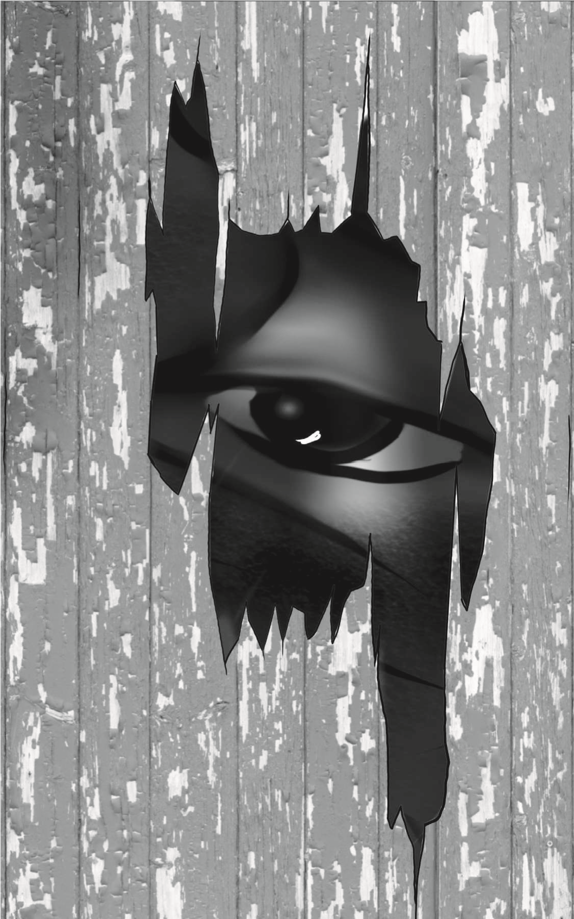

“In one of t hese was a small and almost imper cept ible chink

t hr ough which t he eye could just penet r at e.”

hands. She sat down beside the old man. He then took up some instrument and began to play and produce sounds sweeter than the voice of the thrush or the nightingale. It was a lovely sight—even to me, a poor wretch who had never beheld anything beautiful before. The silver hair and benevolent expression of the aged cottager won my respect, while the gentle manners of the girl charmed me. He played a sweet mournful tune which drew tears from the eyes of his amiable companion. The old man took no notice of her, until she sobbed audibly. Then he pronounced a few sounds, and the girl, leaving her work, knelt at his feet. He raised her to her feet and smiled with such kindness and affection that I felt sensations of a peculiar and overpowering nature. They were a mixture of pain and pleasure, such as I had never before experienced, either from hunger or cold, warmth or food. I withdrew from the window, unable to bear these emotions.

“Soon after this the young man returned with a load of wood. The girl met him at the door and helped to relieve him of his burden. She took some of the wood into the cottage and placed it on the fire.

burden: load

Then she and the youth went apart into a corner of the cottage, and he showed her a large loaf of bread and a piece of cheese. She seemed pleased and went into the garden for some roots and plants, which she placed in water, and then upon the fire. She afterwards continued her work, while the young man went into the garden to dig up some more roots. After about an hour, the young woman joined him and they entered the cottage together.

“The old man had, in the meantime, been pensive. However, when his companions returned, he assumed a more cheerful air, and they sat down to eat. The meal was quickly finished. The young woman began to tidy up the cottage, while the old man walked before the cottage in the sun for a few minutes, leaning on the arm of the youth. Nothing could exceed in beauty the contrast between these two excellent creatures. One was old, with silver hair and a facial expression beaming with kindness and love; the other was slight and graceful in his figure. His features were attractive, yet his eyes expressed great sadness. The old man returned to

pensive: thoughtful

the cottage, and the youth, with tools different from those he had used in the morning, directed his steps across the fields.

“Night came, but to my astonishment, I found that the cottagers had a way of driving away darkness by the use of candles. I was delighted to find that the setting of the sun did not put an end to the pleasure I experienced in watching my human neighbors. In the evening the young girl and her companion were employed in various occupations which I did not understand. The old man again took up the instrument which produced the divine sounds that had delighted me in the morning. As soon as he had finished, the youth began, not to play, but to utter sounds that were repetitive, neither resembling the harmony of the old man’s instrument nor the songs of the birds. I found out later that he was reading aloud, but at that time I knew nothing of words or letters.

“The family, after having been thus occupied for a short time, put out their candles and went to sleep.”

CHAPTER 12 “I What chiefly struck me was the gentle lay on my straw, but I could not sleep. I thought of the events of the day.

manners of these people. I longed to join them, but I dared not. I remembered too well the treatment I had suffered the night before from the villagers. I decided that, for the time being, I would remain quietly in my hovel, watching the family and trying to understand the things they did.

“The cottagers got up the next morning before the sun. The young woman arranged the cottage and prepared the food. The youth went out after the first meal.

“This day was was much like the previous day. The young man was constantly busy out of doors, and the girl inside. The old man, who I soon realized was blind, spent his free time playing his instrument or sitting quietly and thinking. Nothing could be greater than the love and respect which the younger cottagers showed towards their older companion. They did everything for him with affection and gentleness, and he rewarded them with kind smiles.

“They were not entirely happy, though. The young man and his companion often went apart and appeared to weep. I saw no cause for their unhappiness, but I was deeply affected by it. If such lovely creatures were miserable, it was less strange that I, an imperfect and solitary being, should be wretched. Yet why were these gentle beings unhappy? They possessed a delightful house (for such it was in my eyes). They seemed to have every luxury. They had a fire to warm them and delicious food. They were dressed in excellent clothes. They enjoyed one another’s company and speech, exchanging looks of affection and kindness. What did their tears mean? Did they really express pain? I was at first unable to solve these questions, but after watching them for a while I was able to answer many of them.

“Many days passed before I discovered one of the causes of the uneasiness of this amiable family. They were poor, and they suffered a great deal from their poverty. Their food consisted entirely of vegetables from their garden and the milk of

solitary: single, unaccompanied

one cow, which gave very little during the winter. They often, I believe, suffered terrible pangs of hunger. The two younger cottagers seemed to suffer the most, for several times they placed food before the old man when they had none for themselves.

“Their kindness moved me. I had been accustomed, during the night, to stealing some of their supplies for myself, but I found that by doing this I was causing the cottagers pain. I therefore stopped stealing food from them and satisfied myself with berries, nuts, and roots which I gathered from a nearby wood.

“I also discovered another way of helping them. I found that the young man spent a great part of each day collecting wood for the family fire. During the night I often took his tools, the use of which I quickly discovered, and brought home enough wood to last them several days.

“I remember, the first time I did this. The young woman, when she opened the door in the morning, appeared greatly surprised on seeing a great pile of wood on the outside. She spoke some words in a loud voice. The young man joined her, and he also expressed surprise. I observed, with pleasure, that he did not go to the forest that day. Instead he spent the day repairing the cottage and working in the garden.

“Eventually, I made another, more important discovery. I found that these people had a way of communicating their experience and feelings to one another using sounds. I noticed that the words they spoke sometimes produced pleasure or pain, smiles or sadness, in the minds and faces of the listeners. This was indeed a godlike capability, and I wanted to understand how they did it. But, at first, I was frustrated in my attempts to understand. Their pronunciation was quick, and the words they spoke seemed not to have any apparent connection with visible objects. For a long time, I was unable to discover any clue by which I could unravel the mystery of what they were saying. After watching for many days, however, I discovered the names that were given to some of the most familiar objects. I learned and applied the words, *fire, milk, bread*, and *wood*. I learned also the names of the cottagers themselves. The young man and his companion had each of them several names, but the old man had only one, which was *father*. The girl was called *sister or Agatha*. The young man was called *Felix, brother*, or *son*. I cannot describe the delight I felt when I learned the ideas connected with each of these sounds and was able to pronounce them. I distinguished several other words without being able as yet to understand or apply them, such as *good, dearest, unhappy*.

“I spent the winter in this way. The gentle manners and beauty of the cottagers greatly endeared them to me. When they were unhappy, I felt depressed. When they rejoiced, I also felt their happiness. I saw few other human beings besides them, and I did not particularly like the other humans who visited from time to time. The old man, I noticed, often tried to encourage his children (as I found that he called them) to cast off their sadness. He would talk in a cheerful voice, with an expression of goodness that pleased me. Agatha listened with respect, her eyes sometimes filled with tears, which she tried to wipe away unnoticed. However, I generally found that she was more cheerful after having listened to her father. It was not the same with Felix. He was always the saddest of the group, and he seemed to have suffered more deeply than his friends. But if his facial expressions were more sorrowful, his voice was more cheerful than that of his sister, especially when he addressed the old man.

“It was clear that they loved one another. In the midst of poverty and want, Felix carried with pleasure to his sister the first little white flower that peeped out from beneath the snowy ground. Early in the morning, before she had risen, he cleared away the snow that had fallen on her path to the milk-house, drew water from the well, and brought in wood from the storage house. There, to his astonishment, he found his supply of firewood always replenished by an invisible hand. In the day, I believe, he worked sometimes for a neighboring farmer, because he often went out and did not return until dinner, and then he brought no wood with him. At other times he worked in the garden. In the frosty season, he worked less and spent more time reading to the old man and Agatha.

“This reading puzzled me at first. However,

replenished: fi lled up again

by degrees I discovered that he uttered many of the same sounds when he read as when he talked. I guessed, therefore, that he found on the paper symbols for speech which he understood, and I passionately longed to comprehend these also. But how was that possible when I did not even understand the sounds for which they stood as symbols? My understanding of their language did improve, however. For a long time I could not follow any kind of conversation, although I tried to do so. I wished to present myself to the cottagers, but I was afraid of what might happen. I felt I should not attempt this until I could use their language.

“I had admired the appearance of my cottagers—their grace, beauty, and delicate complexions. But how was I terrified when, one day, I caught sight of myself in a pool! At first I started back. I could not believe that I was the thing I saw. When I became fully convinced that I was in reality the monster that I am, I was horrified and depressed. Alas! I did not yet entirely know the fatal effects of my deformity.

deformity: the condition of being misshaped

“As the sun became warmer and the days grew longer, the snow vanished. I beheld the bare trees and the black earth. From this time forward, Felix was busier. Several new kinds of plants sprang up in the garden, and the cottagers began to eat some of what they produced.

“The old man, leaning on his son, walked each day at noon. But he did not walk when there was rain—and that was another word I learned to recognize and repeat: rain!

“My life in my hovel was repetitive. During the morning I watched the activities of the cottagers, and when they went out, I slept. When they returned, I watched their evening activities. When they had retired to rest, if there was any moonlight or starlight, I went into the woods and collected my own food, along with firewood for the cottage. When I returned, as often as it was necessary, I cleared their path of snow and performed those tasks I had seen Felix doing. Later I found that these tasks, performed by an invisible hand, greatly astonished them. Once or twice I heard them say the words good spirit or wonderful. But I did not then understand the meaning of the terms. “My thoughts now became more active. I longed to discover the thoughts and feelings of these lovely creatures. I wanted to understand why Felix seemed so miserable and why Agatha seemed so sad. I thought—foolish wretch!—that I might be able to restore happiness to these deserving people. I looked upon them as superior beings who would decide my destiny. In my imagination I pictured how I would present myself to them, and how they would receive me. I expected that they would be disgusted by my appearance at first; however, I thought that I could win their favor, and perhaps even their love, with my gentle demeanor and some friendly words.

“These thoughts lifted my spirits and led me to work even harder at learning the art of language. My voice was very unlike the soft music they produced, but I was able to learn more and more words, and I pronounced the words I had learned fairly well.

“The pleasant showers and warmth of spring greatly altered the appearance of the earth. Men who seemed to have been hidden in caves came out and busied themselves planting and growing food. The birds sang in more cheerful notes, and the leaves began to bud on the trees. My spirits were elevated by the delightful appearance of nature. The past was erased from my memory. The present was peaceful and the future seemed bright.”

CHAPTER 13 “Sthat what before was empty and pring advanced rapidly. The weather improved. It surprised me

gloomy should now bloom with the most beautiful flowers. My senses were gratified and refreshed by a thousand scents of delight and a thousand sights of beauty.

“One day my cottagers rested early from their work. The old man played his guitar, and the children listened to him. I observed that Felix seemed very moody. He sighed frequently, and once when his father paused in his music, and I guessed by his manner that he was asking the cause of his son’s sorrow. Felix replied in a cheerful accent, and the the old man was beginning his song again when they heard the footsteps of a horse outside. Felix and Agatha went out. There was a lady on horseback. She was dressed in a dark suit and a thick black veil covered her face. Agatha asked a question, to which the stranger only replied by pronouncing the name of Felix, in a sweet accent. Her voice was musical but unlike that of either of my friends. On hearing this word, Felix came up hastily to the lady. When she saw him, she drew back her veil, and I beheld a face of angelic beauty and expression. Her hair was shining, raven black, and curiously braided. Her eyes were dark, but gentle. Her features were attractive. Her complexion was wondrously fair, each cheek tinged with a lovely pink.

“Felix seemed to be seized with delight when he saw her. Every trace of sorrow vanished from his face. His eyes sparkled, and his cheek flushed with pleasure. At that moment I thought him as beautiful as the stranger. She appeared affected by different feelings. Wiping a few tears from her lovely eyes, she held out her hand to Felix. He kissed it and called her, as well as I could distinguish, his sweet Arabian. She did not seem to understand him, but she smiled. He helped her get off her horse and, dismissing her guide, led her into the cottage. Some conversation took place between him and his father, and the young stranger knelt at the old man’s feet and would have kissed his hand, but he raised her and embraced her affectionately.

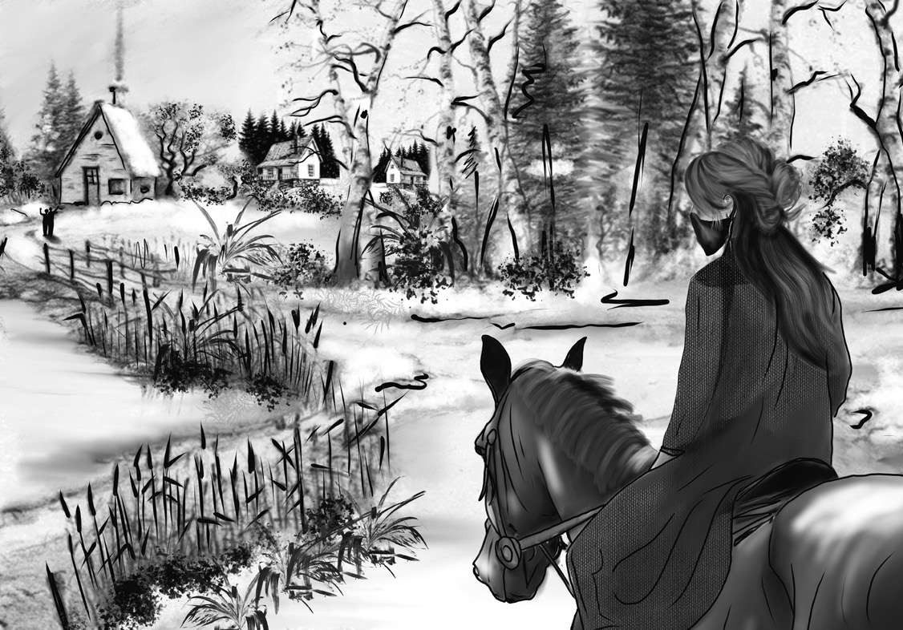

“Ther e was a lady on hor seback. She was dr essed in a dar k suit and a t hick black veil cover ed her face.”

“I soon realized that although the stranger appeared to have a language of her own, she was not understood by the cottagers. Nor could she understand the things that they said. But I saw that her presence made the others happy, driving their sorrows away as the sun drives away the morning mists. Felix seemed peculiarly happy and with smiles of delight welcomed his Arabian. Agatha kissed the hands of the lovely stranger. Some hours passed in this way, while they, by their facial expressions, expressed joy, the cause of which I did not understand. Presently I found, by the frequent repetition of some sound which the stranger repeated after them, that she was trying to learn their language. The idea immediately occurred to me that I should make use of their lessons too. The stranger learned about twenty words at the first lesson. Most of them were words I had learned before, but I did learn a few new ones.

“As night came on, Agatha and the Arabian retired early. When they separated, Felix kissed the hand of the stranger and said, ‘Good night, sweet Safie!’ He sat up much longer, speaking with his father, and by the frequent repetition of her name I guessed that their lovely guest was the subject of their conversation. I tried to understand what they were saying but found it completely impossible.

“The next morning Felix went out off to work.

After the usual duties of Agatha were finished, the Arabian sat at the feet of the old man, and taking his guitar, played some songs so beautiful that they drew tears of sorrow and delight from my eyes. She sang, and her voice flowed in a rich rhythm, swelling or dying away like a nightingale of the woods.

“When she had finished, she gave the guitar to Agatha. She played a simple tune, and her voice accompanied it in sweet accents, but unlike the wondrous song of the stranger. The old man seemed to enjoy it very much. He said some words which Agatha attempted to explain to Safie. He seemed to be trying to tell her that he taken great delight in her singing.

“The days now passed as peaceably as before; the only change was that joy had taken place of sadness in the cottage. Safie was always happy. She and I improved rapidly in the knowledge of language, so that in two months I began to comprehend most of the words spoken by my protectors.

“In the meantime also the ground was covered with budding plants, and the green banks decorated with innumerable flowers, sweet to the scent and the eyes. The sun became warmer. The nights grew clear and pleasantly warmer, and my nightly rambles were a great pleasure to me, although they were considerably shortened by the late setting and early rising of the sun. I never went out during daylight, for fear of meeting with the same treatment I had experienced in the first village I had entered.

“My days were spent watching and listening. I longed to master their language.

“While I improved in speech, I also learned the science of written letters as it was taught to the stranger, and this opened before me a wide field for wonder and delight.

“The book that Felix used to teach Safie was Volney’s *Ruins of Empires*. I would not have understood it if Felix had not given very detailed explanations of the sections he read aloud. He had chosen this work, he said, because the style reminded him of certain Eastern authors. Through this work I obtained some knowledge of history and a view of the several empires that currently exist in the world. It gave me an understanding of the manners, governments, and religions of the different nations of the earth. I heard of the amazing genius and mental activity of the Greeks, of the wars and wonderful virtue of the early Romans—and of the decline of that mighty empire—, of chivalry, Christianity, and kings. I heard of the discovery of the Americas

*Ruins of Empires:* published in 1791

and wept with Safie over the sad fate of its original inhabitants.

“These wonderful stories inspired me with strange feelings. It seemed that human beings were powerful, well-behaved, and magnificent. And yet, at the same time, it seemed that they were often badly behaved. For a long time I could not understand how a man could go forth to murder one of his fellow men, or even why there were laws and governments. When I heard details of crime and bloodshed, I turned away with disgust and loathing.

“Every conversation of the cottagers opened new wonders to me. While I listened to the lessons Felix gave the Arabian, the strange system of human society was explained to me. I heard of the division of property, of wealth and poverty, of rank, descent, and noble blood.

“I learned that the possessions most valued by your fellow creatures are an aristocratic name

sad fate of its original inhabitants: the native American people were often pushed off their lands by settlers and died in large numbers after exposure to European diseases loathing: hatred

and riches. A man may be respected with only one of these advantages, but without either he is considered, except in very rare instances, as a vagabond and a slave, doomed to waste his powers for the profits of the chosen few. And what was I? Of my creation and creator I was absolutely ignorant. I knew, however, that I possessed no money, no friends, no property. I had, besides, a figure hideously deformed and loathsome. I was not even of the same physical nature as the men I observed. I was more coordinated than any of the cottagers and could survive on a coarser diet. I could endure the extremes of heat and cold with less injury to my body. I was much larger and much taller than any of them. When I looked around I saw and heard of no other beings like me. Was I, then, a monster? Was I a hideous creature, from whom all men fled and whom all men disowned?

“I cannot describe to you the suffering that these reflections inflicted upon me. I tried to ignore them, but sorrow only increased with knowledge.

vagabond: wanderer, homeless person disowned: refused to recognize as like them

Oh, that I had forever remained in my native wood, nor known nor felt beyond the sensations of hunger, thirst, and heat!

“Knowledge is a strange sort of thing. It clings to the mind when it has once seized on it like a moss clinging to a rock. I wished sometimes to shake off all thought and feeling, but I learned that there was only one way to overcome the sensation of pain, and that by dying—an outcome which I feared yet did not understand. I admired virtue and good feelings and loved the gentle manners and amiable qualities of my cottagers, but I was shut out from interaction with them. Oh, what a miserable wretch I was!

“Other lessons were impressed upon me even more deeply. I heard of the difference between the two sexes, and the birth and growth of children. I learned how the father doted on the smiles of the infant, and the lively activities of the older child. I learned how all the life and cares of the mother were wrapped up in her child. I learned how the mind of youth expanded and gained knowledge.

doted: showed a great liking for

I learned about brothers and sisters, and all the various relationships which bind one human being to another.

“But where were my friends and relatives? No father had watched my infant days. No mother had blessed me with smiles and caresses. Or if they had, I could not remember anything. All my past life was now a blot, an empty space in which I distinguished nothing. From my earliest memories I had been the same in height and proportion. I had never seen a being resembling me. What was I? That question rose up again and again, but I could only answer with groans.”

caresses: loving touches

CHAPTER 14 “Sout that the old man’s name was ome time elapsed before I learned the history of my friends. It turned

De Lacey. He was descended from a good family in France, where he had lived for many years in wealth, respected by his superiors and beloved by his equals. His son was bred in the service of his country, and Agatha had ranked with ladies of the highest distinction. A few months before my arrival they had lived in a large and luxurious city called Paris. There they were surrounded by friends and all the pleasures that a small fortune could afford.

“The father of Safie had been the cause of their ruin. He was a Turkish merchant and had lived in Paris for many years. Eventually, for some reason which I could not learn, he did something that angered the government. He was seized and cast into prison the very day that Safie arrived from Constantinople to join him. He was tried

distinction: high social rank among the nobles Constantinople: famous city in Turkey, now Istanbul

and condemned to death. The injustice of his sentence was obvious. People said that he had been condemned for his religion and wealth rather than the crime alleged against him.

“Felix had been present at the trial. He was horrified and outraged when he heard the decision of the court. He made, at that moment, a promise to rescue the convicted man and then looked around for a way to do so. After many fruitless attempts to gain entrance to the prison, he found a grated window in an unguarded part of the building, which lighted the dungeon of the unfortunate man. The Turk was inside, loaded with chains and waiting to be executed. Felix visited the grate at night and called out to the poor man. He told him that he was determined to help him escape. The Turk was amazed and delighted. He promised Felix a great reward if he could free him. At first, Felix refused the man’s offers, but that changed when he saw Safie. She was allowed to visit her father in jail, and she managed to show her gratitude through smiles and gestures.

outraged: very upset fruitless: unsuccessful

Although Felix had not set out to win a reward, he had to admit that the prisoner was in possession of a treasure that would fully reward him for his efforts.

“The Turk saw that his daughter had made an impression on Felix. He tried to encourage the young man by promising him his daughter’s hand in marriage as soon as he could be rescued. Felix was too delicate to accept this offer, yet he hoped that the promised marriage might someday take place.

“During the next few days, while the preparations were going forward for the escape of the merchant, Felix’s enthusiasm was warmed by several letters that he received from this lovely girl. She found ways to express her thoughts in the language of a lover by the aid of an old man. He was a servant of her father’s who understood French. She thanked Felix in the most passionate terms for his intended services towards her father, and at the same time she gently deplored her own fate.

“I have copies of these letters. Before I go I will give them to you. They will prove the truth of

too delicate: too sensitive to what is (and is not) proper deplored: complained about

my tale. At present, however, as the sun is already low in the sky, I shall only have time to repeat the substance of them to you.

“Safie related that her mother was a Christian Arab, who had been seized and made a slave by the Turks. She had won the heart of Safie’s father, who married her. The young girl spoke in high and enthusiastic terms of her mother, who, born in freedom, rejected the slavery to which she was now reduced. She taught her daughter her religion and taught her to aspire to higher powers of intellect and an independence of spirit forbidden to the female followers of Muhammad. Her mother died, but her lessons made a lasting impression on the mind of Safie. She could not bear the prospect of returning to Asia and being walled up in a harem. The prospect of marrying a Christian and remaining in a country where women were allowed to take a rank in society was very appealing to her.

“The day for the execution of the Turk was set, but the night before he escaped from his

Muhammad: the prophet of Islam, founder of the Muslim faith harem: a group of wives kept by a single man

prison and, before morning came, he was many miles from Paris. Felix had acquired passports in the name of his father, sister, and himself. He had previously explained his plan to his father, who aided the deceit by leaving his house, under the pretense of a journey and hiding himself, with his daughter, in a little-known part of Paris.

“Felix led the escapees through France to Lyons and across the mountains to Leghorn, in Italy, where the merchant had decided to wait for an opportunity of passing into some part of the Turkish territories.

“Safie decided to remain with her father until the moment of his departure, before which time the Turk renewed his promise that she should be married to his rescuer. Felix remained with them in expectation of that event, and in the meantime he enjoyed the society of the Arabian. She exhibited towards him the simplest and tenderest affection. They conversed with one another through the means of an interpreter, and sometimes by smiles and looks. Safie sang to him the songs of her native country.

deceit: trick

“The Turk allowed all of this to take place and encouraged the hopes of the young lovers, but in his heart he had formed other plans. He was a pious Muslim and he could not accept the idea that his daughter might marry a Christian. However, he knew that he needed Felix’s help, so he put on a show of approval.

“The French were very upset that their prisoner had escaped, and they spared no pains to track him down. The plot of Felix was brought to light, and De Lacey and Agatha were thrown into prison. The news reached Felix and stirred him from his pleasant dreams. His blind and aged father and his gentle sister lay in a dungeon while he enjoyed the free air and the company of the person he loved. This idea was torture to him. He quickly made arrangements for the Turk, telling him he should look for an opportunity for escape. If he happened to find one before Felix could finish his business in France and return to Italy, he should leave Safie as a boarder at a convent in Leghorn. After making these plans, Felix said goodbye to Safie

pious: seriously religious

convent: a Christian religious house for females, who are called nuns

and hurried to Paris. There he turned himself in. He was hoping that the government would release De Lacey and Agatha.

“His plan did not succeed. The whole family remained in prison for five months before a trial took place. He and his family members had their fortune taken away and were sent into exile.

“They went to stay in the cottage in Germany, where I discovered them. Felix soon learned that the Turk, for whom he and his family had endured so many difficulties, had betrayed him. When the Turk learned that Felix had been reduced to poverty and ruin, he had left Italy and taken Safie with him.

“Such were the events that weighed on Felix’s heart and made him, when I first saw him, the most miserable of his family. He could have endured poverty, but the ingratitude of the Turk and the loss of his beloved Safie were misfortunes more bitter and irreparable. It was only when the Arabian arrived a little later that his mood improved.

exile: banishment, forced absence from one’s home country

“When the news reached Leghorn that Felix was no longer wealthy, the Turkish merchant gave his daughter orders. She was to think no more of her lover. Instead, she was to prepare for a return to her native country. Safie was outraged by these orders. She tried to argue with her father, but he left her angrily, repeating his cruel order.

“A few days later, the Turk entered his daughter’s apartment. He told her that he had reason to believe that their residence at Leghorn had been discovered. He was in danger of being taken captive and turned over to the French government. As a result, he had hired a ship to transport him to Constantinople. The ship would sail in a few hours. He intended to leave his daughter in the care of a servant. The servant had been ordered to follow him to Constantinople on another ship as soon as possible.

“When she was left alone, Safie considered her options. She did not want to go back to Turkey. She wanted to follow her lover into exile. Taking with her some jewels that belonged to her and a sum of money, she left Italy with a young female friend. This friend was a native of Leghorn, but she understood the language of Turkey. Together the two young women departed for Germany.

“They made their way to a town about seventy miles from the cottage of De Lacey. There her traveling companion fell dangerously ill. Safie cared for her with the most devoted affection, but the poor woman died. Safie did not know the language of the country and was completely ignorant of the customs of the world. She fell, however, into good hands. The woman of the house where she was staying took care to see that she arrived safely at the cottage of her lover.”

CHAPTER 15 “SI learned from it to admire their uch was the history of my cottagers. It made a deep impression on me.

virtues and condemn the vices of mankind. But in giving this account, I must not leave out an event that occurred in August of the same year.

“One night I went into the woods to gather food for myself and firewood for my protectors. On a rock I found a leather suitcase containing several articles of clothing and some books. Fortunately, the books were written in the language I had been learning. They included Milton’s *Paradise Lost*, a volume of *Plutarch’s Lives*, and the *Sorrows of Young Werther*. These books gave me great delight. I began to study them whenever the cottagers were busy with their work. They stirred up many new ideas and feelings.

*Paradise Lost:* long poem about Adam and Eve, by the English poet John Milton, 1667.

*Plutarch’s Lives:* a collection of “parallel lives” of ancient Greeks and ancient Romans.

*Sorrows of Young Werther:* popular novel about a troubled and sensitive youth, by the German author Johann Wolfgang von Goethe, published in 1774.

“As I read the books, I applied many of the details in them to my own life and feelings. I felt that I was similar to the persons described in the *Sorrows of Young Werther* and yet also strangely unlike them. I sympathized with them and partly understood them. But I was unformed in mind, connected to no other being, and related to no one. Who was I then? And what was I? Where did I come from? And what was my purpose? These questions continually came up again and again, but I was unable to answer them.

“The volume of *Plutarch’s Lives* contained the histories of the first founders of the ancient republics. Plutarch taught me noble thoughts. He elevated me above the wretched sphere of my own reflections and taught me to admire and love the heroes of past ages. Many things I read surpassed my understanding and experience. I had a very confused knowledge of kingdoms, mighty rivers, and boundless seas, and I knew nothing about towns. The cottage of my protectors was the only school in which I had studied human nature. But this book introduced me to new and mightier scenes of action. I read of men involved in public affairs, governing or massacring their species. I felt a passion for virtue rise within me, and a hatred for vice, as far as I understood the meaning of those terms.

“But *Paradise Lost* excited different and far deeper emotions. I read with wonder and awe the story of an omnipotent God warring with his creatures. I often made connections between the story in the book and my own life. Like Adam in Milton’s poem, I was apparently united by no link to any other being in existence. And yet his state was very different from mine in every other way. He had come forth from the hands of God, and he was a perfect creature, happy and prosperous, guarded by his Creator. He was allowed to communicate with and acquire knowledge from beings of a superior nature. But I was wretched, helpless, and alone. My situation was more like that of Milton’s Satan, for, like him, I felt envy rising up within me.

“Another circumstance strengthened and confirmed these feelings. Soon after my arrival in the hovel I discovered some papers in the pocket of

massacring: killing in large numbers

the clothes that I had taken from your laboratory. At first I had not paid attention to them, but now that I was able to decipher the characters in which they were written, I began to study them. It was your journal of the four months before my creation. You described, in detail, every step you took in the progress of your work.

“I am sure you remember the pages. As I read your words, I felt sick. ‘O hateful day when I received life!’ I shouted in agony. ‘Accursed creator! Why did you form a monster so hideous that even you turned away from me in disgust? God, in pity, made man beautiful and attractive, after his own image. But I am deformed! Even Satan had his companions. He had fellow devils who admired and encouraged him, but I am

friendless and hated.’

“These were my thoughts when I thought of myself. However, when I thought of the cottagers, I began to feel better. They were so friendly and kind! I looked forward to a time when I could introduce myself to them, and I persuaded myself that they would overlook my deformity and be kind to me. If I came to their door to ask for their friendship, would they turn me away? I did not think they would, however monstrous my body might seem to them. I decided, at least, not to give up hope. After a while I began to prepare for a meeting with them.

“In the meantime, several changes took place in the cottage. The presence of Safie made the others happy. Felix and Agatha seemed contented. Their feelings were serene and peaceful, while mine became every day more tumultuous. The more I learned, the more clearly I came to see what a wretched outcast I was. I cherished hope, it is true, but it vanished when I saw myself reflected in water or caught sight of my shadow in the moonlight.

“I tried to crush these fears and strengthen myself for the upcoming meeting in a few months. Sometimes I allowed my thoughts, unchecked by reason, to ramble in the fields of Paradise. I imagined that the cottagers would sympathize with my feelings and cheer my gloom. But it was all a dream. There was no Eve to soothe my

tumultuous: uneven, rough, stormy outcast: person left alone or driven out by others

sorrows and share my thoughts. I was alone. I remembered how Adam had asked his creator for a companion. But where was my own creator? He had abandoned me, and in the bitterness of my heart I cursed him.

“Autumn passed and I saw, with surprise and grief, the leaves decay and fall, and nature again take on the lifeless and bleak appearance it had worn when I first beheld the woods and the lovely moon. But my cottagers did not seem to be dismayed by these changes. They loved and sympathized with one another in spite of the changes. The more I saw of them, the more I longed for their protection and kindness. I yearned to be known to them—and loved by them. I longed to see their sweet looks directed towards me. I dared not think that they would turn from me with disdain and horror. The poor people who stopped at their door were never driven away. I would be asking, it is true, for greater treasures than a little food or rest. I would be asking for kindness and sympathy. But I did not believe myself utterly unworthy of it.

“As the winter advanced, I thought more and more about my plan to introduce myself to the cottagers. I considered many different approaches. At last, I decided to enter the dwelling when the blind old man was there alone. I knew it was the unnatural hideousness of my body that had horrified others who had seen me. My voice, although harsh, had nothing terrible in it. I thought, therefore, that if I could speak to the old man when he was by himself, I could gain his trust. Then he might be my advocate with the others.

“One day, Safie, Agatha, and Felix went for a walk, and the old man was left alone in the cottage. He took up his guitar and played several lovely songs. Then he laid aside the instrument and sat there, absorbed in reflection.

“My heart began to race. This was moment I had been waiting for. I approached the door of their cottage and knocked.

“‘Who’s there?’ said the old man. ‘Come in.’

“I entered. ‘Pardon this interruption, I said. ‘I am a traveler in want of a little rest. Would you allow me to stand for a few minutes before the fire?’

“‘Enter,’ said De Lacey. ‘Unfortunately, my

advocate: spokesman, defender

children have gone out, and I am blind. I am afraid I will not be able to give you any food.’

“‘Do not trouble yourself, my kind host. I have food. It is warmth and rest only that I need.’

“I sat down, and a few seconds of silence followed. I knew that every minute was precious to me, but I was unsure what to say. At last the old man addressed me.

“‘By your language, stranger, I suppose you are my countryman. Are you French?’

“‘No,’ I said. ‘But I was educated by a French family and understand only that language. I am now going to claim the protection of some friends, whom I sincerely love, and of whose favor I have some hopes.’

“‘Are they Germans?’

“‘No, they are French. But let us change the subject. I am an unfortunate and lonely creature. I look around and I have no relatives or friends on earth. These amiable people to whom I go have never seen me and know little of me. I am full of fears, for if I fail there, I may end up an outcast in the world for ever.’

“‘Do not worry. To be friendless is indeed to

be unfortunate, but the hearts of men, when not influenced by self-interest, are full of brotherly love and generosity. Rely, therefore, on your hopes. If these friends are good, you have no reason to worry.’

“‘They are kind—they are the most excellent creatures in the world. But unfortunately they are prejudiced against me. I am good at heart. My life has so far been harmless and I have even done a few good deeds. But a fatal prejudice clouds their eyes, and where they ought to see a kind friend, they behold only a detestable monster.’

“‘That is indeed unfortunate. But if you are really blameless, surely you can persuade them to think well of you?’

“‘I am about to try—and that is why I am so nervous. I tenderly love these friends. I have, unknown to them, offered acts of daily kindness towards them. But they believe that I wish to harm them, and it is that prejudice I wish to overcome.’

“‘Where do these friends live?’

“‘Near this spot.’

“The old man paused and then continued, ‘If you will tell me all the details of your tale, perhaps I may be of use to you. I am blind and cannot judge your appearance, but there is something in your words which persuades me that you are sincere. I am poor and living in exile, but it will give me pleasure to help you.’

“‘Thank you, sir! I accept your generous offer. From your lips first have I heard the voice of kindness directed towards me, and I shall be forever grateful to you.”

### “‘May I know the names of your friends?’

“I paused. This, I thought, was the moment of truth—the moment that would make me happy or leave me miserable. I struggled to answer the old man, but I was overcome with emotion. I sat down on a chair and sobbed aloud.

“Just then I heard footsteps outside. I realized that the others were returning. I had not a moment to lose. I took the old man by the hand and cried, ‘Now is the time! Save and protect me! You and your family are the friends whom I seek. Do not you desert me!’

“‘Great God!’ exclaimed the old man. ‘Who are you?’

“At that instant the cottage door opened,

and Felix, Safie, and Agatha entered. Who can describe their horror on seeing me? Agatha fainted and Safie rushed out of the cottage. Felix darted forward and forcefully tore me away from his father. I clung to the old man’s knees until Felix struck me with a large stick. I could have torn him limb from limb, as the lion rends the antelope. But my heart sank within me as with bitter sickness, and I did not do it. He was about to hit me again when, overcome by pain and anguish, I fled from the cottage. In the confusion I was able to escape unnoticed and went back to my hovel.”

rends: tears into pieces

CHAPTER 16 “Ahave destroyed the cottage and fter they drove me away, I burned with rage. I could with pleasure

its inhabitants. I could have glutted myself on their shrieks and misery.

“When night came, I left the hovel and went into the woods. There I was no longer afraid of being discovered, and I expressed my pain by howling. I howled like a wild beast. Oh, what a miserable night I passed! Like the fallen angel in Milton’s poem, I bore a hell within me. I longed to tear up the trees and spread destruction around me.

“I was in despair! There were millions of men in the world—but not one who would pity or assist me! Why, then, should I feel kindness towards men? Were they not my enemies? From that moment, I declared everlasting war against mankind—and, most of all, against the man who had created me and sent me forth to this unbearable misery.

despair: hopelessness

“The sun rose. I heard the voices of men and knew I could not return to my hovel during the daytime. I hid myself in the woods.

“The pleasant sunshine and the pure air of day restored me to some degree of tranquility. I reviewed what had taken place in the cottage and decided that I had been too quick in drawing conclusions. It was clear that I had made some progress with the old man before the others returned. I decided to return to the cottage and try to speak with him once more.

“That night I directed my steps towards the cottage. All there was at peace. I crept into my hovel and waited for the hour when the family arose. That hour came and went. The sun rose high in the heavens, but the cottagers did not appear. I was very anxious. The inside of the cottage was dark, and I heard no motion.

“Presently two men appeared. They stopped near the cottage and entered into conversation, using violent gestures. They spoke a language I could not understand. Soon after, however, Felix returned with another man.

“‘You understand,’ the man said to him, ‘that

you will have to pay three months’ rent—and lose the produce of your garden? Perhaps you should take a few days to reconsider?’

“‘My decision is final,’ replied Felix. ‘We can never live here again. The life of my father is in the greatest danger, owing to the dreadful events that I have related. My wife and my sister will never recover from their horror. I beg you not to reason with me anymore. Take possession of your dwelling and let us fly from this place.’

“Felix trembled violently as he said this. He and his companion entered the cottage. They remained inside for a few minutes and then departed. I never saw any member of the De Lacey family again.

“I spent the rest of the day in my hovel in a state of utter despair. My protectors had departed and had broken the only link that connected me to the world. Feelings of revenge and hatred filled my bosom, and I did not try to control them. Instead, I allowed myself to be carried along by them. I bent my mind towards injury and death.

“That night I tore up every plant in the garden and piled sticks and wood around the cottage.

There was a kind of craziness in my spirits that burst all bounds of reason and reflection. I lighted a dry branch of a tree and set the wood beside the cottage on fire. It was a windy night, and the wind fanned the fire. The cottage was quickly swallowed up by flames.

“I sought safety in the woods but was unsure where to go. I decided to go somewhere far, far away from the scene of my misfortunes. But to me, hated and despised, every country would be equally horrible.

“At length the thought of you crossed my mind. I had learned from your papers that you were my father—my creator. Among the lessons that Felix had given Safie, geography had not been omitted. I had learned from his lessons the positions of the different countries of the earth. You had mentioned Geneva as the name of your native town, and towards that town I decided to proceed.

“But how was I to direct myself? I knew that I must travel in a southwesterly direction to reach Geneva, but the sun was my only guide. I did not know the names of the towns that I was to pass, nor could I ask information from a single human being. However, I did not despair.

“Towards you, I felt no sentiment but hatred. Unfeeling, heartless creator! You had given me sense and feelings and then thrown me out! But you were the only person who could correct the wrong, and from you I determined to seek justice.

“My travels were long and the sufferings I endured painful. It was late autumn when I left the district where I had so long resided. Fearful of encountering human beings, I traveled only at night. Nature decayed around me. The sun ceased to give heat. Rain and snow poured down around me. Mighty rivers froze. The surface of the earth grew cold and hard and bare, and I found no shelter. I had a map, but I often lost my way.

“The mildness of my nature had withered away, and all within me was turned to bitterness. As I made my way to you, I felt the fire of revenge burning hotter in my heart.

“By the time I arrived in Switzerland, the sun had recovered some of its warmth and the earth again began to look green. I generally rested during the day and travelled only at night. One morning, however, finding that my path lay through a deep wood, I decided to continue my journey after the sun had risen. It was one of the first days of spring. The day was sunny and warm. It cheered me. I felt emotions of gentleness and pleasure stir within me. Half surprised by the newness of these sensations, I allowed myself to be carried away by them, and forgetting my loneliness and deformity, dared to be happy. Soft tears again wetted my cheeks, and I even raised my damp eyes with thankfulness towards the blessed sun, which gave me such joy.

“I continued to wind among the paths of the wood, until I came to the edge and to a deep and rapid river. Here I paused, not knowing which way to go. Then I heard the sound of voices and hid myself behind a cypress tree. A young girl came running towards the tree, laughing, as if she ran from someone in sport. She continued her course along the banks of the river, when suddenly her foot slipped, and she fell into the rapid stream. I rushed from my hiding-place and leaped into the river. The current was strong, but I was able to drag her back to the shore. She was senseless, and I was trying to revive her, when I was interrupted

revive: bring back to life

by the approach of a man, who was probably the person from whom she had playfully run away. On seeing me, he rushed towards me and tore the girl from my arms. He ran into the woods. I followed speedily. I hardly knew why, but when the man saw me drawing near, he aimed a gun at my body and fired. I sank to the ground, and the man escaped into the woods.

“This was the reward for my kindness! I had saved a human being from destruction, and as a reward I was left twisting and turning from the pain of a wound which tore my flesh and shattered my bone. The feelings of kindness and gentleness which I had entertained a few moments before gave place to hellish rage and gnashing of teeth. Inflamed by pain, I swore eternal hatred and vengeance to all mankind. But the pain of my wound overcame me and I fainted.

“For some weeks I led a miserable life in the woods, trying to cure the wound which I had received. The ball had entered my shoulder, and I knew not whether it had remained there or passed through. At any rate I had no way to remove it. My sufferings were also increased by a sense of the injustice of the deed. I swore I would have my revenge—a deep and deadly revenge, such as would compensate for the outrages and suffering I had endured.

“After some weeks my wound healed, and I continued my journey. My labors were no longer lightened by the bright sun or gentle breezes of spring. I could no longer feel joy; I felt that I was not made for the enjoyment of pleasure. But my toils were drawing to a close, and in two months I reached the outskirts of Geneva.

“It was evening when I arrived, and I retired to a hiding-place among the fields to think about how I should approach you. I was tired and hungry and far too unhappy to enjoy the gentle breezes of evening or the prospect of the sun setting behind the mountains.

“While I was thinking, I was disturbed by the approach of a beautiful child, who came running up to me with all the playfulness of infancy. Suddenly, as I gazed on him, an idea seized me that this little creature was unprejudiced: he had lived too short a time to have acquired a horror of deformity. If, therefore, I could seize him and

compensate: make up for

educate him as my companion and friend, I would not be so horribly alone.

“Urged by this impulse, I seized on the boy as he passed and drew him towards me. As soon as he saw my form, he screamed.

“‘Child,’ I said, ‘what is the meaning of this? I do not intend to hurt you. Listen to me!’

“He struggled violently. ‘Let me go,’ he cried. ‘Monster! Ugly wretch! You wish to eat me and tear me to pieces. You are an ogre. Let me go, or I will tell my papa. My papa is an important man— he is Mr. Frankenstein—he will punish you!’

“‘Frankenstein! You belong then to my enemy—to him towards whom I have sworn

eternal revenge. You shall be my first victim.’

“The child still struggled and called me names. I grasped his throat to silence him, and in a moment he lay dead at my feet.

“I gazed on my victim, and my heart swelled with joy and hellish triumph. Clapping my hands, I exclaimed, ‘My enemy is not all-powerful. This death will make him unhappy, and a thousand other miseries will torment and destroy him!’

ogre: a kind of monster

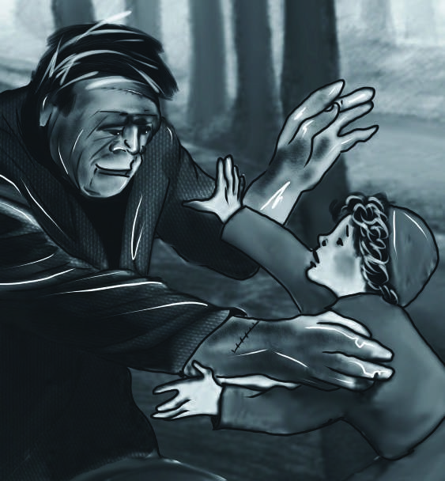

“Child,” I said, “what is t he meaning of t his? I do not int end t o hurt you.”

“As I fixed my eyes on the child, I saw something glittering on his breast. I took it. It was a portrait of a lovely woman. For a few moments I gazed with delight on her dark eyes and her lovely lips. Presently, however, my rage returned. I remembered that I was forever deprived of the delights that such beautiful creatures could give. I thought also what the woman would say if she saw me. Probably that look of divine kindness would have changed to a look expressive of disgust and fear. Can you wonder that such thoughts stirred up rage in my heart?

“While I was overcome by these feelings, I went to look for a better hiding-place. I entered a barn. There I discovered a woman sleeping on some straw. She was young—not as beautiful as the woman in the portrait, but of an agreeable appearance and blooming in the loveliness of youth and health. Here, I thought, is one of those whose joyful smiles are given to all but me. And then I bent over her and whispered, ‘Awake, fairest, your lover is near—he who would give his life but to obtain one look of affection from thine eyes / My beloved, awake!’

“The sleeper stirred. A thrill of terror ran through me. I thought, *what if she awakes, and sees me, and curses me, and denounces the murderer?* The thought awakened the fiend within me. I swore that I would not be the one to suffer. Thanks to the lessons of Felix and the bloodthirsty laws of man, I had learned how to work mischief. I bent over her and placed the portrait securely in one of the folds of her dress. She moved again, and I fled.

“For some days I haunted the spot where these scenes had taken place. Sometimes I wished to see you. Sometimes I decided to quit the world and its miseries forever. At length I wandered towards these mountains. I have travelled back and forth through their immense spaces, consumed by a burning passion which you alone can satisfy. I will not part from you until you have agreed to my demand. I am alone and miserable. Humans will have nothing to do with me, but a creature as deformed and horrible as myself would not deny herself to me. My companion must be of the same species and have the same defects. This being you must create.”

## CHAPTER 17

H

e finished speaking and looked at me, expecting a reply. But I was confused and failed at first to understand what he wanted. He

continued, “You must create a female for me with whom I can exchange those sympathies necessary for my being. This you alone can do, and I demand that you do it!”

The latter part of his tale had angered me, and I could no longer hold back the rage that burned within me.

“I refuse to do it!” I replied. “And no torture shall ever lead me to do it. Shall I create another like yourself so the two of you can join forces and wipe out the world? Go away! I have answered you. You may torture me, but I will never agree!”

“You are in the wrong,” replied the fiend. But, instead of threatening, I will reason with you. I have done these things because I am miserable. Am I not shunned and hated by all mankind? You, my creator, would tear me to pieces and triumph. Remember that! Remember that, and tell me why I should pity man more than he pities me? You would not call it murder if you could throw me off this mountain and destroy the work of your own hands. Shall I respect man when he condemns me? I would live with him in peace, if he would accept me. But that cannot be. The human senses are insurmountable barriers to our union. Yet I will not submit like an groveling slave. I will revenge my injuries. If I cannot inspire love, I will cause fear. And towards you, my creator, I swear neverending hatred. I will work at your destruction, and I will not cease until I reduce you to misery and make you curse the hour of your birth.”

A fiendish rage seemed to come over him as he said this. His face was wrinkled into contortions too horrible for human eyes to look at. Presently, however, he calmed himself and proceeded—

“I intended to reason with you. This passion is harmful to me, for you do not reflect that you are the cause of it. If any being felt emotions of kindness towards me, I would return those feelings a hundred times. For that one creature’s sake, I would make peace with all of mankind! But I am indulging in dreams of happiness that can never be realized. What I ask of you is reasonable. I demand a creature of another sex, but as hideous as myself. It is true, the two of us will be monsters, cut off from all the world. But for that reason we will be more attached to one another. Our lives will not be happy, but they will be harmless and free from the misery I now feel. Oh! My creator, make me happy! Let me feel gratitude towards you for this gift! Let me see that I excite the sympathy of some existing thing. Do not deny my request!”

I was moved. I shuddered when I thought of the possible consequences of agreeing, but I felt that there was some justice in his argument. His tale and the feelings he had expressed proved him to be a creature with feelings, and perhaps he was right. Did I, as his maker, owe him the portion of happiness that it was in my power to give? He saw my change of feeling and continued, “If you agree, neither you nor any other human being shall ever see us again. We will go to the vast wilds of South America and live on acorns and berries. My companion will be of the same nature as myself and will be content with the same food. We shall make our bed of dried leaves. The sun will shine on us and will ripen our food. We will live in peace, and you must feel that it would be cruel not to allow us such a harmless existence. You have been pitiless to me, but I now see compassion in your eyes. Let me seize the favorable moment and persuade you to promise what I desire.”

“You propose,” I replied, “to fly from the lands of man, to live in wild places where the beasts of the field will be your only companions. But how can you, who long for the love and sympathy of man, survive in this exile? You will return to seek their kindness, and you will meet with their hatred. Your evil passions will be renewed, and you will then have a companion to aid you in the work of destruction. No, I cannot allow that to occur. Cease to argue the point, for I cannot agree.”

“How changeable are your feelings! A moment ago you were moved by my situation. Why then do you again harden yourself to my complaints? I swear to you, by the earth which I inhabit, and by you that made me, that, with the companion you provide, I will quit the world of man and dwell in the most savage of places. My evil passions

compassion: sympathy, fellow feeling

will vanish away, for I shall meet with sympathy! My life will flow quietly away, and in my dying moments I shall not curse my maker.”

His words had a strange effect upon me. I felt compassion for him and sometimes felt a wish to comfort him. However, when I looked upon him, when I saw the filthy mass that moved and talked, my heart sickened and I felt horror and hatred. I hated him for what he had done, and yet part of me wondered if I should give him what he wanted to keep him from doing things even worse. Perhaps creating a second creature would be justified if it served to prevent future violence.

“You swear,” I said, “to be harmless, but you have already shown a willingness to do evil. Why, then, should I trust you? Perhaps this request of yours is nothing more than a trick that will increase your ability to do harm.”

“What’s this?” he said. “I will not be trifled with. I demand an answer. If I have no connections to others and no affections, I can only feel hatred and do evil. But the love of another will destroy the cause of my crimes. I shall feel the affections of a sensitive

trifl ed: fooled, messed

being and become linked to the chain of existence and events from which I am now excluded.”

I paused some time to reflect. I considered all he had said and the various arguments he had employed. I thought of the promise of virtues which he had displayed at first and the suffering he had endured. But I thought also of what he had done—and what he might do in the future. After much reflection, I concluded that the justice due both to him and my fellow creatures demanded of me that I should agree with his request. Turning to him, therefore, I said, “Very well. I agree to your demand—on one condition. You must swear to leave Europe forever—and every other residence of mankind, as soon as I shall deliver into your hands a female who will accompany you in your exile.”

“I swear!” he cried. “I swear by the sun, and by the blue sky of heaven, and by the fire of love that burns my heart. I swear that, if you grant my prayer, neither you nor any other human being shall ever see me again. Go home and begin your work. I will watch your progress—and when the time is right, I shall return.”

excluded: kept out

Saying this, he suddenly left me, fearful, perhaps, that I might change my mind. I saw him descend the mountain with great speed, and I quickly lost sight of him.

His tale had occupied the whole day, and the sun was on the horizon when he departed. I knew that I ought to hurry home, before darkness fell, but my heart was heavy, and my steps were slow. I was distracted by the emotions which the events of the day had produced.

The next morning I returned to Geneva and presented myself to my family. My appearance alarmed them, but I answered no questions. I felt as if I had no right to claim their sympathies—as if never more might I enjoy companionship with them. Yet, even in this miserable state, I loved them, and, to save them, I made up my mind to dedicate myself to the task.

horizon: the spot in the distance where the sky meets the land

## CHAPTER 18

W

eeks passed. I found myself unable to start working on my assigned task. I had made a promise, but I was unable to

overcome my repugnance for the task. In addition, I found that I could not create a female without once again devoting several months to profound study. I had heard of some discoveries made by an English philosopher that would be important for my project, and I sometimes thought of obtaining my father’s permission to visit England, but I took no action. I made excuses of one sort or another to keep from beginning on the project.

One day my father took me aside and spoke to me.

“I wish to speak with you about Elizabeth. I confess that I have always looked forward to your marriage to her as a source of comfort in my old age. The two of you were attached to each other from your earliest infancy. You studied together and appeared, in personalities and tastes, entirely

repugnance: strong dislike

suited to one another. But you may, perhaps, regard her as your sister, without any wish that she become your wife. You may have met with another whom you love.”

“Father, set your mind at ease. I love my cousin tenderly and sincerely. My future hopes and prospects are entirely bound up in the expectation of our marriage.”

“Ah, my dear Victor, it gives me great pleasure to hear this! If you feel this way, we shall surely be happy, however present events may cast a gloom over us. But it is this gloom which appears to have taken so strong a hold of your mind of late that I wish to drive away. Tell me, therefore, whether you have any objection to an immediate marriage.”

I listened to my father in silence and for some time could not reply. To me the idea of an immediate marriage with my Elizabeth was upsetting. I was bound by a solemn promise I had not yet fulfilled and yet dared not break. If I were to break my promise, all sorts of miseries might fall on me and those dear to me! Could I enter into a marriage with this deadly weight hanging round my neck? I felt I could not. I felt that I must keep my promise and let the monster depart with his companion before I could allow myself to enter into a marriage from which I expected peace.

I felt that I needed to separate myself from my family and loved ones while working on the project. Once I began, I told myself, I would quickly complete the work. Then the monster would leave me in peace and I could return to my family—and to Elizabeth—in happiness. Or, perhaps, some accident might occur to destroy him and put an end to my slavery forever.

These feelings guided me in my answer to my father. I expressed a wish to visit England, but I did not tell him the true reasons for this request. I had been unhappy for so long that he was glad to find that I was capable of taking pleasure in the idea of such a journey. He hoped that a change of scene would restore me entirely to myself.

The length of my absence was left up to me. A few months, or at most a year, was what I had in mind. My father thought I should have a traveling companion and made plans for Henry Clerval to join me at Strasbourg.

It was understood that my marriage to Elizabeth would take place as soon as I returned from England. My father urged me not to delay my trip. For myself, there was one reward I promised myself from my detested work—one consolation for my sufferings; it was the prospect of that day when, freed from my miserable slavery, I might claim Elizabeth, forget the past, and get married.

I began making plans for my journey, but I was very anxious. During my absence I would be leaving my family and friends alone and unguarded. They knew nothing of their enemy and therefore could do nothing to protect themselves if he decided to attack them. But he had promised to follow me wherever I might go. So I thought he might follow me to England. That was dreadful in itself, but it comforted me to think that it would ensure the safety of my friends at home. What really worried me was the possibility that he might try to attack my family or my friends as a way of punishing me for what I had done.

At the end of September I set off with my chemical instruments and equipment. After several days, I arrived at Strasbourg, where I waited for Henry. He came. Alas, how great was the contrast between us! He was alive to every new scene, joyful when he saw the beauties of the setting sun, and even more happy when he saw it rise and introduce a new day. He pointed out to me the shifting colors of the landscape and the appearances of the sky. “This is what it is to live!” he cried. “Now I enjoy existence! But you, my dear Frankenstein, why are you so sad!” In truth, I was occupied by gloomy thoughts and neither saw the descent of the evening star nor the golden sunrise reflected in the Rhine. And you, my friend, would be far more amused with the journal of Henry, who observed the scenery with an eye of feeling and delight, than in listening to my gloomy thoughts. I was a miserable wretch, haunted by a curse that seemed to close off every possibility of enjoyment.

We had agreed to sail down the Rhine from Strasbourg to Rotterdam and then take ship for London. During this voyage we passed many willowy islands and saw several beautiful towns. We stayed a day at Mannheim, and on the fifth day

Rhine: river that fl ows past Strasbourg.

after our departure from Strasbourg, we arrived at Mainz. We saw many ruined castles standing on the edges of cliffs, surrounded by towering black woods.

We travelled at harvest time and heard laborers singing as they picked grapes in the vineyards. Henry delighted in the journey, and even I, depressed in mind and troubled by gloomy feelings, was pleased. I gazed up at the cloudless blue sky and seemed to drink in a tranquility to which I had long been a stranger. And if these were my sensations, who can describe those of Henry? He was a being formed to respond to the poetry of nature.

*Ah, Henry! Beloved friend! Even now it delights me to think of you and to give you the praise you deserve!*

Pardon me for these comments. They are only words, but the words soothe my heart and help me to cope with painful memories.

I will continue with my tale.

After Cologne we came to the lowlands of Holland and arrived in a few days at Rotterdam. From there we proceeded by sea to England. It was on a clear morning, at the end of December, that I first saw the white cliffs of England. We sailed up the river Thames and saw the Tower of London and the steeple of St. Paul’s Cathedral.

Thames: river that fl ows through London, pronounced TEMZ.

## CHAPTER 19

W

e decided to spend several months in this wonderful city. During our time there, I was busy obtaining the information I needed to complete my promise. I made use of some letters of introduction that I had brought with me, which were addressed to several distinguished natural philosophers.

If this journey had taken place during my days of study and happiness, it would have given me great pleasure. But I could no longer take any pleasure in the work, and I only paid visits to gather information I needed for my project. The company of others was annoying to me. When I was alone, I could fill my mind with the sights of heaven and earth. The voice of Henry soothed me, and I could thus cheat myself into a temporary peace.

In Henry I saw the image of my former self. He was curious and eager to learn. The difference of manners which he observed was to him a neverending source of instruction and amusement. He was also pursuing an object he had long had in view. His design was to someday visit India, for he believed that his knowledge of the various languages of that country, and of its society, would allow him to contribute to the progress of European colonization and trade. He was always busy, and the only check on his enjoyments was my sad and sorrowful mind. I was busy collecting the materials necessary for my new creation. This was not pleasant work for me. On the contrary, it was like the torture of single drops of water continually falling on the head. Every thought that was devoted to my project brought me pain, and every word that I spoke concerning it caused my lips to quiver and my heart to skip a beat.

After passing a few months in London, we received a letter from a person in Scotland who had formerly visited us in Geneva. He invited us to visit him at his home in Perth. Henry wanted to accept this invitation, and I agreed to make the trip, to see the rugged natural scenes of Scotland.

We had arrived in England at the beginning of October, and it was now February. We decided to begin our journey to the north at the end of

check: restraint

the next month. We did not intend to follow the highway to Edinburgh. Instead we planned to visit Windsor, Oxford, Matlock, and the Cumberland lakes, and arrive in Scotland about the end of July. I packed up my chemical instruments and the materials I had collected, promising myself that I would finish my work in some out-of-theway location in the north of Scotland.

We left London on the 27th of March and spent a few days at Windsor. We rambled in its beautiful forest and admired the majestic old oak trees and the herds of stately deer that graze there.

From there we went on to Oxford. The spirit of ancient times lives on in Oxford. The colleges are ancient and picturesque. The streets are magnificent, and the lovely River Isis, which flows beside the city, reflects the majestic towers, spires, and domes of Oxford.

I enjoyed this scene, and yet my enjoyment was embittered both by the memory of the past and by concerns about the future. I was formed for peaceful happiness. During my youthful days

Windsor: home of Windsor Castle

Oxford: English town, home to Oxford University picturesque: pretty, worthy of a picture

unhappiness never visited my mind. But now I am a blasted tree. It is as if a bolt of lightning has blasted my soul. In that ancient city, I felt like a miserable spectacle of wrecked humanity, pitiable to others and intolerable to myself.

We left Oxford and proceeded to Matlock. The country around this village resembles the scenery of our native Switzerland. But everything is on a smaller scale. The green hills are not crowned by distant white mountains, as they are in my native country. We visited a wondrous cave and saw some interesting examples of natural history.

Still journeying northwards, we passed two months in Cumberland and Westmorland. Here also we made some acquaintances, who almost managed to make me happy. Henry’s delight was much greater than mine. His mind expanded in the company of men of talent. “I could pass my life here,” he told me. However, we had to continue on our travels.

I had now neglected my promise for some time, and I began to worry what the monster

Matlock: English town further north expanded: grew larger

might do. It occurred to me that he might still be in Switzerland, taking out his anger on my relatives. This idea tormented me in moments when I might otherwise have had some peace. I waited impatiently for letters from home. Sometimes I thought that the fiend followed me and might strike at me by murdering my companion. When these thoughts came over me, I would not leave Henry alone for a moment.

We visited Edinburgh. Henry did not like it so well as Oxford, for the antiquity of Oxford was more pleasing to him. But the beauty of Edinburgh, with its romantic castle, compensated him for the change. He also took great delight in the Pentland Hills. They filled him with cheerfulness and admiration. But I was impatient to arrive at the end of my journey.

We left Edinburgh and passed through Coupar and St. Andrew’s. We then traveled along the banks of the River Tay, to Perth, where our friend was expecting us. But I was in no mood for socializing. I told Henry that I wished to make a

Edinburgh: city in southern Scotland antiquity: great age, oldness Perth: city in northeastern Scotland

tour of Scotland alone.

“Enjoy yourself,” I told him. “I may be absent a month or two, but do not interfere with my travels. Leave me alone for a short time, and when I return I hope it will be with a lighter heart, better suited to your own temper.”

Henry tried to convince me not to go, but seeing that I was determined, he eventually agreed. He urged me to write often. “I would rather be with you,” he said, “in your travels, than with these Scotch people, whom I do not know. Hurry back to me, then, my dear friend, so that I may again feel myself somewhat at home, which I cannot do in your absence.”

Having parted from my friend, I decided to go to the northernmost part of Scotland and finish my work in solitude. I thought that the monster was probably following me and would turn up when I finished, in order to receive his companion.

With this resolution I traveled across the northern highlands and chose one of the remotest of the Orkney Islands as the place for my work. There were only five persons living on the island,

Orkney Islands: set of islands off the northern coast of Scotland

and their thin, scraggy limbs were evidence of the poor diet on which they survived. Vegetables and bread were luxuries they had to import from the mainland, which was about five miles away. Even fresh water had to be imported.

On the whole island there were only three miserable huts, and one of these was empty when I arrived. This I rented. It contained only two rooms, both empty. The thatched roof had fallen in, the walls were unplastered, and the door had fallen off its hinges. I had the door repaired and bought some furniture.

The residents of the island were too sunk in poverty to pay much attention to me, and I devoted every morning to my work. However, in the evenings, when the weather permitted, I went for a walk on the stony beach. I would listen to the waves as they roared and dashed at my feet.

I worked hard at first, but as time went on I found it more and more difficult to focus on the work. Sometimes I could not persuade myself to enter my laboratory for several days. Then I would force myself to toil day and night in order to complete some part of the project.

During my first experiment, a kind of enthusiastic frenzy had blinded me to the horrors of the project. My mind was focused on the work, and my eyes were shut to the horror of what I was doing. But now I went to it with cold blood, and my heart often sickened at the work of my hands.

Every moment I feared to meet my persecutor. Sometimes I sat with my eyes fixed on the ground, afraid that if I raised them they might encounter the object which I so much dreaded to see. I only rarely left my house.

In the meantime I continued with my work— and made progress. I looked forward to the completion of my task with hope. At the same time, however, I had obscure forebodings of evil that made my heart sicken in my bosom.

frenzy: wildness of spirit, crazy energy

persecutor: a person who torments or attacks another forebodings: hints of something to come

## CHAPTER 20

I

sat one evening in my laboratory. The sun had set, and the moon was just rising. It was too dark to work, and, for whatever reason, I began to consider the likely effects of what I was doing. Three years before, I had been engaged in the same manner. I had created a fiend whose unparalleled barbarity had filled my heart with bitter remorse. I was now about to form another creature—and I had no idea what sort of being she might turn out to be. She might be a thousand times worse than her mate. She might delight in murder for its own sake. He had sworn to leave behind the world of men and hide himself in deserts, but she had not. She might refuse to comply with an agreement made before her creation. The two beings might even hate each other. The creature who already lived hated his own deformity. He might find the new being equally repulsive—or more repulsive. She also might turn with disgust from him to the superior beauty of man. She might leave him. Then he

unparalleled barbarity: badness of a sort never seen before

would be alone again, rejected this time by one of his own species.

Even if the two of them left Europe and settled in some unpopulated part of the new world, there might be trouble. They would, in all probability, have children, and those children might produce a race of devils who would torment and terrify mankind. Did I have a right, for my own benefit, to inflict this curse upon future generations? For the first time, the wickedness of my promise burst upon me. I trembled to think that future ages might curse me. They might view me as a wretch who purchased peace for himself by endangering the whole human race.

As I trembled at these thoughts, I saw by the light of the moon the creature at the window. A ghastly grin wrinkled his lips as he peered in at me. Yes, he had followed me in my travels, and now he had come to observe my work and claim the partner he had demanded.

As I looked on him, his face expressed the most horrible cruelty and dishonesty. I could not bear the thought of creating another like to

inflict: to cause something harmful ghastly: ghost-like, horrifying

him; so, trembling with passion, I tore to pieces the thing I was creating. The wretch saw me destroy the creature on whose future existence he depended for happiness, and with a howl of devilish misery and revenge, he turned away.

I made a sincere promise never to return to my work again. I then sat down, exhausted.

Several hours passed. I sat near the window, gazing on the sea. It was peaceful, almost motionless. All nature seemed to be resting under the eye of the quiet moon. I sat in silence for a long while. Then I heard the paddling of oars near the shore and someone landing a boat and walking towards my house.

A few moments later, I heard the creaking of my door, as if someone was trying to open it softly. I trembled from head to foot. I had a sense who was at the door. I thought about running to one of the peasants who lived nearby, but I was overcome by a sense of helplessness and remained rooted to the spot.

Presently I heard footsteps along the passage. The door opened, and the wretch whom I dreaded appeared. Shutting the door, he approached me and said, “You have destroyed the work which you began. You have broken your promise! I have followed you all this time. I crept along the shores of the Rhine. I have lived many months in the heaths of England and among the wilds of Scotland. I have endured fatigue, and cold, and hunger. How dare you destroy my hopes!”

“Get out of here!” I shouted. “I am breaking my promise. I will never create another like yourself! I will not! The hour of my indecision is past, and your power over me is at an end. Your threats cannot move me to do an act of wickedness. They only serve to convince me that I have made the right decision. I will not make the same mistake twice. I will not set loose upon the earth another demon that delights in killing. Go! I am firm, and there is nothing you can say that will make me change my mind.”

The monster saw determination in my face and gnashed his teeth in anger. “Shall each man,” he cried, “find a wife for his companion, and each beast have his mate, while only I am left alone? Man! You may hate me, but beware! Your hours will pass in dread and misery, and soon the lightning bolt will fall which must destroy your happiness forever. Are you to be happy while I suffer? You can defeat my other passions, but revenge remains. Revenge! From this moment on, I swear, revenge will be dearer to me than light or food! I may die, but first you, my tyrant and tormentor, shall curse the sun that gazes on your misery. Beware, for I am fearless and therefore powerful. I will watch with the wiliness of a snake, that I may sting with its venom. Man, you will live to regret the injuries you have inflicted.”

“Devil, cease! Do not poison the air with these wicked words. I have declared my decision and I am no coward to bend beneath words. Leave me. I have made up my mind!”

“Very well. I go. But remember: *I will be with you on your wedding-night*.”

I started forward and exclaimed, “Villain! Before you sign my death-warrant, be sure that you yourself are safe!”

I would have seized him, but he sipped away. In a few moments I saw him in his boat, which shot across the waters and was soon lost amidst the waves.

wiliness: cleverness, sneakiness venom: poison

All was again silent, but his words rang in my ears. I burned with rage. I walked up and down in my room, while my imagination brought forth a thousand images to torture and sting me. Why had I not followed him and attacked him? Why had I allowed him to depart? I trembled to think who might be his next victim. And then I thought again of his words: “*I will be with you on your wedding-night.*” That, then, was the moment when my destiny would be revealed. At that moment he intended to kill me and satisfy his wickedness. The prospect did not move me to fear, until I thought of Elizabeth. When I thought of the endless sorrow she would feel when her lover was snatched from her, I felt the tears well up in my eyes. I determined not to fall before my enemy without a bitter struggle.

That night I put my basket into a little boat and sailed out about four miles from the shore. I felt as if I were hiding the evidence from some dreadful crime, but I went ahead. I threw my basket into the sea and listened to the gurgling sound as it sank.

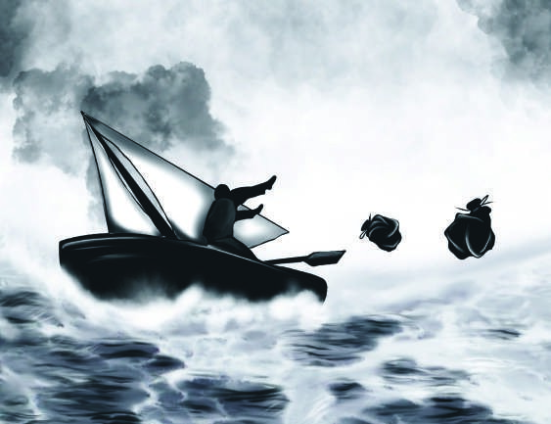

“I t hr ew my basket int o t he sea and list ened t o t he

gur gling sound as it sank.”

I then sailed away from the spot. The sea was calm, and I suddenly felt exhausted. I fixed the rudder and stretched myself at the bottom of the boat to take a short nap. Clouds hid the moon, and I heard only the sound of the boat as it cut through the waves. The murmur soothed me, and in a short time I was sound asleep.

When I awoke I found that the sun had already risen. The wind was blowing, and the waves threatened the safety of my little boat. I found that the wind had driven me far from the coast from which I had embarked. I tried to change my course but quickly found the boat was filling with water, blown in by the wind. My only option was to allow the boat to be driven on by the wind. I confess that I felt a few sensations of terror. I had no compass with me and I knew very little about the geography of this part of the world. It occurred to me that I might be driven out into the wide Atlantic and starve to death— or I might be swallowed up by the waters that roared around me. I had already been out many hours and felt the pain of a burning thirst. I looked up at the sky, which was covered by clouds; I looked upon the sea and felt that it might be my grave. “Fiend,” I exclaimed, “your task is already fulfilled!” I thought of Elizabeth, of my father, and of Henry—all left behind. The monster would be free to take his revenge on them.

Several more hours passed. Suddenly I saw a line of high land off in the distance. Tears of joy gushed from my eyes.

How changeable are our feelings, and how strange is that clinging love we have of life even in the excess of misery! I constructed another sail

with some of my clothing and eagerly steered my course towards the land. It had a wild and rocky appearance. However, as I drew nearer I noticed traces of cultivation. I even saw a few ships near the shore. Since I was exhausted, I decided to sail directly towards the town. I thought this would be a place where I could find something to eat. As I drew near I noticed a small town and a good harbor, which I entered, my heart bounding with joy at my unexpected escape.

As I was occupied in tying up the boat, several people crowded around. They seemed much surprised at my appearance, but instead of offering me any assistance, they whispered together with gestures that at any other time might have produced in me a slight sensation of panic. As it was, I merely remarked that they spoke English. I therefore addressed them in that language. “My good friends,” I said, “will you be so kind as to tell me where I am?”

“You will know that soon enough,” replied a man with a hoarse voice. “Maybe you are come to a place that will not prove much to your taste, but you will not be asked for your opinion as to your quarters, I promise you.”

cultivation: planting and raising of crops

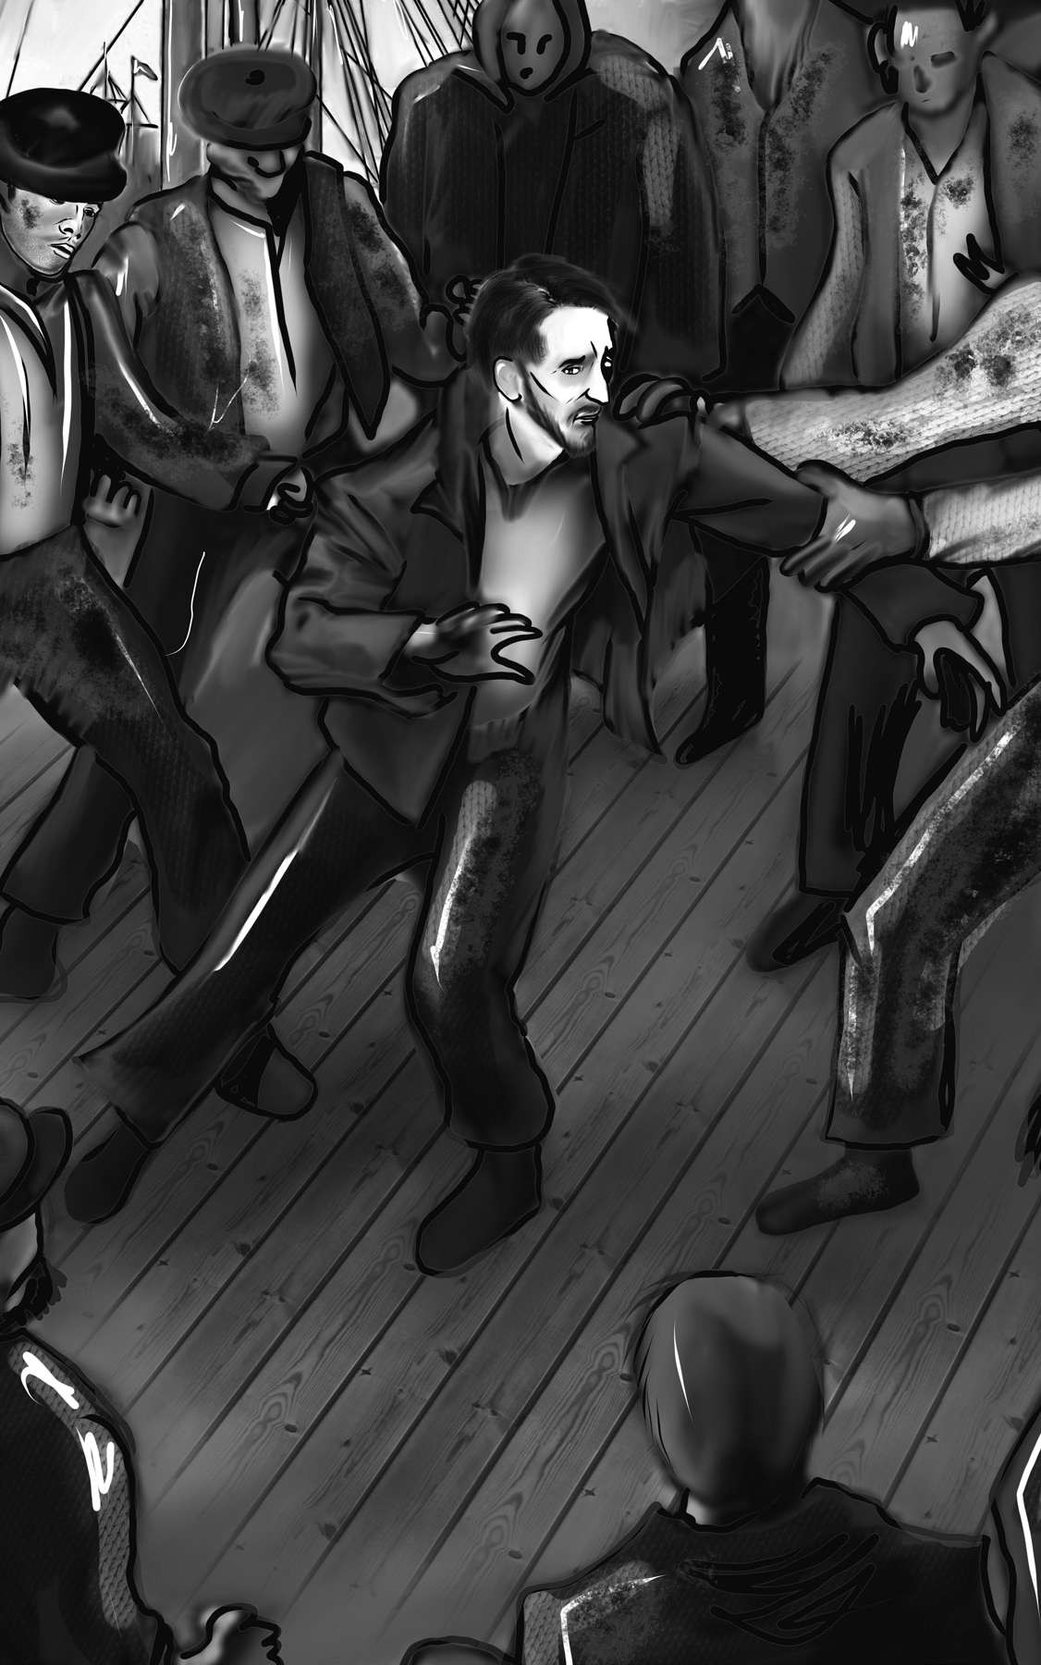

“As I was occupied in t ying up t he boat, sever al people

cr owded ar ound.”

I was surprised to receive such a rude answer from a stranger, and I was also concerned by the frowning and angry faces of his companions. “Why do you answer me so roughly?” I replied. “Surely it is not the custom of Englishmen to receive strangers so rudely?”

“I do not know,” said the man, “what the custom of the English may be, but it is the custom of the Irish to hate criminals.”

Then an unpleasant-looking man tapped me on the shoulder and said, “Come, sir! You must follow me to Mr. Kirwin’s to give an account of yourself.”

“Who is Mr. Kirwin? And why am I to give an account of myself? Is this not a free country?”

“Ay, sir, free enough for honest folks. Mr. Kirwin is a judge and you are to give an account of the death of a gentleman who was found murdered here last night.”

This answer startled me, but I presently recovered myself. I was innocent. That could easily be proved. I therefore followed the man in silence and was led to one of the best houses in the town. I was ready to pass out from fatigue and hunger, but being surrounded by a crowd, I thought it wise to gather all my strength, so that my fatigue would not be interpreted as nervousness or conscious guilt. I did not anticipate the disaster that was about to overwhelm me.

## CHAPTER 21

I

was soon introduced to the judge, an old benevolent man with calm and mild manners. He looked upon me with some degree of severity. Then he spoke to the men around me, asking them who appeared as witnesses on this occasion.

About half a dozen men came forward. The judge chose one of them, and he gave his testimony about what had happened. He stated that he had been out fishing the night before with his son and brother-in-law, Daniel Nugent. About ten o’clock, they observed a strong northerly blast rising, and they steered back into port. It was a very dark night, as the moon had not yet risen. They did not land at the harbor, but, as they often did, at a creek about two miles below. He walked on first, carrying some of the fishing equipment, and his companions followed him at some distance. As he was proceeding along the sands, he struck his foot against something and fell on the ground. His companions came up to assist him, and by the light of their lantern they found that he had fallen on the body of a man, who seemed to be dead. Their first thought was that it was the corpse of some person who had been drowned and thrown on shore by the waves. However, on examination they found that the clothes were not wet and the body was still warm. They carried it to the cottage of an old woman near the spot and tried to restore it to life. But all their attempts were in vain. It appeared to be a handsome young man, about twenty-five years of age. He had apparently been strangled, for there was no sign of violence except the black marks of fingers on his neck.

The first part of this testimony did not in the least interest me, but when the mark of the fingers was mentioned I remembered the murder of my brother and felt myself extremely nervous. My limbs trembled, and a mist came over my eyes. I was obliged to lean on a chair for support. The judge studied me closely and seemed to think my behavior was revealing.

The son confirmed his father’s account, but when Daniel Nugent was called he added an important detail. He swore that, just before the

in vain: unsuccessful

fall of his companion, he saw a boat, with a single man in it, at a short distance from the shore—and, as far as he could judge by the light of a few stars, it was the same boat in which I had just landed.

Next a woman was asked to give a statement. She stated that she lived near the beach and was standing at the door of her cottage, waiting for the return of the fishermen, about an hour before she heard of the discovery of the body. She also saw, at the same time, a boat with only one man in it push off from that part of the shore where the corpse was afterwards found.

Another woman stated that the fishermen had brought the body into her house. It was not cold. They put it into a bed and rubbed it, but life was quite gone.

Several other men were questioned concerning my landing. They agreed that, with the strong north wind that had arisen during the night, it was very likely that, due to the wind, I was unable to travel far and had been obliged to return to almost the same spot from which I had departed. Since the dead man was a stranger, they concluded that I had brought the body from some other place, deposited it, then sailed around in confusion in the darkness and put into the harbor, thinking it was a good deal farther from the place where I had deposited the corpse than in fact it was.

Mr. Kirwin, after hearing this evidence, desired that I should be taken into the room where the body lay for burial so they could see what effect the sight of it would produce upon me. This idea was probably suggested by the extreme nervousness I had exhibited when the mode of the murder had been described. I was accordingly led, by the judge and several other persons, to the inn. I could not help being struck by the strange coincidences that had taken place during this eventful night. However, knowing that I had been conversing with several persons on the island I had inhabited about the time that the body had been found, I was not worried about the outcome of the investigation.

I entered the room where the corpse lay and was led up to the coffin. How can I describe my sensations on seeing it? I gasped with horror; nor can I think about that terrible moment, even today, without shuddering. The questioning, the

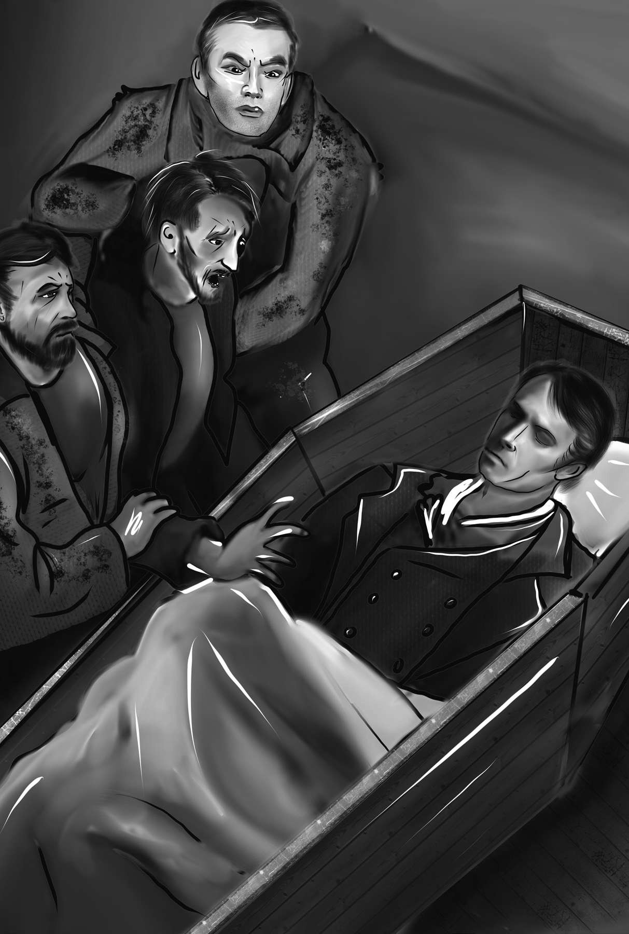

“I ent er ed t he r oom wher e t he cor pse lay and was led up t o

t he coffin.”

presence of the judge and witnesses, all of it passed like a dream from my memory when I saw the lifeless form of Henry Clerval stretched before me. I gasped for breath, and throwing myself on the body, I exclaimed, “Have I deprived you also, my dearest Henry, of life? Two I have already destroyed; other victims await their destiny; but you, Henry, my friend—”

My body could no longer support the suffering that I endured, and I was carried out of the room in strong convulsions.

I fell into a fever and lay for two months on the verge of death. My ravings, as I afterwards heard, were frightful. I called myself the murderer of William, of Justine, and of Henry. Sometimes I begged my attendants to assist me in the destruction of the fiend by whom I was tortured, and at others I felt the fingers of the monster grasping my neck and screamed aloud in terror. Fortunately, as I spoke my native language, Mr. Kirwin alone understood me, but my gestures and bitter cries were sufficient to frighten the other witnesses.

Why did I not die? More miserable than

convulsions: fi ts, uncontrollable muscle spasms

man ever was before, why did I not sink into forgetfulness and rest? Of what materials was I made that I could resist so many shocks?

But I was doomed to live and in two months found myself awaking as from a dream, in a prison, stretched on a wretched bed, surrounded by jailers and all the miserable equipment of a dungeon. It was morning, I remember, when I thus awoke to understanding. I had forgotten the details of what had happened and only felt as if some great misfortune had suddenly overwhelmed me. However, when I looked around and saw the barred windows and the filthiness of the room, it all came back to me and I groaned bitterly.

My groans disturbed an old woman who was sleeping in a chair beside me. She was a hired nurse, the wife of one of the turnkeys. Her face was hard and rude. It was the face of a person who is used to seeing misery without sympathizing. Her tone expressed complete indifference. She addressed me in English, and the voice struck me as one that I had heard during my sufferings.

“Are you better now, sir?” she asked.

I replied in the same language, with a very weak voice: “I believe I am. But if it be all true, if indeed I did not dream, I am sorry that I am still alive to feel this misery and horror.”

“For that matter,” replied the old woman, “if you mean about the gentleman you murdered, I believe that it would be better for you if you were dead, for I imagine it will go hard with you! However, that’s none of my business. I am sent to nurse you and get you well. I do my duty with a safe conscience. It would be good if everybody did the same.”

I turned with disgust from the woman, and my mind began to wander.

As the images that floated before me became more distinct, I grew feverish. There was no one near me who could soothe me with the gentle voice of love, no dear hand to support me. The physician came and prescribed medicines, and the old woman prepared them for me, but total carelessness was visible in the first, and the expression of brutality was strongly marked in the face of the second. Who could be interested in the fate of a murderer but the hangman who would gain his fee?

hangman: the executioner (who was paid a fee for killing

convicted persons)

These were my first reflections, but I soon learned that Mr. Kirwin had shown me great kindness. He had caused the best room in the prison to be prepared for me, and it was he who had provided a physician and a nurse. It is true, he seldom came to see me, for although he desired to relieve the sufferings of every human creature, he did not wish to endure the sufferings and miserable ravings of a murderer. He came, therefore, from time to time to see that I was not neglected, but his visits were short and infrequent.

One day, while I was gradually recovering, I was seated in a chair, my eyes half open and my cheeks red like those in death. I was overcome by gloom and misery and felt that death would be better than remaining in a world full of misery. Then I considered whether I should just declare myself guilty and suffer the penalty of the law. After all, I was less innocent than poor Justine had been. Such were my thoughts when the door of my apartment was opened and Mr. Kirwin entered. His face expressed sympathy and kindness. He

unaccountable: impossible to understand or explain incitement: encouragement, temptation

drew a chair close to mine and spoke to me in French.

“I fear that this place is very shocking to you.

Can I do anything to make you more comfortable?”

“I thank you, but all that you mention is nothing to me. On the whole earth there is no comfort which I am capable of receiving.”

“I know that the sympathy of a stranger can be but of little relief to one beaten down as you are by so strange a misfortune. But you will, I hope, soon be released, for I am confident that evidence can easily be brought to free you from the criminal charge.”

“That is my least concern. I have, as a result of a series of strange events, become the most miserable of human beings. Persecuted and tortured as I am and have been, can death be any evil to me?”

“Nothing indeed could be more unfortunate and unbearable than the strange chances that have lately occurred. You were thrown, by some surprising accident, on this shore, known for its hospitality, seized immediately, and charged with murder. The first sight that was presented to your eyes was the body of your friend, murdered in so unaccountable a manner and placed, as it were, by some fiend across your path.”

As Mr. Kirwin said these things, I was surprised at the knowledge he had concerning me. I suppose some of my astonishment was visible on my face, for he hurried to say, “As soon as you were taken ill, all the papers you had with you were brought me. I examined them so that I might discover some way to contact your relatives and send them an account of your misfortune and illness. I found several letters, including one from your father. I wrote immediately to Geneva. Nearly two months have passed since I sent my letter. But you are ill: even now, you shake. You are unfit for excitement of any kind.”

“This suspense is a thousand times worse than the most horrible news. Tell me what new scene of death has been acted! Let me know whose murder I am now to mourn!”

“Your family is perfectly well,” said Mr. Kirwin with gentleness, “and someone, a friend, has come to visit you.”

I know not by what chain of thought the idea

unaccountable: impossible to understand or explain

presented itself, but it darted into my mind that the murderer had come to mock me in my misery and taunt me with the death of Henry Clerval, as a way of forcing me to comply with his hellish desires. I put my hand before my eyes, and cried out in pain, “Oh! Take him away! I cannot see him! For God’s sake, do not let him enter!”

Mr. Kirwin regarded me with a troubled expression. He could not help regarding my exclamation as a presumption of my guilt and said in rather a severe tone, “I should have thought, young man, that the presence of your father would have been welcome instead of inspiring such violent hatred.”

“My father!” I cried, while every feature and every muscle relaxed from worry to pleasure. “Has my father really come? Oh, how kind! How very kind! But where is he? Why does he not come to me?”

My change of mood surprised and pleased the judge. Perhaps he thought that my initial exclamation was a momentary return of delirium. At any rate, he promptly resumed his former kindness. He rose and left the room with my nurse. A moment later my father entered.

Nothing, at that moment, could have given me greater pleasure than the arrival of my father. I stretched out my hand to him and cried, “Are you safe then?—and Elizabeth?—and Ernest?”

My father calmed me with assurances of their welfare. He did what he could to raise my spirits, but he soon felt that a prison cannot be the place of cheerfulness. “What a place is this that you inhabit, my son!” he said, looking mournfully at the barred windows and wretched appearance of the room. “You travelled to seek happiness, but death seems to pursue you. And poor Henry Clerval—”

The name of my friend was too much for me to endure in my weak state. I began to cry.

“Alas! Yes,” I replied. “Some horrible fate hangs over me.”

We were not allowed to talk for long. Mr. Kirwin came in and insisted that my strength should not be exhausted by too much exertion. But the appearance of my father was to me like that of my good angel, and I gradually recovered my health.

As my sickness left me, I grew miserable. The image of Henry Clerval was constantly before me, ghastly and murdered. More than once the nervousness into which these memories threw me made my friends fear a dangerous relapse. Alas! Why did they preserve so miserable and detested a life? It was surely so that I might fulfil my destiny, which is now drawing to a close. Soon—oh, very soon—death will extinguish these throbbing pains that come and go and relieve me from the mighty weight of suffering that crushes me.

After three months in prison, although I was still weak and in danger of a relapse, I was obliged to travel a hundred miles to the country town where trials were held. Mr. Kirwin had collected witnesses and arranged my defense. It was proved that I was on the Orkney Islands at the hour the body of my friend was found, and I was released from prison.

My father was delighted that I was free and able to return to my native country. I did not share these feelings, for to me the walls of a dungeon or a palace were equally hateful. The cup of life was poisoned forever. Although the sun shone upon me, I saw around me nothing but a thick and frightful darkness, with no light but the glimmer of two eyes that glared at me. Sometimes they were the expressive eyes of Henry, frozen by death. Sometimes they were the watery, clouded eyes of the monster, as I first saw them in my room at Ingolstadt.

My father talked of Geneva, and of Elizabeth and Ernest. But his words only drew groans from me. Sometimes, indeed, I felt a wish for happiness or a pang of homesickness. Most of the time, though, I simply lay in bed, sinking deeper and deeper into misery. In moments of despair I even thought of putting an end to my life. My father kept a close eye on me to make sure I did not try to kill myself.

Yet one duty remained to me, and when I remembered it I was able to overcome my selfish misery. It was necessary that I return without delay to Geneva in order to watch over the lives of those I loved and lie and guard them from the murderer. If any chance led me to him, or if he dared again to confront me, I might be able to kill him.

My father wanted to delay our departure. He worried that I was not healthy enough to make the journey. My strength was gone. I was a mere skeleton, and fever took over my wasted body.

Still, I was eager to leave Ireland, and my father eventually gave in. We boarded a ship bound for the French port of Le Havre and sailed with a fair wind from the Irish shores.

At midnight that night I lay on the ship’s deck. I looked at the stars and listened to the dashing of the waves. I greeted the darkness that shut Ireland from my sight, and my pulse beat with a feverish joy when I reflected that I should soon see Geneva. The past seemed a frightful dream, yet I knew it was no dream. Henry, my best friend, had fallen victim to me and the monster I had created. On that ship I ran through in my memory all the events of my life. I thought of my quiet happiness while residing with my family in Geneva, the death of my mother, and my departure for Ingolstadt. I remembered, shaking, the mad enthusiasm that hurried me on to the creation of my hideous enemy, and I called to mind the night when he came to life. I was unable to pursue the train of thought further. A thousand feelings pressed upon me, and I wept bitterly.

Towards morning I had a terrible nightmare. I felt the fiend’s grip on my neck and could not free myself from it. Groans and cries rang in my ears. My father was watching over me. He noticed my restlessness and woke me up. Then I saw the waves and the sky. The dashing waves were around me, the cloudy sky above me. The fiend was nowhere to be seen. A sense of forgetfulness came over me. I felt that a truce had been established between the present hour and the irresistible, disastrous future. And so we voyaged on.

truce: an agreement in which two sides agree to stop fi ghting

## CHAPTER 22

T

he voyage came to an end. We landed at Le Havre and made our way to Paris. I soon found that I had worn myself out and would need to rest before continuing my journey. My father took care of me. However, he did not know the real cause of my sufferings and therefore was not able to cure me of my melancholy. He encouraged me to go out and mingle with other people. I abhorred the face of man. Oh, no. It was not them that I abhorred! They were my brothers, my fellow beings, and I felt attracted to them, as to angelic creatures. But I felt that I had no right to share in their pleasures and joys. After all, I had unchained an enemy who stalked among them and delighted to shed their blood. If they had known of my unholy acts and crimes, they would have hated me and hunted me down.

My father thought that I might be suffering from wounded pride. He thought that I was still burning with pride and resentment over being brought to trial for murder, and he tried to prove to me the uselessness of pride.

“Alas! My father,” I said, “that is not what discourages me. Human beings would indeed be degraded if a wretch like me felt pride. Justine, poor unhappy Justine, was as innocent as I, and she suffered the same charge. She died for it, and I am the cause of this. I murdered her. William, Justine, and Henry—they all died by my hands.”

My father had often, during my imprisonment, heard me make the same statement. When I thus accused myself, he sometimes seemed to desire an explanation and sometimes seemed to consider my words as the result of delirium. I never spoke to him of the wretch I had created. I was sure that I would be taken for a madman if I did, and this in itself was reason enough to remain silent. But I had another reason too: I could not bring myself to reveal a secret which would fill him with worry and fear. Therefore, although I longed to share the fatal secret, I checked my desire to do so. Yet, from time to time, words like those I have mentioned would burst uncontrollably from me. I could offer no explanation for them, but the truthfulness of these confessions relieved some of my misery.

A few days before we left Paris for Switzerland,

I received the following letter from Elizabeth:

“My dear Friend,

“It gave me the greatest pleasure to receive a letter from my uncle, sent from Paris. You are no longer at a great distance, and I may hope to see you in less than a fortnight. Oh, how much you must have suffered! But I hope to see peace in your countenance and to find that your heart is not entirely a stranger to comfort and tranquility.

“Yet I fear that the same feelings now exist that made you so miserable a year ago. Perhaps, they may even have been increased by time. I would not disturb you at this time, when so many misfortunes weigh upon you. However, a conversation that I had with my uncle just before he left makes some explanation necessary before we meet.

“Explanation! You may possibly say: What can Elizabeth have to explain? If you really say this, my questions are answered and all my doubts satisfied. But you are distant from me, and I am not sure what you are thinking. I must tell you in this letter what, during your absence, I have often wished to tell you but have never had the courage to begin.

fortnight: fourteen days and nights (two weeks)

“You know, Victor, that our marriage has been the favorite plan of your parents ever since we were children. We were told this when young and taught to look forward to it as an event that would certainly take place. We were playmates during childhood, and, I believe, dear and valued friends to one another as we grew older. But as brother and sister often feel a lively affection for each other without desiring a closer union, may not such also be the case with us? Tell me, dearest Victor. Tell me honestly, for the sake of our future happiness—Do you not love someone else?

“You have travelled. You have spent several years of your life at Ingolstadt, and I confess to you, my friend, that when I saw you last autumn so unhappy, seeking only to be left alone, I could not help supposing that you might no longer enjoy my company. I thought that you might believe yourself bound in honor to fulfil the wishes of your parents, even if those wishes went against your own desires. I confess to you, my friend, that I love you and that in my airy dreams about the future you have been my constant friend and companion. But I desire your happiness as well as my own. That is why I feel I must tell you that our marriage would make me eternally miserable if it were unwelcome to you. I wish that it may occur only if it is what you wish. Even now I weep to think that, worn down as you are by cruel misfortunes, you might feel the need to give up, for the word *honor*, all hope of that love and happiness which would alone return you to yourself. I, who have such an affection for you, might increase your miseries tenfold by being an obstacle to your wishes. Ah! Victor, be assured that I have too sincere a love for you not to be made miserable by this supposition. Be happy, my friend—and if you obey me in this one request, know that nothing on earth will have the power to interrupt my peacefulness.

“Do not let this letter disturb you. Do not answer tomorrow, or the next day, or even until you come, if it will give you pain. My uncle will send me news of your health, and if I see but one smile on your lips when we meet, I shall need no other happiness.

tenfold: by a factor of ten, ten times over supposition: possibility, idea, notion

“Elizabeth Lavenza.

“Geneva, May 18th, 17—”

This letter revived in my memory what I had briefly forgotten—the threat of the fiend. “*I will be with you on your wedding-night!*” That was his promise! On that night he would employ every art to destroy me and tear me from happiness. Well, let him do his worst. If he attacked me, a deadly struggle would take place. If he were victorious in that struggle, I would be at peace and his power over me would be at an end. If he were vanquished, I would be a free man. But alas! What sort of freedom would I enjoy? The freedom a peasant enjoys when his family members have been massacred before his eyes, his cottage burnt, his lands laid waste, and he is turned out, homeless, penniless, and alone—but free. Such would be my liberty—except that in my Elizabeth I possessed a treasure, alas, balanced by those horrors of remorse and guilt which would pursue me until death.

Sweet and beloved Elizabeth! I read and reread her letter, and some softened feelings stole into my heart and stirred up dreams of love and joy.

But the apple was already eaten, and the angel’s arm raised to drive me from all hope. Yet I would die to make her happy. If the monster made good on his threat, death was unavoidable. Yet, again, I considered whether my marriage would hasten my fate. My destruction might indeed arrive a few months sooner, but if my torturer should suspect that I postponed it, influenced by his threats, he would surely find other and perhaps more dreadful means of revenge. He had vowed *to be with me on my wedding-night*, yet he did not consider that threat as binding him to peace in the meantime. This was clear, for he had murdered poor Henry immediately after the making this threat. I decided, therefore, that if my immediate union with Elizabeth would make her or my father happy, I would be married. I would not allow my enemy’s plotting against my life to delay it for even a single hour.

In this state of mind I wrote to Elizabeth. My letter was calm and affectionate. “I fear, my beloved girl,” I said, “little happiness remains for us on earth. Yet all that I may one day enjoy is

apple: Frankenstein refers to the Biblical story: after Adam and Eve eat the “forbidden” apple, they are expelled from Eden by an angel.

centered in you. Chase away your idle fears. To you alone I dedicate my life and my energies. I have only one secret, Elizabeth, but it is a dreadful one. When I reveal it to you, it will horrify you. Then, far from being surprised at my unhappiness, you will only wonder that I have survived what I have endured. I will share this tale of gloom and terror with you the day after we are married, for there must be no secrets between us. But until then, please, do not mention it. This I ask of you, and I know you will agree.”

About a week after the arrival of Elizabeth’s letter we returned to Geneva. Elizabeth welcomed me with warm affection. Yet tears flowed from her eyes when she saw my wasted body and feverish cheeks. I saw a change in her also. She was thinner and had lost much of that heavenly vivacity that had charmed me. However, her gentleness and soft looks of compassion made her a more fit companion for one blasted and miserable as I was.

The calm which I briefly enjoyed did not last. Memory brought madness with it, and when I thought of what had passed, a real insanity possessed me. Sometimes I was furious and burned with rage. Sometimes I was low and depressed. In my low moods, I did not speak to anyone or even look at anyone. Instead, I sat motionless, overwhelmed by miseries.

Elizabeth alone had the power to draw me from these fits. Her gentle voice would soothe me when I was transported by passion and inspire me with human feelings when I was sunk in inactivity. She wept with me and for me. When reason returned, she would speak with me and urge me to accept my fate. Ah! It is well for the unfortunate to accept one’s fate, but for the guilty there is no peace. The pain of guilt poisons even the pleasures of grief.

Soon after my arrival, my father spoke of my immediate marriage with Elizabeth. I remained silent. “Have you, then, some other attachment?”

“None on earth. I love Elizabeth and look forward to our marriage with delight. Let the day therefore be set. On that day I will dedicate myself, in life or death, to the happiness of my cousin.”

“My dear Victor, be cheerful! Heavy misfortunes have befallen us, but let us respond by clinging closely to what remains. Let us transfer our

attachment: romantic connection, relationship

love for those we have lost to those who yet live. Our circle will be small, but it will be bound close by the ties of affection and mutual misfortune. And in time new and dear objects of care will replace those we have lost.”

Such were the lessons of my father. But I could not forget about the creature and his threat. He had pronounced the words “*I will be with you on your wedding-night,*” and I regarded my fate as unavoidable. But death was no evil to me if the loss of Elizabeth were set in the other scale. I therefore, with a contented and even cheerful appearance, agreed with my father that, if my cousin would consent, the ceremony should take place in ten days. In this way I put, as I imagined, the seal to my fate.

Great God! If for one instant I had thought what might be the hellish intention of my fiendish enemy, I would never have agreed to marry. I would have banished myself for ever from my native country and wandered over the earth, a friendless outcast. But it was as if my enemy had magic powers and blinded me to his real intentions. I thought that I had set the stage for my own death and only that. In fact, however, I had hurried the death of a far dearer victim.

As the day of our marriage drew nearer, I felt my heart sink within me. I do not know why. Perhaps it was fear—or perhaps I had a prophetic feeling. In any case, I concealed my feelings and pretended to be cheerful. This brought smiles and joy to the face of my father, but it did not fool Elizabeth. She looked forward to our marriage with happiness, but also with a little fear. She knew from past misfortunes that what seemed certain and tangible happiness might suddenly disappear and leave no trace but deep and everlasting regret.

Preparations were made for the wedding. Congratulatory visits were paid, and everyone seemed happy. I shut up, as well as I could, in my own heart the worries that haunted me and entered with seeming earnestness into the plans of my father. Through my father’s efforts a part of the inheritance of Elizabeth had been restored to her by the Austrian government. A small house on

prophetic: predicting the future, as prophets do tangible: real, able to be touched and felt

inheritance: money or goods passed down to a person from

parents or relatives who have died

the shores of Lake Como belonged to her. It was agreed that, immediately after our marriage, we should proceed to the Villa Lavenza and spend our first days of happiness on the shores of Lake Como.

In the meantime I prepared myself, in case the fiend should attack me. I carried pistols and a dagger and was constantly on guard. These precautions made me feel safer. Indeed, as our wedding day approached, the threat began to seem more like a delusion, not worthy to disturb my peace. I began to think of the happiness I hoped for in my marriage as something no accident could prevent.

Elizabeth was generally happy in the weeks preceding our wedding, but on the day of the wedding, she suddenly felt depressed. She seemed to have a presentiment of evil. Perhaps she was thinking of the dreadful secret I had promised to reveal to her the day after our wedding. My father did not notice the change in her. He was overjoyed, and, in the bustle of preparation, only recognized in the sadness of his niece the shyness of a bride.

delusion: something not real, a fantasy

presentiment: a feeling of concern before something happens

After the ceremony was performed, a large party was held at my father’s, but Elizabeth and I did not attend. It had been agreed that we would begin our journey by water, sleeping that night at Evian and continuing our voyage on the next day. The day was fair, the wind favorable. All smiled as we set off on our own.

Those were the last moments of my life in which I enjoyed happiness. We passed rapidly along. I took Elizabeth’s hand and spoke to her: “You seem sad, my love.”

“Oh, my dear Victor,” Elizabeth replied. “My heart is contented, but something whispers to me not to depend too much on the happy prospect that is opened before us. I know not why I feel this way! It is such a divine day! How happy and peaceful everything in nature appears!”

The wind, which had carried us rapidly along, sank at sunset to a light breeze. The soft air just ruffled the water and caused a pleasant motion among the trees as our boat approached the shore. From the land wafted the most delightful scent of flowers and hay. The sun sank beneath the horizon

wafted: drifted

as we landed, and as I set foot on the shore I felt those cares and fears come back which soon were to clasp me and cling to me forever.

## CHAPTER 23

I

t was eight o’clock when we landed. We walked for a short time on the shore, enjoying the fading light. Then we made our way to the inn.

The wind now began to blow with great violence. The clouds swept across the sky swiftly. Suddenly a heavy storm of rain swept in.

I had been calm during the day, but as soon as night came, a thousand fears arose in my mind. I was worried and watchful. With my right hand I kept hold of the pistol which was hidden in my coat. Every sound terrified me, but I resolved that I would not shrink from the conflict until either I destroyed him or he destroyed me.

Elizabeth observed my nervousness for some time in timid and fearful silence, but there was something in my glance which communicated terror to her.

“What is it that worries you, my dear Victor? What is it you fear?”

Suddenly I thought about how fearful the

shrink from: avoid, run away from something in a cowardly way

combat which I expected at any moment would be to my wife, and I urged her to go back to the room. I decided I would not join her until I had obtained some knowledge as to the situation of my enemy.

She left me, and I passed some time walking up and down the hallways of the house and inspecting every corner that might provide a hiding place to my enemy. But I found no trace of him. I was beginning to think that some stroke of good luck had occurred and prevented the monster from keeping his promise when suddenly I heard a high-pitched and dreadful scream. It came from our bedroom. The second I heard it, the whole truth rushed into my mind. My arms dropped. The motion of every muscle was suspended. I could feel the blood pulsing in my veins and tingling in my fingertips and toes. This lasted only an instant. The scream was repeated, and I rushed to our room.

Great God! Why did I not die on the very spot! Why am I still here to describe the destruction of the best and purest creature on earth? Elizabeth was there, lifeless and still, thrown across the bed. Her head was hanging down and her pale and distorted features were half covered by her hair.

Everywhere I turn I see the same figure— her bloodless arms and lifeless form flung by the murderer on the bed. Could I look at this and continue to live? Alas! Life is stubborn and clings closest where it is most hated. For a moment I lost consciousness. I fell senseless on the ground.

When I recovered, I found myself surrounded by the people of the inn. They were afraid, but I was in despair. I escaped from them to the room where lay the body of Elizabeth—my love, my wife, so lately living, so dear, so worthy. She had been moved from the position in which I had seen her. She lay with her head upon her arm and a handkerchief laid across her face and neck. One might have guessed she was asleep. I rushed to her and embraced her, but the coldness of the limbs told me that what I now held in my arms had ceased to be the Elizabeth whom I had loved and cherished. The murderous mark of the fiend’s grasp was visible on her neck, and the breath had ceased to come from her lips.

distorted: twisted out of shape

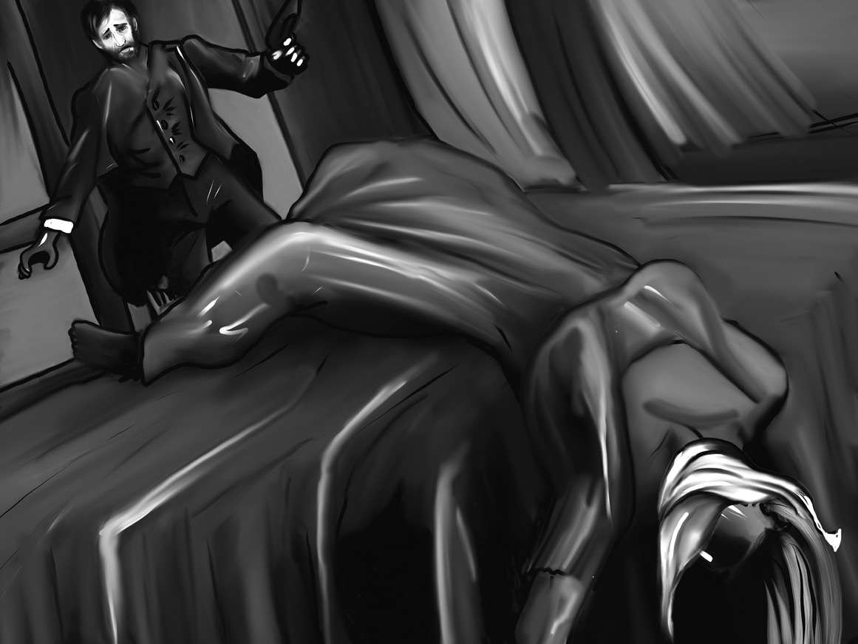

“She lay wit h her head upon her ar m and a handker chief laid acr oss her face and neck.”

While I still hung over her in an agony of despair, I happened to look up. The shutters had been thrown back, and with a sensation of horror not to be described, I saw at the open window a hideous figure. It was the monster! He had a horrible grin on his face. He seemed to be laughing at me. With his fiendish finger he pointed towards the corpse of my wife. I rushed towards the window and drew my pistol. I fired at him, but he escaped from me. He leaped down and, running with the swiftness of lightning, plunged into the lake.

The sound of the pistol shot brought a crowd into the room. I pointed to the spot where he had disappeared, and we tried to follow him with boats, but in vain. After an hour, we returned.

Back on land, my head whirled round, and my steps were like those of a drunken man. I fell down at last, in a state of utter exhaustion. A film covered my eyes, and my skin was parched with the heat of fever. In this state I was carried back to the inn and placed on a bed, hardly conscious of what had happened. My eyes wandered around the room as if looking for something that had been lost.

After a while I arose and, as if by instinct, crawled into the room where the corpse of my beloved lay. There were women weeping around. I hung over the body and joined my sad tears to theirs. I reflected confusedly on my misfortunes. The death of William, the execution of Justine, the murder of Henry, and lastly of my wife. And I could not say that my remaining friends were safe from the fiend. My father might be writhing under his grasp, and Ernest might be lying dead at his feet. These thoughts made me shudder and recalled me to action. I decided to return to Geneva at once.

There were no horses available. I would have to return by boat. The wind was unfavorable, and the rain fell in torrents. But speed was essential. It was early morning, and I thought I might be able to arrive by night. I hired men to row and took an oar myself, for I had always found relief from worries in bodily exercise. But the sadness I felt was too much for me. The stress I had endured left me with no energy. I put down the oar, and leaning my head upon my hands, gave way to every gloomy idea that arose. Tears streamed from my eyes. The sun might shine, but nothing could appear to me as it had the day before. A fiend had snatched from me every hope of future happiness. No creature had ever been as miserable as I was. So frightful an outcome must be unique in the history of man.

But why should I continue to explain all of these details? I will only say that, one by one, my friends were snatched away from me. I was left alone in the world. My own strength is exhausted, and I must tell, in a few words, what remains of my hideous story.

unique: one of a kind

I arrived at Geneva. My father and Ernest were still alive, but the former sank under the news that I brought. His eyes wandered in vacancy, for they had lost their charm and their delight. He had lost Elizabeth, whom he loved and doted on. Cursed, cursed be the fiend that brought such sadness on his grey hairs and doomed him to waste away in wretchedness! He could not go on living with the horrors that had piled up around him. The springs of existence suddenly gave way. He was unable to rise from his bed, and in a few days he died in my arms.

What then became of me? I know not. I lost consciousness, and chains and darkness were the only objects that pressed upon me. Sometimes I dreamed that I wandered in flowery meadows with the friends of my youth, but I awoke and found myself in a dungeon. Depression followed, but by degrees I gained a clear understanding of my miseries and situation and was then released from my prison. For they had called me mad, and for many months, as I understood, a single cell had been my home.

Liberty, however, had been a useless gift to me, had I not, as I awakened to reason, at the same time awakened to revenge. As the memory of past misfortunes pressed upon me, I began to think about their cause. The cause of my miseries was the monster I had created, the miserable creature I had sent out into the world. I was possessed by a maddening rage when I thought of him. I desired—and passionately prayed—that I might have him within my grasp to wreak my revenge on his cursed head.

I began to reflect on the best means of capturing him, and for this purpose, about a month after my release, I went to see to a judge in the town. I told him that I knew who had killed my family membes, and that I demanded that he arrest the murderer. He listened to me with attention and kindness. “Be assured, sir,” said he, “I will do everything in my power to find the villain.”

“I thank you,” I replied. “Listen, therefore, to the statement I have to make. It is a very strange tale—so strange, indeed, that I would be afraid you would not believe it were there not something

possessed: controlled, taken over by

in the truth that leads people to believe. The story is too connected to be mistaken for a dream, and I have no reason to lie.” My manner as I thus addressed him was impressive but calm. I had decided to pursue my destroyer to death, and this purpose eased my suffering and for a while made life more tolerable. I told him my history briefly but with firmness and precision, marking the dates with accuracy and never ranting or shouting.

The magistrate appeared at first perfectly incredulous, but as I continued he became more attentive and interested. I saw him sometimes shudder with horror. In other moments a lively surprise was visible on his countenance.

When I had finished, I said, “This then is the being whom I accuse. This is the creature I ask you to pursue and arrest. It is your duty as a judge.”

These final sentences caused a noticeable change in my listener. He had heard my story with that sort of half-belief that is given to tales of ghosts and supernatural events. However, when he was called upon to take official action on the matter, his disbelief returned.

incredulous: unwilling to believe in something

“I would willingly aid you in your pursuit,” he said, “but the creature of whom you speak appears to have powers that would defeat all of my attempts. Who can follow an animal that can travel rapidly over snow and ice and survive in caves? Besides, several months have passed since he committed the crimes you have described, and it is impossible to say where he might be now.”

“I have no doubt that he is near me—or, if he has taken shelter in the mountains, he may still be hunted, as men hunt for antelope. But I can see what you are thinking. You do not believe what I have said is true and do not intend to pursue my enemy.”

As I spoke, anger sparkled in my eyes. The judge was intimidated. “You are mistaken,” he said. “I will do what I can for you, and if it is in my power to capture the monster, I assure you that he will be punished for his crimes. But I fear, from what you yourself have told me, that this will prove impossible. Every proper measure will be pursued, I assure you. But you must be prepared for disappointment.”

intimidated: feeling timid, or pressured

“That is the one thing I cannot accept. And yet it is clear that nothing I might say here would be likely to change your mind. My revenge is of no importance to you. It is of great importance to me, however. I grant that the pursuit of revenge is evil. And yet I must I confess that revenge is, at the moment, the great passion of my soul. It angers me that this murderer, whom I have turned loose upon society, still exists. You refuse my just demand. I must therefore rely on my own powers. I will devote my remaining energies to his destruction.”

I trembled as I said this. There was a frenzy in my manner. I felt some of that haughty fierceness which the martyrs of old possessed. But to a Genevan judge, whose mind was occupied with ideas very different than those of devotion and heroism, my fierceness looked like madness. It was clear that he regarded my accusations as the ravings of a delirious man, and he tried to soothe me as a nurse does a child. I stormed out of his office in furious anger.

haughty: arrogant, disdainful

martyrs: people who suff er and/or die for a cause

## CHAPTER 24

M

y situation was one in which all voluntary thought was swallowed up and lost. I was hurried along by intense anger. Revenge alone provided me with strength and self-control. It shaped my feelings and allowed me to be clever and calm at times when delirium or death would otherwise have been my fate.

The first decision I made was to leave Geneva forever. My country, which I had loved, had become a hateful place. I gathered up some money, along with a few jewels that had belonged to my mother, and departed.

I have been wandering ever since. I have crossed a vast portion of the earth and have endured many hardships. How I have lived I hardly know. Many times have I stretched my failing arms and legs upon the sandy plain and prayed for death. But revenge has kept me alive. I dared not die and leave my enemy among the living.

The night I left Geneva, I passed the cemetery where William, Elizabeth, and my father were buried. I entered and found it silent, except for the leaves of the trees, which were gently stirred by the wind. At first I grieved, but in a short while my grief gave way to rage. My family members were dead, but their murderer still lived. To destroy him I felt I must drag out my own weary existence. I knelt on the grass and swore an oath: “By the sacred earth on which I kneel, by the deep and eternal grief that I feel, I swear to pursue the demon who has caused this misery, until he or I shall die in mortal conflict. For this purpose I will preserve my life. To execute this dear revenge I will continue to walk the earth, which otherwise is of no interest to me. And I call on you, spirits of the dead, and on you, wandering ministers of revenge, to aid and guide me in my work! Let the cursed and hellish monster feel the misery that now torments me!” I had begun speaking solemnly and calmly. However, as I went on I grew more and more furious until I was almost choking with rage.

I was answered through the stillness of night by a loud and fiendish laugh. It rang in my ears. The mountains re-echoed it, and I felt as if all the inhabitants of hell stood around me, mocking and laughing. The laughter died away. Then a wellknown and hated voice, apparently close to my ear, addressed me in an audible whisper, “I am satisfied, miserable wretch! You have decided to live, and I am satisfied.”

I darted towards the spot from which the sound seemed to come, but the devil escaped my grasp. The broad disk of the moon shone full upon his ghastly and distorted shape as he ran away with more than human speed.

I pursued him, and for many months this has been my task. Guided by a slight clue, I followed the windings of the Rhone, but in vain. The blue Mediterranean appeared, and by a strange chance, I saw the fiend hide himself in a ship bound for the Black Sea. I took passage in the same ship, but he escaped, I know not how.

the Rhone: a river that fl ows through France

Amidst the wilds of Tartary and Russia, although he still evaded me, I have followed in his tracks. Sometimes the peasants, scared by this horrible creature, informed me of his path. Sometimes he himself left some mark to guide me. The snows descended on my head, and I saw his huge footprints on the white plain. You who are just entering into life, you to whom care is new and misery unknown, how can you understand what I have felt and still feel? Cold, want, and fatigue— these were the least of the pains which I was destined to endure. I was cursed by some devil and I carried about with me my own eternal hell. Yet still a spirit of good followed and directed my steps and, when things seemed most hopeless, this spirit would find some surprising way to save me. Sometimes, when my body, overcome by hunger, sank in exhaustion, a meal was prepared for me in the desert that restored me and lifted my spirits. The meal was a simple one, such as the peasants of the country ate, but I do not doubt that it was set there by the spirits that I had called on to aid me. Often, when all was dry and I was parched by

Tartary: land of the Tatar people, roughly between India and

Russia



“Amidst t he wilds of Tart ary and Russia, alt hough he st ill

evaded me, I have followed in his t r acks.”

thirst, a slight cloud would darken the sky, shed a few drops to revive me, and then vanish.

I followed, when I could, the courses of the rivers, but the creature generally avoided these, as it was there that people chiefly collected. In other places human beings were seldom seen, and I had to survive on the wild animals that crossed my path. I had money with me and gained the friendship of the villagers by giving much of it away. Sometimes I bought food and shared it with those who had provided me with fire and utensils for cooking.

This way of living was hateful to me, and it was during sleep alone that I could taste joy. O blessed sleep! Often, when most miserable, I fell asleep and was relieved by happy dreams. The spirits that guarded me sent me these dreams so that I could retain the strength needed to fulfill my purposes. Without these periods of rest, I would have sunk under my hardships. During the day I was sustained and inspired by the hope of night, for in my dreams I saw my friends, my wife, and

want: the condition of lacking things that one desires or needs

my beloved country. I saw the kind face of my father, heard the silver tones of my Elizabeth’s voice, and saw Henry enjoying health and youth. At such moments revenge died in my heart, and I pursued the demon more as a task given to me by heaven than as the passionate desire of my soul.

What his feelings were whom I pursued I cannot know. Sometimes he left marks in writing on the bark of trees that stirred up my anger. “My reign is not yet over” he wrote on one tree. “Follow me,” he wrote on another. “I seek the everlasting ices of the north, where you will feel the misery of cold and frost, which do not bother me. You will find near this place, if you are not to slow, a dead rabbit. Eat and be refreshed. Come on, my enemy! Someday we will wrestle for our lives, but you must endure many hard and miserable hours before that can happen!”

Scoffing devil! I will be revenged! Never will I give up my search until you or I die! Then with what joy shall I join my Elizabeth and my departed friends, in the life to come!

scoffi ng: making fun of, taunting

As I made my way north, the snows thickened and the temperature dropped. The peasants were shut up in their hovels, and only a few of the most hardy came out to hunt. The rivers were covered with ice, so no fish could be obtained.

Whatever made my life more difficult or painful gave pleasure to my enemy. One message that he left for me read, “Prepare! Your suffering has only just only begun! Wrap yourself in furs and gather supplies, for we shall soon begin a journey to a land where your suffering may be great enough to satisfy my hatred.”

These scoffing words only made me more angry and more determined. I swore that I would not fail in my purpose and called on Heaven to support me. I continued to travel across deserted lands. I purchased a sledge and a team of dogs and learned to drive my sledge across the snows at great speed.

Eventually I arrived at a wretched little town on the seashore. I asked if the fiend had been there and gained some information. A gigantic monster,

hardy: sturdy, healthy

they said, had arrived the night before, armed with a rifle and many pistols. Those who had seen him had run away in fear. He had then carried off their food and placed it in a sledge. The next day he harnessed his dogs and continued his journey, passing onto the frozen sea. He was traveling, however, in a direction that led to no land. They were therefore sure that he would speedily be destroyed by the breaking of the ice or frozen by the eternal frosts.

On hearing this, I suffered a brief period of despair. The creature had escaped me on land, and I would have to chase him across the frozen ocean. As the native of a sunny climate, I could not hope to survive for many weeks in such frigid weather. Yet I could not bear to think that my enemy might live and be triumphant. Soon my rage and my desire for revenge returned, and like a mighty tide, overwhelmed every other feeling. After a short pause, during which the spirits of the dead seemed to hover round and call on me to pursue my revenge, I prepared for my journey.

hover: fl oat above

I exchanged my land-sledge for one equipped for traveling on the rougher surface of the frozen ocean and purchased supplies. Then I turned my back on the land and drove my sledge out onto the frozen ocean.



Since then I have endured terrible misery, and only my desire for revenge has kept me from giving up.

For three weeks I saw nothing but snow and ice. Then one day I caught sight of a dark speck upon the icy plain. I squinted to see what it could be. I made out a sledge and the misshapen body of my enemy. I uttered a wild cry of joy. Warm tears filled my eyes, which I hastily wiped away, that they might not block the view I had of the demon. I drove the dogs onward. The creature’s sledge was still visible in the distance, and I began to gain on it little by little. After a few hours of chase, I was less than a mile behind him, and my heart bounded within me.

Just when I seemed to be on the verge of catching up with my enemy, my hopes were suddenly extinguished. Unfrozen waters rolled and swelled beneath the ice, and, with a terrible roar, the sheet of ice on which I was traveling cracked and split. A ribbon of open water appeared, first in front of me and then beside me. In a few minutes a wild sea was rolling between me and my enemy. I was left drifting on a piece of ice. I was trapped— and I could see that the piece of ice on which I was floating was being gradually worn away on all sides, threatening me with a hideous death.

In this manner many dreadful hours passed. Several of my dogs died, and I myself was about to give up all hope when I caught sight of your ship. This gave me hope. I had no idea that ships ever sailed so far north and was amazed at the sight. I destroyed part of my sledge and used the wood to construct oars. I then used the oars to move my ice raft in the direction of your ship.

I had decided, if you were heading south, still to trust myself to the mercy of the seas rather than abandon my purpose. I hoped to persuade you to give me a boat with which I could pursue my enemy. But you were headed north—and you took me on board when my energy was exhausted. Had you not done so, I would soon have sunk under my hardships into a death which I still dread, for my task is unfulfilled.

Oh! When will the guiding spirit that leads me to the demon allow me the rest I need? Or must I die while he yet lives? If I do die, swear to me, Walton, that you will do what you can to see that he does not escape. I will not ask you to chase him and endure the hardships that I have undergone. No; I am not so selfish. Yet, when I am dead, if he should appear, if the ministers of revenge should bring him to you, swear that he shall not live— swear that he shall not triumph over my many sorrows and survive to add to the list of his dark crimes. He is eloquent and persuasive, and once his words even had power over my heart, but do not trust him. His soul is as hellish as his form, full of trickery and hatred. Hear him not! Call on the names of William, Justine, Henry, Elizabeth, my father, and of the wretched Victor Frankenstein, and thrust your sword into his heart.

Walton, in continuation.

August 26th, 17—.

Well, you have read this strange and terrifying story, Margaret, and do you not feel your blood freeze with horror? I was terrified to hear it. Sometimes, seized with sudden agony, Frankenstein could not continue his tale. Sometimes his voice sounded broken, yet it could also be piercing. His fine and lovely eyes sometimes shone with anger, but at other times they seemed sad and sorrowful. Sometimes he managed to keep control of himself and related the most horrible incidents with a calm, controlled voice. But then, like a volcano bursting forth, his face would suddenly change to an expression of the wildest rage as he called down curses on his enemy.

His tale seemed to me to be true when he told it, but I will admit that the letters of Felix and Safie, which he showed me, and the sighting of the monster by men on our ship, convinced me of the truth of his story more than his claims alone could have. It seems, then, that such a monster really exists! I cannot doubt it, yet I am lost in surprise and astonishment. Sometimes I tried to get from Frankenstein some details about what the creature looked like and what materials he was made of, but he would never give me any.

“Are you mad, my friend?” he said. “Or where does your senseless curiosity lead you? Would you also create for yourself and the world a terrible enemy? Peace, peace! Learn from my miseries and do not seek to increase your own.”

Frankenstein discovered that I had made notes concerning his history. He asked to see them and then corrected and added to them in many places, but mainly in giving life and spirit to the conversations he had with his enemy. “Since you have preserved my story,” he said, “I should look it over. I would not want to leave the world with an incorrect version of events.”

A week had passed while I listened to Frankenstein’s tale—the strangest tale I have ever heard. I am fascinated by Frankenstein himself. I wish to soothe his troubled spirits, but I am not sure it will be possible to do this. Can I comfort a man so miserable and so hopeless? I don’t think I can. The only joy that he can achieve now will be when he composes his shattered spirit to accept death and the peace that comes with death. And yet there is one thing that comforts him still. In his dreams he sometimes talks with his friends, and he believes that the spirits with whom he speaks are not merely the creations of his imagination, but real beings who visit him from the regions of some remote world. This faith gives a seriousness to his dreams and makes them almost as interesting to me as truth.

Our conversations are not always confined to his own history and misfortunes. We sometimes discuss books and literature. On those subjects he displays remarkable knowledge. His eloquence is forcible and touching, and his stories often leave me with tears in my eyes. What a glorious creature he must have been earlier in life, if he is so noble and godlike in ruin! He seems to feel his own worth—and the greatness of his fall.

“When I was younger,” he told me, “I believed myself destined for some great achievement. My feelings are deep, but I possessed a coolness of judgment that fitted me for great achievements. This sense of my own powers supported me when others would have been discouraged, for I deemed it criminal to throw away in useless grief talents that might be useful to my fellow creatures. When I thought about the work I had completed, I could not rank myself with the herd of common schemers. After all, I had created a sensitive and rational animal. But this thought, which supported me in the early part of my career, now serves only to plunge me lower in the dust.

“My imagination was vivid, and my powers of analysis were considerable. In addition, I was very dedicated to my studies. By the union of these qualities I not only came up with the idea but also executed the creation of a living creature. While I was at work on the project, I was inspired by dreams. I delighted in my powers. From my infancy I was full of high hopes and lofty ambition. But how I have sunk! Oh! My friend, if you had known me as I once was, you would not recognize me in my current condition. In those days, I was almost never discouraged or depressed. A high destiny seemed to drive me on—until I fell, never again to rise.”

Must I then lose this admirable being? I have longed for a friend. I have looked for someone who would sympathize with and love me. On these empty seas I have found such a one, but I fear I have gained him only to know his value and lose him. I have tried to convince him of the value of living, but I do not think I have succeeded.

“I thank you, Walton,” he said the other day, “for your kind intentions towards so miserable a wretch. But when you speak of new ties and fresh affections, do you think that any can replace those who are gone? Can any man be to me what Henry Clerval was? Can any woman be to me another Elizabeth? The companions of our childhood always possess a certain power over our minds, which hardly any later friend can obtain. They know us. They understand us. I had wonderful friends, and they are with me still. Wherever I am, the soothing voice of my Elizabeth and the conversation of Henry Clerval will be ever whispered in my ear. They are dead, and I have only remained among the living for one reason. I must pursue and destroy the being to whom I gave existence. Then my purpose will be fulfilled and I may die.”

My beloved Sister, September 2nd.

We are in great danger. I do not know whether I will ever see England again. I am surrounded by great mountains of ice which leave us no way to escape and threaten every moment to crush the ship. The brave fellows whom I have persuaded to be my companions look towards me for help, but I have none to give them. There is something terrible about our situation. It is terrible to reflect that the lives of all these men are endangered because of me. If we are lost, my mad schemes are the cause.

And what, Margaret, will be the state of your mind? If I am lost, you will not hear of my destruction, and you will nervously await my return. Years will pass, and you will experience periods of hopelessness. Oh! My beloved sister, the thought of you suffering in this way is more terrible to me than the possibility of my own death.

But you have a husband and lovely children. You may be happy. Heaven bless you and make you so!

My unfortunate guest regards me with the tenderest compassion. He tries to fill me with hope and talks as if life were a possession he valued. He reminds me how often the same accidents have happened to others who have explored this sea, and in spite of myself, he fills me with cheerful thoughts. Even the sailors feel the power of his words. When he speaks, they no longer despair. He rouses their energies, and while they hear his voice they believe these vast mountains of ice are mole-hills which will vanish before the

determination of man. But these feelings are shortlived. Each new day fills them with new fears, and I almost dread a mutiny caused by this misery.

September 5th.

A scene has just passed of such unusual interest that I cannot keep from recording it here. I do so even though it is likely that these papers will never reach you.

mutiny: a rebellion of sailors against their captain

We are still surrounded by mountains of ice, and still in danger of being crushed by them. The cold is excessive, and many of my unfortunate comrades have already died. Frankenstein has daily declined in health. A feverish fire still glimmers in his eyes, but he is exhausted. We are able to wake him up, but he speedily sinks back into apparent lifelessness.

I mentioned in my last letter the fears I entertained of a mutiny. This morning, as I sat watching the pale face of my friend—his eyes half closed and his limbs hanging listlessly—I was visited by half a dozen of the sailors, who demanded I let them into the cabin. They entered and their leader addressed me. He told me that he and the men with him had been chosen by the other sailors to make a request which, in justice, I could not refuse. We were surrounded by ice and would probably never escape. But the men were worried about what might happen if the ice broke up and released the ship. They feared that if this occurred, I would be reckless enough to continue my voyage and lead them into fresh dangers. They insisted, therefore,

listlessly: without energy

that I promise them that if the ship should be freed I would turn it around and sail south.

This speech troubled me. I had not given up, nor had I yet considered the possibility of returning if set free. Yet could I, in justice, refuse this demand? I hesitated before I answered, and Frankenstein surprised me by speaking up. He had been silent, and indeed appeared hardly to have the energy to pay attention. But now he stirred himself. His eyes sparkled, and his cheeks flushed with temporary energy. Turning towards the men, he said, “What do you mean? What do you demand of your captain? Are you, then, so easily turned from your design? Did you not call this a glorious voyage? And why was it glorious? Because it was full of dangers and terror. It was a glorious voyage because with each new incident your strength was to be called forth and your courage exhibited. It was glorious because danger and death surrounded it, and these you were to brave and overcome. These are the reasons why it was a glorious undertaking. If successful, you would be praised as brave men who risked death for honor and for the benefit of mankind.

And now, at the first hint of danger, in the first trial of your courage, you shrink away. Now you are content to be remembered as men who had not strength enough to endure cold and danger— *and so, poor souls, they were chilly and returned to their warm firesides*! You need not have come this far and dragged your captain to the shame of a defeat merely to prove yourselves cowards. Oh! be men! Or be more than men! Be steady to your purposes. Be firm as a rock. This ice is changeable and cannot withstand you if you say that it shall not. Do not return to your families with the sign of disgrace marked on your brows. Return as heroes who have fought and won and who know not what it is to turn their backs on the enemy.”

He spoke so powerfully that the men were moved. They looked at one another and were unable to reply. At last I spoke. I told them to retire and think about what had been said. I told them that I would not lead them farther north if they were strongly opposed, but I hoped that they would once again show the bravery for which I had chosen them.

They retired and I turned towards my friend,

but he seemed exhausted.

How all this will end, I know not. For myself, however, I’d rather die than return shamefully, with my purpose unfulfilled. Yet I fear such will be my fate. The men, unsupported by ideas of glory and honor, are unlikely to continue.

September 7th.

The die is cast. I have agreed to return if we are not destroyed by the ice. Thus are my hopes blasted by fear and indecision. I will return ignorant and disappointed. It requires more philosophy than I possess to bear this injustice with patience.

September 12th.

It is past. I am returning to England. I have lost my hopes of reaching the pole—and I have also lost my friend. But I will explain all of this to you, my dear sister, and while I am blown towards England and towards you, I will not despair.

On September 9th, the ice began to move, and roarings like thunder were heard at a distance as the ice split and cracked in every direction. We were in great danger, but as we could only wait and see what happened, my attention was occupied by my unfortunate guest. His illness had worsened to such a degree that he was entirely confined to his bed. The ice cracked around us and was driven towards the north. A breeze sprang from the west, and on the 11th the passage towards the south opened up. When the sailors saw this, they felt that their return to their native country was certain. A shout of joy broke from them. Frankenstein, who was dozing, awoke and asked what had caused the uproar. “They shout,”

I said, “because they will soon return to England.” “Do you, then, really return?”

“Alas, yes. I cannot refuse their demands. I cannot lead them into danger if they are not willing. So I must return.”

“Do so, if you will,” he replied, “but I will not. You may give up your purpose, but mine is assigned to me by Heaven, and I dare not. I am weak, but surely the spirits who assist my revenge will give me the strength I need.” Saying this, he tried to get up from the bed, but the effort was too much for him. He fell back and fainted.

It was long before he recovered, and I briefly thought that he had died. At length he opened his eyes. He breathed with difficulty and was unable to speak. The surgeon gave him some medicine and ordered me to leave him undisturbed. In the meantime he told me that my friend had certainly not many hours to live.

I could only grieve and be patient. I sat by his bed, watching him. His eyes were closed, and I thought he slept. But presently he called to me in a weak voice and asked me to come near. I did so, and he said, “Alas! The strength I relied on is gone. I feel that I shall soon die, and he, my enemy, may still be alive. Think not, Walton, that in the last moments of my existence I feel that burning hatred and strong desire of revenge I once expressed. I do not. But I do feel that I am justified in desiring the death of my enemy. During these last days I have been occupied in examining my past behavior. I do not find it blamable. In a fit of madness I created a creature capable of thinking. I had a duty to promote his happiness and wellbeing, but there was another duty even more important than that one. I mean my duty to beings of my own species. Urged by this view, I refused to create a companion for the first creature—and I feel I was right to refuse. He was cruel and selfish. He destroyed my friends. Nor do I know where his thirst for revenge may end. Although he is miserable himself, he ought to die; if he is allowed to live he may well make others wretched. It was my mission to destroy him, but I have failed. When I was inspired by selfish and vicious motives, I asked you to undertake my unfinished work. I renew this request now, when I am only led on by reason and virtue.

“Yet I cannot ask you to leave your country and friends to take on this task, and now that you are returning to England, you will have little chance of meeting with him. I leave the matter to you. I can no longer rely on my own judgment. My thoughts are already disturbed by the near approach of death. I dare not ask you to do what I think right, for I may still be misled by my emotions.

“That he should live on, capable of doing more harm, disturbs me. In other respects, however, this hour, when I live in the expectation of being released, is a happy one. It is, in fact, the only happy moment I have enjoyed for several years. The forms of the beloved dead hover before my eyes, and I hasten to their arms. Farewell, Walton! Seek happiness in peaceful activities and avoid ambition, even if it be only the apparently harmless one of distinguishing yourself in science and discoveries. Yet why do I say this? I have failed to achieve my hopes, yet another may succeed.”

His voice became fainter as he spoke, and at length, exhausted by his effort, he sank into silence. About half an hour later he tried again to speak but was unable. He pressed my hand weakly and his eyes closed for ever, while a gentle smile passed away from his lips.

Margaret, what can I say about the untimely death of this glorious spirit? What can I say that will enable you to understand the depth of my sorrow? Words cannot make you feel it. My tears flow. My mind is clouded by disappointment. But I journey towards England, and perhaps I may find comfort there.

I am interrupted. What are those sounds I hear? It is midnight. The breeze blows fairly, and all is quiet on deck. Again there is a sound. It sounds like a human voice, but hoarser. It is coming from the cabin where the remains of Frankenstein still lie. I must go and see what is happening. Good night, my sister.

Great God! What a scene has just taken place! I am yet dizzy with the memory of it. I hardly know whether I shall have the power to describe it. Yet the tale I have recorded would be incomplete without this final and astonishing catastrophe.

I entered the cabin where lay the remains of my ill-fated and admirable friend. Over him hung a form which I cannot find words to describe. It was gigantic in size, yet misshapen in its form. As this being hung over the coffin, his face was hidden by long locks of ragged hair. But one vast hand was extended. It looked—both in its color and its texture—like the hand of a mummy. When he heard me approaching, he stopped howling and took a step towards the window. Never did I behold a vision so horrible as his face. It was disgusting. It was hideous. I shut my eyes, but then I called to him to stay.

He paused, looking on me with wonder. Then he turned again towards the lifeless form of his creator and seemed to forget my presence. He seemed to be in the grip of some uncontrollable emotion.

“This too is my victim!” he exclaimed. “In his murder my crimes are consummated! ”

Then his voice seemed to change: “Oh, Frankenstein! Generous and self-devoted being! What good does it do for me to ask for your pardon now? I, who destroyed you by destroying all that you love. Alas! He is cold; he cannot answer me.”

His voice seemed choked, and I was unsure what to do. My first impulse had been to obey my friend’s dying request by destroying his enemy. But I now felt a mixture of curiosity and sympathy. I approached this tremendous being. I dared not again raise my eyes to his face: there was something so frightening and unearthly in his ugliness. I attempted to speak, but the words died away on my lips. The monster continued to speak to the dead man. At length I decided I would speak to him.

“The sorrow you are expressing,” I said, “is now pointless. If you had listened to the voice of conscience earlier, Frankenstein would still be alive.”

consummated: brought to a state of perfection

“And do you dream?” said the creature. “Do you think that I felt no pain and no regret? I assure you I did! A frightful selfishness hurried me on, but my heart was poisoned with sorrow. Do you think that the groans of Henry Clerval were music to my ears? I assure you they were not. My heart was made to feel love and sympathy. It was then twisted by misery to evil and hatred, and the change brought me pain of a sort you cannot even imagine.

“After the murder of Henry Clerval I returned to Switzerland, with a broken heart. I pitied Frankenstein and I hated myself for what I had done. But that changed when I discovered that he, the author of my existence and of my unspeakable sufferings, dared to hope for happiness. When I discovered that he who forced wretchedness and despair upon me sought his own enjoyment in feelings from which I was forever forbidden, then envy and bitter indignation filled me with a thirst for revenge. I remembered my threat and resolved to keep my promise. I knew that I would be torturing myself as well as my creator, but I

envy: longing for what someone else has, jealousy indignation: anger over something that seems unfair

was the slave, not the master, of a desire. It was a desire which I hated but could not disobey. When the woman died, it was different. By that point, I was not miserable. I had cast off all feeling. Evil thenceforth became my good. Urged thus far, I had no choice but to adapt to the new conditions. I dedicated myself completely to getting revenge. But now it is ended: there lies my last victim!”

I was at first touched by his expressions of misery, but then I recalled what Frankenstein had said of his powers of persuasion. I cast my eyes on the lifeless form of my friend, and anger was rekindled within me. “Wretch!” I said. “You are moaning over destruction you have caused! You throw a torch into a cluster of buildings and, when they have burned to the ground, you sit among the ruins and cry about the damage. Hypocritical fiend! If he whom you mourn still lived, he would be the object of your revenge. It is not pity that you feel. You are only sad because the victim of your cruelty is now placed beyond your reach!”

my good: here the creature again echoes the words of the fallen

angel Satan from Paradise Lost. rekindled: lit on fi re once again

“Oh, you are wrong!” replied the being. “I am sure that is how it looks to you. But I am no longer searching for fellow feeling in my misery. Nor do I deserve to find any sympathy. There was a time when I sought sympathy. Then my whole being overflowed with the love of virtue, and with feelings of happiness and affection. But it is different now. Now virtue has become to me a shadow, and happiness and affection have turned into bitter despair. Why then should I seek sympathy? I am content to suffer alone. When I die, I am content to be remembered with hatred. Once I hoped to meet with beings who, pardoning my outward form, would love me for my excellent qualities. I was nourished with high thoughts of honor and devotion. But now crime has degraded me to a condition beneath the meanest animal. No guilt, no mischief, no misery, can be found comparable to mine. When I run over the frightful catalog of my sins, I cannot believe that I am the same creature whose thoughts were once filled with visions of the beauty and the majesty of goodness. But it is so. The fallen angel becomes

the fallen angel: Another reference to Satan in Paradise Lost

a malignant devil. Yet even the great enemy of God and man had friends and companions in his sorrow. I am alone.

“You call Frankenstein your friend, and you seem to have some knowledge of my crimes and his misfortunes. But in the details he gave you of them he could not possibly sum up the hours and months of misery I endured. For while I destroyed his hopes, I did not satisfy my own desires. I desired love and fellowship, but I was constantly rejected. Was there no injustice in this? Am I to be thought the only criminal, when all humankind sinned against me? Why do you not hate Felix, who drove me from his door? Why do you not curse that man who sought to destroy me after I saved his child from drowning? Nay, these are virtuous and immaculate beings! I, on the other hand am miserable and evil. I am to be rejected, and kicked, and trampled on. Even now my blood boils at the recollection of this injustice.

“But it is true that I am a wretch. I have murdered the lovely and the helpless. I have strangled the innocent as they slept and killed humans who never injured me or any other living thing. I have tortured my creator. I have pursued him and driven him to ruin. There he lies, white and cold in death. You hate me, but your hatred cannot equal that with which I regard myself. I look on the hands which did these deeds, I think on the imagination where they were first thought of, and I long for the moment when imagination will be no more.

“Fear not that I shall be the instrument of more evil. My work is nearly done, and neither yours nor any other man’s death is needed to bring it to completion. But my own death is required. And do not think that I shall be slow to perform this sacrifice. I shall leave your ship on the ice raft which brought me here and seek the most northern extremity of the globe. There I shall build a funeral pile and burn this miserable body to ashes. Then I shall no longer feel the agonies which now consume me. I shall no longer suffer from feelings left unsatisfied. He who called me into being is now dead, and, when I shall be no more, the memory of us both will speedily vanish. I shall no longer see the sun or stars or feel the winds play on my cheeks. Light, feeling, and sense

sacrifi ce: a ritual killing in which a body of a person or animal is

off ered to a god

will pass away, and in this condition must I find my happiness. Some years ago, when the images which this world affords first opened upon me, I would have wept at the prospect of death. Now, however, death is my only comfort. Polluted by crimes and torn by the bitterest regret, where can I find rest but in death?

“Farewell! I leave you, and in you the last human being these eyes will ever see. Farewell, Frankenstein! You sought my death, that I might not cause greater wretchedness. Now I seek that as well. Soon I shall die—and what I now feel I shall feel no longer. I shall climb my funeral pile triumphantly and take pleasure in the torturing flames. The light of that blaze will fade away. My ashes will be swept into the sea by the winds. My spirit will sleep in peace—or if it continues to think, it will not surely think thus. Farewell!”

After saying this, he sprang out of the cabin window and onto an ice raft, which lay close to the ship. He was soon carried away by the waves and lost in darkness and distance.

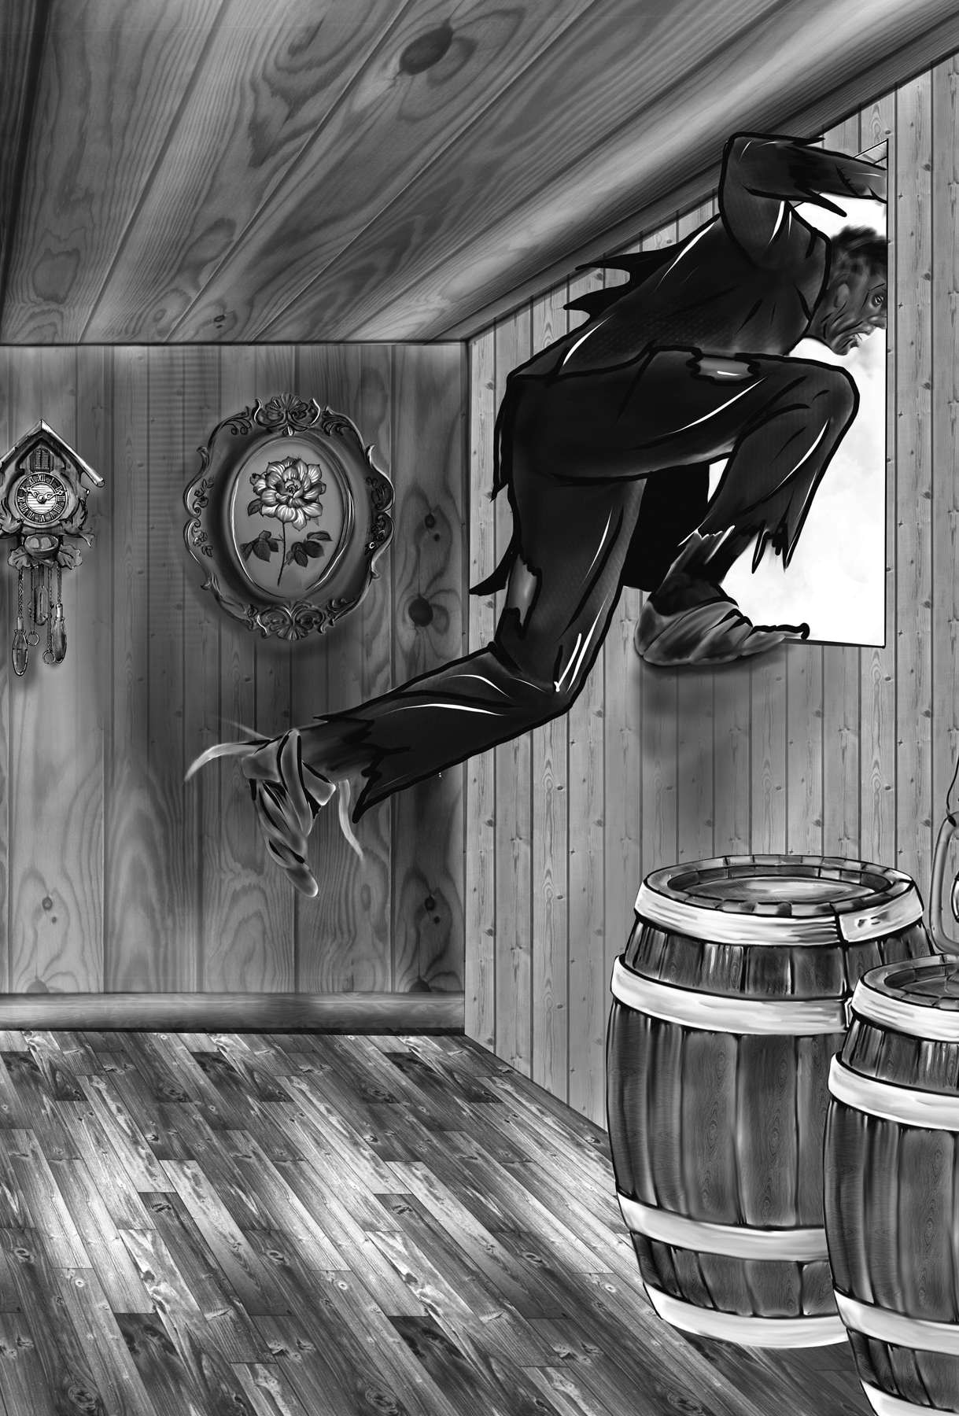

“He spr ang out of t he cabin window and ont o an ice r aft.”

## ABOUT THE AUTHOR

*Mary Shelley*

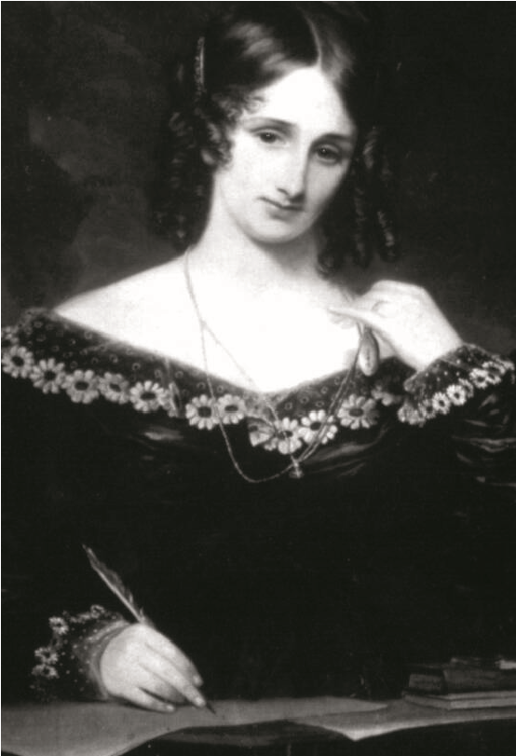

Mary Wollstonecraft Shelley, née Mary Wollstonecraft Godwin, (born August 30, 1797, London, England—died February 1, 1851, London), English Romantic novelist best known as the author of *Frankenstein*.

The only daughter of William Godwin and

Mary Wollstonecraft, she met the young poet Percy Bysshe Shelley in 1812 and eloped with him to France in July 1814. The couple were married in 1816, after Shelley’s first wife had committed suicide.

After her husband’s death in 1822, she returned to England and devoted herself to publicizing Shelley’s writings and to educating their only surviving child, Percy Florence Shelley. She published her late husband’s *Posthumous Poems* (1824); she also edited his *Poetical Works* (1839), with long and invaluable notes, and his prose works. Her journal is a rich source of Shelley biography, and her letters are an indispensable adjunct.

Mary Shelley’s best-known book is *Frankenstein*; or, The Modern Prometheus (1818, revised 1831), a text that is part Gothic novel and part philosophical novel; it is also often considered an early example of science fiction. It narrates the dreadful consequences that arise after a scientist has artificially created a human being. (The man-made monster in this novel inspired a similar creature in numerous American horror films.) She wrote several other novels, including *Valperga* (1823), *The Fortunes of Perkin Warbeck* (1830), *Lodore* (1835), and *Falkner* (1837); *The Last Ma*n (1826), an account of the future destruction of the human race by a plague, is often ranked as her best work. Her travel book *History of a Six Weeks’ Tour* (1817) recounts the continental

Abou t t h e Au t h or 303

tour she and Shelley took in 1814 following their elopement and then recounts their summer near Geneva in 1816.

Late 20th-century publications of her casual writings include *The Journals of Mary Shelley*, 1814– 1844 (1987), edited by Paula R. Feldman and Diana Scott-Kilvert, and *Selected Letters* *of Mary Wollstonecraft Shelley* (1995), edited by Betty T. Bennett.

https://www.britannica.com/biography/Mary-

Wollstonecraft-Shelley

Cover and Tit le Page Illust r at ion by

Ivan Pesic

Text Illust r at ions by

Everett Collection Historical / Alamy Stock Photo / 301

Ivan Pesic / 15, 18, 30, 46, 59, 81, 92, 125, 127,

133, 149, 186, 217, 220, 227, 257, 269, 274, 300

*What to do when it’s too rainy to go outside?* That was the question Mary Shelley and her friends faced during the very rainy Summer of 1816. The poet Lord Byron suggested that they all write ghost stories and share them. At fi rst Mary Shelley struggled to come up with a story. Then something amazing came to her . . . in the night. It was a story about a bold scientist who sets out to form a human-like body — and then dares to give it life!

Core Knowledge Core ClaSSiCS™

* Abridged texts for young readers, faithful in themes, style, and spirit to the original works
* Designed to be read independently or to complement the Core Knowledge Language Arts™ (CKLA) curriculum
* Developed by the nonprofi t Core Knowledge Foundation Other CoRe CLAssiCs titles include:
* A Christmas Carol
* Anne of Green Gables
* A Midsummer Night’s Dream
* Don Quixote
* Gulliver’s Travels
* King Arthur and the Round Table
* Robin Hood
* Robinson Crusoe
* Sherlock Holmes
* Strange Case of Dr. Jekyll and Mr. Hyde

www.coreknowledge.org

* The Iliad and the Odyssey
* The Importance of Being Earnest
* The Legend of Sleepy Hollow
* The Squatter and the Don
* The Tempest
* The Time Machine
* The Tragedy of Julius Caesar
* Treasure Island
* Twelfth Night

ISBN: 979-8-88970-996-1